**3-Dimensional Glass Laser Etching System**

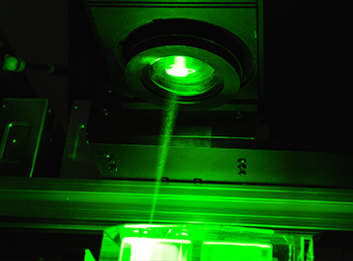

**University of Central Florida**

*Department of Electrical Engineering and Computer Science*

*Department of Photonics Science and Engineering*

*Dr. Lei Wei*

*Dr. David Hagan*

*Sponsor: Dr. M.J. Soileau*

*Senior Design I Final Documentation*

*Submission Date: December 6th, 2016*

**Group 20**

|  |  |  |
| --- | --- | --- |
| Monushka Sicar | Electrical Engineer | monushkasicar@knights.ucf.edu |
| Phillip Lane | Electrical Engineer | plane94@knights.ucf.edu |
| Burdley Colas | Photonics Science & Engineer | b.colas@knights.ucf.edu |
| Nicolas Ramirez | Computer Engineer | nicolas.ramirez@knights.ucf.edu |

# 

# **Table of Contents**

1.0 Executive Summary ....................................................................................................1

2.0 Project Description……………………………………………………………………….…2

2.1 Motivation …………………………………………………………………………...2

2.2 Goals and Objectives ……………………………………………………………....2

2.2.1 Current System………………………………………………………...….2

2.2.2 Customer Needs….………………..……………………………………..3

2.3 General Project Specifications…………………………………………………..…4

2.3.1 Optical Specifications……………………………………………….……4

2.3.2 Electrical Specifications ………………………………………………….5

2.3.3 Mechanical Specifications……………………………………….……….6

2.3.4 Software Specifications………………………………….……………….7

2.4 Specific Constraints and Standards……………………………………..………...8

2.4.1 Optical Constraints………………………………………………………..8

2.4.2 Software Constraints……………………………………………..……....9

2.4.3 Electrical Constraints……………………………………………………10

2.4.4 Mechanical Constraints……………………………………………..…..10

2.4.5 House of Quality……………………… …….…………………….…….11

2.4.6 Existing System………………………………………….………………12

2.4.7 Software Standards………………………………………….……….....13

2.4.8 Optical Standards……………………………………………………….14

2.4.8.1 ANSI Z 87.1 (1989)…………………………………………....15

2.4.8.2 ANSI Z 136.1 (1993)…………………………………………..15

2.4.8.3 CDRH/IEC (21 CFR 1040)…………………………….……..15

2.4.9 Electrical Standards - IEEE Std 3007.3 – 2012…………………...…..16

2.5 Senior Design Project …………..………………………………………...…….. 17

2.6 Background …………………...…….…………………………………...………..18

3.0 Research…………………………………………………………………………………...21

3.1 Optical System Research………………………………………………………...21

3.1.1 Types of Lasers………...………….……………………………...….....21

3.1.2 Selection of Laser ……………………………………..……………….. 24

3.1.3 Etching with the Current System……………………….………………26

3.1.4 Cleaning Optics……………………………………………..………...…29

3.2 Software Research………………………………………………………………...30

3.2.1 Programming Language……………………………………………..…30

3.2.2 Python GUI Toolkits……………………………………………………..31

3.2.2.1 Tkinter…………………………………………………………..31

3.2.2.2 wxPython (Phoenix)……………………………….………….32

3.2.2.3 PyQt…………………………………………………………….33

3.2.2.4 PySide………………………………………………………….34

3.2.2.5 Conclusion on Toolkits……………………………….……….35

3.2.3 3D Conversion……………………………………………..………….…35

3.2.3.1 STL (STereoLithography) File Format…………...………….35

3.2.3.2 2D to 3D Conversion……………………………………...…..36

3.2.3.3 STL Tools Module………………………………………….….36

3.2.3.4 ImageMagick + Potrace + Blender…………………………..38

3.2.4 STL Slicer / Gcode Generator…………………………....…………….40

3.2.5 GCode Streamer…………………………………………………….......42

3.2.6 RS-232 Interfacing……………………………………………….….…..42

3.2.7 PySerial Module…………………..……………………….…………….43

3.2.8 Microcontroller Firmware……………………………………………….44

3.3 Electronics Research…………………………………………………………..….46

3.3.1 Power…………………………………………………………………..…46

3.3.1.1 DC vs. AC Power Supply…....………………………………. 46

3.3.1.2 Power Conversion…………...…………………….……….....48

3.3.1.3 Voltage Regulation…………………………………….……...49

3.3.2 Microcontrollers………………………………………………………….51

3.3.2.1 Relevant Capabilities…………………………………...….....51

3.3.2.2 ATmega 328P and ATmega 32U4…………………………...52

3.3.3 Motors…………………………………………………………………….53

3.3.3.1 Servo Motors…………………………………..…………...….55

3.3.3.2 Stepper Motors……………………………………………….. 58

3.3.3.3 Servo Drivers…………………………………………………. 61

3.3.3.4 Linear Encoder... …………………………………………..... 63

3.3.3.5 Motor and Driver Power Supply…………………………..….65

3.4 Mechanical Frame Structure……………………………………..……………….68

3.4.1 XY Stage - Option 1 Velmex BiSlides………………...………………..69

3.4.2 XY Stage - Option 2 InteLiDrives BSMA - 080…………….…………..71

3.4.3 Safety Shielding Assembly Materials..………………………….….....73

3.5 Scanning Mirror Approach ………………………...……………………..………73

4.0 Design………………………………………………………………………………...…….77

4.1 Software Design……………………………………………………………..…….77

4.1.1 Software Design Summary…………………………….………….……77

4.1.2 GUI Design…………………………………………………………….... 79

4.1.3 3D Conversion………………………………………………………….. 82

4.1.4 G-Code Construction and Streaming …………………….……….…. 83

4.1.5 Microcontroller G-Code Interpretation………………………….……..85

4.1.6 RS-232 Interface ……………………………………………...………...86

4.1.7 Laser Engraving Process…………………………………..………..….87

4.2 Optical Design……………………………………………………………..……….89

4.2.1 Optical System Design………………………………………………….89

4.2.1.1 Single Lens Approach………………………………...………89

4.2.1.2 Telescoping Beam Expansion and Focus Lens………..…..90

4.2.1.3 Zemax Analysis…………………………………………….….92

4.3 Electrical Design - System Layouts and Schematics……………………….…..95

4.3.1 Power Distribution………………………………………………….……95

4.3.1.1 Voltage Regulation………...……………………………….…96

4.3.2 Motors, Drivers, and Laser Unit……………………………..………….98

4.3.3 Communication and Control……………………………………………98

4.3.4 Final Electrical Design…………………………..……………………..101

4.4 Mechanical Design - XYZ Platform Selection…………………………….……103

5.0 Prototype Construction and Coding……………………………………………….……106

5.1 Final Software Plan………………………………………………………………106

5.1.1 Coding Plan……………………………………………………………. 106

5.1.2 Source Control…………………………………………….…..……….107

5.1.3 Choice IDE……………………………………………….……..………108

5.2 Optical System Assembly...……………........................................................109

5.3 Electronics Construction…………………………...……………………………109

5.3.1 Power and Communication Connections........................................109

5.3.2 PCB Vendor and Assembly………………………………...…………111

5.4 Final Mechanical Plan - XYZ Platform Structure……………………………....113

6.0 Prototype Test Procedures………………………………………………………….…..114

6.1 Optical Specific Testing ………………………………………………...……….114

6.1.1 Laser Operation…………………....…………………………………..114

6.1.2 Optical System Alignment…………...………………………………..114

6.2 Software Specific Testing……………………………….……………………….115

6.2.1 Testing Environment……………………………………………......…115

6.2.2 3D Conversion: 2D to 3D……………………...……………………....116

6.2.3 RS232 Interface Testing……………………………………..………..118

6.2.4 STL to GCode Conversion………………………………………...….118

6.2.5 G-code Streaming and Interpreting...…………………………...……119

6.3 Electrical Specific Testing……………………………………………….………120

6.3.1 Testing Environment…………………………………………………..120

6.3.2 Power Distribution Testing…………....………………………….…...121

6.3.2.1 Final Schematic Components…………………...………….121

6.3.2.2 Motor Systems and Drivers…………………………...…….122

6.3.2.3 Laser ICE Unit…………………………………………….….123

6.3.3 Communication and Control Testing………..…………………..……123

6.3.4 Motor Driver Control Testing……………………………………….....123

6.4 Mechanical Specific Testing…………………………………………...………..124

6.4.1 Testing Environment………………………….……………………….124

6.4.2 Safety Shielding Assembly Check Testing…………………….….....124

6.4.3 XYZ Platform Weight Testing.………………………………………...125

7.0 Project Management……………………………………………………………….…….126

7.1 Roles and Responsibilities………………………………………………………126

7.2 Milestones………………………………………………………………………...129

7.3 Project Budgeting and Finance……………………………………...………….130

8.0 Conclusion………………………………………………………………………..……… 132

9.0 References............................................................................................................A - E

10.0 Appendix ...........................................................................................................I - XIII

10.1 Appendix A - Copyright Permissions………………………………………...……I

10.2 Appendix B - Datasheet Information………………………………………..…...X

# **1.0 Executive Summary**

Three Dimensional (3D) Laser Engraving is one of the perfect combinations of art and science in our world. The appreciation of a 3D image inside a piece of well carved glass is as magnificent as a well-carved sculpture in rock, although the tools used for both differ. Certainly, a rendered 3D artwork is scientific and digital representation of an object in its imagined or natural dimensions--width, height, and depth. Creating a 3-Dimensional image and generate that digital artwork into a medium is a complex process. It requires an interdisciplinary collaboration: Physics, Engineering, and Software Engineering to bring together a system of multiple tools creating different dimensions and resolutions of a memorable masterpiece.

With this avid appreciation for art and science, our group took the great interest to redesign and construct an old 3D laser engraving system. The current system though old, yet in function, has multiple downfalls. These include safety, critical time efficiency, bulk in size, underused for the purposed it was built, and operating on a two-decade old computer with an unfriendly user interface.

The main goal is to create a new system that is more compact in size, by taking up less space. As well being able to render many different images, through an updated software. And last but not least, speeding up the process from all many different facades of optical engineering, computer engineering and electrical engineering. It will take many aspects to create a new rendering 3-Dimensional Glass etcher. The laser we’re using must be functional and have the optical power stability to etch in the glass while collaboratively in harmony working with the electrical and mechanical parts which are controlled by the software.

The requirement to fulfill this aspect calls for redesigning the optics system. Its redesign aims to achieve desired laser beam characteristics over shorter beam path distances. Achieving shorter distances positively impacts the goal of reducing the modern system’s size. Updated and improved software will also be required. Within this software the user will be able to define images more precisely which, alternatively, will direct the microcontroller to give precise directions on when and where the glass should be moved. Precise control will allow for causing damage sites at precise locations, producing a quality image inside any glass. This process in combination requires fast motors to react at the exact times necessary.

The project will be a success to our senior design group team members. It will also bring satisfaction to our sponsor and costumer, Dr. M.J. Soileau, who is a renowned scientist in the field of Optics and the area of High Power Laser Damage. Our system presentation will have the Logo of the University of Central Florida etched in a cubic glass with a beam size of 10 microns at the focal point. The cubic glass dimension is 2.75 x 2.75 x 2.75 ${inches^{3}}^{}$ and the Pegasus Logo will have the dimensions of 1 x 1 x 0.2 ${inches^{3}}^{}$ which are 167 x 167 x 33 pixels.

# **2.0 Project Description**

## 2.1 Motivation

May 16, 1960 at the Hughes Research Laboratory in California, Theodore Maiman operated the first working laser, “a solution looking for a problem,” it was referenced as. Since then the laser has been more than a solution to just a problem. Its use has widely spread in science, medicine, and technology due to its versatile qualities. In the industry, laser applications have many advantages such as to cut hard materials with precision and leaving no erosion, controlled easily to create two-dimensional and three-dimensional work pieces or artwork into different materials. With this knowledge, our project is determined to construct a systematic device controlled to create small **damage sites** into a crystal. The **damage sites** will be **pixels** of the rendered image from a computer software.

Laser writing in our modern day is common. Many company use lasers to etch 2-dimensional design on products such as electronics, furniture, appliances, just to name a few. Another amazing and currently booming market idea and product is the creation of awards and presents depicted as crystal with two-dimensional, pseudo 3-dimensional, and three-dimensional images etching into the glass without having its surface damaged. However, as fascinating these presents and aware are the curiosity remains what is the science and engineering behind this process? This same curiosity takes our group to redesign and construct an existing 3-Dimensional Glass Laser Etching System.

The current system we’re redesigning and construct, will be a versatile system with modern technologies. We will have a new computer at the disposition of the customer to operate the system. The software will be user friendly and have a fast response time. The system now is massive, and one of our goal is to make sure that the size will be smaller. Moreover, safety is a potential issue. The current system has electrical wires naked and put whoever will be using it at risk. Also, due to reflections the laser beam presents a safety issue when using the machine. Thus, two solutions we have are to make sure the electrical wiring are well arranged and compact such that we minimize the risk of electrocution, and have a shielding safety frame which will block stray optical beams reflecting from optical elements in the system.

Overall, our motivation is to create a 3Dimensional Glass Etching System which will be far better than the current system the customer has. The satisfactory outcome will be an outcome from the versatility, safety, size, and time reduction compare to the system.

## 2.2 Goals and Objectives

### 2.2.1 Current System

As seen in Figure 2.1, the condition of the current system dramatically aching with several issues that need to be fixed or completely changed.

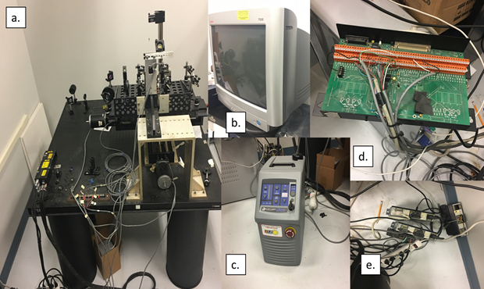

Figure 2.1 - Exposing Current System’s Condition to Emphasize Project Importance

Figure 2.1.a demonstrates the optical system of the current system, mounted on a scaled 3-dimensional stage with 3 stepper motors. Supposedly this current system was built to with the capability of etching 6 transparent crystal glass at the same time. Figure 2.1.b is an extremely outdated computer monitor that is associated with a slow processor on the computer. Figure 2.1.c shows the current cooling system for the laser. Figure 2.1.d show the motherboard of the electronic processing of the system. Figure 2.1.e shows the drivers that are used to control the 3 motors of the system.

It is easily seen that current system has several safety issues. The electrical wires are exposed and can easily yield the user to be electrocuted. There is no safety shielding around the opto-mechanical components, thus the laser beam can potential caused damages to the user. In addition to all these harmful issues, the system is extremely bulky. The computer which is used for controlling the motors and rendering the image to be engraved in the glass is completely outdated. Furthermore, as our group were inspecting the current system we found that the cooling system for the laser has a major leakage which present a potential threat to the condition of the laser. Also we found out that the last time the laser was calibrated was 13 years ago. In summary, our work is imperative to collectively think of creative way to bring our project to a modern state.

### 2.2.2 Customer Needs

Our customer, Dr. M.J. Soileau understand the critical condition of the current system. His proposal to our team is to redesign the system. His requirements were as such. For the system to have decrease in size. Seating on this large current optical breadboard, and with the fact that this system was made to etch six glass at the same time but most of the time it’s only used to etch one at the time. Redesigning the system so that it can etch one glass at the time is imperative and that will drastically change the size of the system. Another aspect is the software to generate the image is complex and time consuming, and the user interface is not as simple when importing the image and setting parameters to before rendering the image in the glass. A new interface is needed which has to be responsive and easy to use. In terms of safety, the current system is definitely not safe, and whenever it is in use it is a danger to the person using also to the whoever might be in the same environment. The laser beam is propagating and reflecting optical elements is dangerous because there is no safety shield around to block the beam. This aspect must be implemented in our future machine. In summary, our customer wants us to have a new system that is versatile, scaled down to its current size, with the ability to have a faster response time and takes less longer compare to the current system which takes approximately two hours to etch one design in one glass without taking into account the additional setup time. Plus, to modernize the system with the capability of etching in 3 dimension rather than simply two mention. Lastly, our system must be able to work efficiently, it must be repeatable, and have a user manual such that whoever is using the system knows how to maneuver the machine. In addition, we must be able to determine the spacing between spots when etching, a way to determine depth in etch image. Thus, a new system that is smaller than the current version, versatile, time efficient, and reproducible.

## 2.3 General Project Specifications

### 2.3.1 Optical Specifications

The Optical and the software specifications are together because they will incorporate the final etch in the glass. To start off, these are the specifications respective to the optical system. Using the laser in the optical system, I am designing to have the beam diameter to etch in the glass to be 10 microns. Furthermore, the laser will be running at an energy 5.5 energy level, repetition rate 20 Hz, and at 532 nm wavelength. The glass we’re planning to use a Standing Cube, pure glass material of the size 2.75 x 2.75 x 2.75 inches. The dimension and code are from the Crystal Mystique by Lemurian Crystal Product Catalog Code 9005. The Image we’re planning to use will have will the University of Central Florida Pegasus Logo. The Pegasus Logo will have the size 1-inch width, 1-inch height, and 0.75-inch depth. To determine the number of pixels per image dimensions We will use the following formula: $inches = Pixels ÷Dots Per Inch (PDI)$ and the DPI will be 0.006. With this formula the Pegasus Logo pixel size are determined (x, y, z) as seen in Figure 2.2:

$Width = 1 inch ÷0.006 = 166.67≍167 pixels$, x

$Height= 1 inch ÷0.006 = 166.67≍167 pixels$, y

$Depth = 0.2 inch ÷0.006 = 125=33 pixels$, z

Continuously, the pixel spacing will set to be $10^{-3}$. This numerical specification will be achieved through the software setting 3 dimensional conversions and controlling the motor speed as the laser is pulsing into the glass.



Figure 2.2 - Pegasus Logo 1in x 1in x .2in

### 2.3.2 Electrical Specifications

The electrical specifications are derived directly from the needs of Dr. M.J Soileau. Overall, it is requested that the system has increased safety (i.e. no exposed circuitry), quicker runtime compared to that of the current system, and a decrease in overall size. Below are the critical specifications for the laser etching system:

* Main external supply: 110 - 120 VAC (US Standard)
* Microcontroller (MCU)
  + Operating voltage of no more than 6 VDC
  + Required communication methods: USB-to-Serial (PC to MCU)
* Motors
  + Max supply voltage: 60 VDC
  + Can move up to 20 lbs. of weight
* Etching Runtime: at least 40% less than current system’s runtime

In regards to safety, the current system has many hazards. Wires are exposed on the printed circuit board and they extend from one part of the system to another. A critical issue with the laser ICE unit is that there exists a leakage problem from the laser’s cooling system. When a leakage occurs a puddle is created around the laser unit, the main user computer, and the motor drivers. As they all sit on the floor together there now exists a risk of the user being electrocuted when operating the machine. All of these safety hazards are apparent in Figure 2.1. The electrical specifications contributing to increased safety of the system include: **minimizing the wired inputs and outputs to the printed circuit board and placing all electronics (excluding the Laser ICE unit)** together in **one electronics box.**

In regards to improving the system’s runtime, this focuses more so on the motor’s ability to respond quickly and the responsiveness of the microcontroller. At the start of the etching process, the 3-D Laser Etching System will have access to the necessary information that describes how the motors will be controlled exactly. With this information the amount of processing by the microcontroller is minimized, leaving the existing processing activities solely for motor control. The runtime specification to sufficiently meet the customer’s needs is 40% reduction from the current system typical runtime, which is ~2 hours. So an achievable runtime would approximately be 1 hour 12 minutes at most (with 2-hour runtime for the current system).

As for the overall size of the system, this will be the simplest customer need to fulfill. By etching one crystal glass at a time, the size of the platform that will hold the glass will need not to be large in size. A small sized platform means smaller motors can be considered. With smaller motors comes smaller motor drivers, providing more flexibility in using available space for all other electronics.

### 2.3.3 Mechanical Specifications

As previously stated, one of the project’s main purpose is design a more compact and efficient system. The mechanical specifications to achieve that are as follows:

* Motor Torque: no more than 3200 oz.-in
* Must support up to 20 lbs. of weight either on Z-axis or XY platform
* Optical breadboard dimensions: up to 3 ft. by 3 ft. surface area
* Electronics housing dimensions: up to 1 square feet surface area
* Staging/Etching platforms must occupy up to 4 square feet surface area

The motor specification discussed with Dr. Soileau is to provide no more than 3200 oz.-in of torque. Going higher may require larger, more powerful motors. Hence, a team decision is made that the max weight being moved by any one motor is approximately 20 lbs. A team goal will then be to achieve a torque of 320 oz-in which is sufficient for moving 20 lbs., assuming a distance of one inch from the weight being moved. Ultimately, this means that large motors may not be required. The use of a larger motor would waste energy and power. Smaller sized motors are therefore an option to achieve a reduction in overall system size.

Another specification important for size reduction is to limit the new system’s optical breadboard surface area. Essentially, the specification of no more than 3 ft. by 3 ft. of surface area will be realized for the breadboard. This goal will be achieved by creating an XY staging platform in which two motors will control each axis. The staging platform needs to use no more than 4 square feet of surface area to comply with the above specification and be compatible with allowing 1 square foot for an electronics housing box mentioned previously.

### 2.3.3 Software Specifications

The software specifications for our design project are much less numerical and are more functional specifications of the software design. These functional specifications are there to fit the needs of the sponsor of the project. As the software design is the front-end of the project, many of the specifications are how the software application interacts with the user. The other sets of specifications outline how the physical functions, such as the etching itself, function within the software design.

The first set of specifications describe how the front-end of the software application will work. In short, how the graphical user interface interacts with the end-user. The specifications for user input and the graphical user interface are as follows:

* Any 2D Raster image to 3D vector image (STL) conversion
* Immediate input of 3D image/object (STL)
* User configurable options

These specifications are describing how the input of the user interacts with the rest of the software. Our design calls for the software to convert any 2-dimensional image, such as JPG, PNG, and other 2D raster formats, to a 3-dimensional image or object that is capable of being etched into the glass. However, if a user already has a 3D STL file that they would like to etch into the glass, and would like to bypass the 2D to 3D conversion, they should be able to do so. Finally, the graphical user interface should have many different options, such as being able to configure the command line options of any step in the 2D to 3D conversion process, such as how much they would like to extrude the 2D image when converting to 3D.

Other specifications describe the general back-end functionality of the software application. These specifications are also not numerical specifications. The following are the specifications:

* Complete laser control using RS-232 interface
* Motor control for glass etching
* Glass etching of any suitable 3D vector image
* Capability of having high resolution

These specifications describe more of how the software application will function. For example, the complete laser control through the software will be done through the RS-232 interface. This laser control needs to be incorporated inside the software application as the previous software did not have this functionality. These other specifications describe the actual glass etching process. Quite obviously, control of the motors through the software needs to be achieved. Also, the system should be able to etch any suitable 3D vector image and it should be capable of at least analyzing and trying to etch a high resolution 3D vector object or image.

The last set of specifications describes the ideal computer system that would run the software design. While these are certainly not the minimum specifications of the computer to be able to run the software, these are the recommended specifications that would allow for smooth operation of the entire etching system and design.

* Windows 10 64-bit Operating System
* Intel i5/i7 Quad Core
* 8GB DDR3/DDR4 RAM
* Decent GPU for faster 3D calculations (optional)

As stated before, these specifications do not outline the minimum specifications for the software design. Instead, these are a general guideline for what the recommended hardware specifications of the system that runs our software would be.

Lastly, it is important to note that the main goal of the software design is to automate the entire process as much as possible. Many software designs for similar functions such as 3D printing focus specifically on mastering a single task. While this is generally a much better philosophy to have in software design, we are going for a much broader scoped software design.

## 2.4 Specific Constraints and Standards

## 2.4.1 Optical Constraints

Our project is very rather expensive is we were to purchase every element in its assembly. Although our customer gave us ten thousand dollars maximum for our expenses, accumulate the price for multiple optical elements would certainly exceed the proposed amount for the entire project and then some. One of the main constraints is the laser we have to use. As part of the current system, the laser and its cooling system have been in use for more than fifteen years. After gathering maintenance documents, we found that the laser was last checked for maintenance in 2014. The maintenance before then was 2003. In 2003, the maintenance that was done did not address the problems cooling system has. In 2014, the laser head was sent for maintenance and was found to be working perfectly well and the power was stabilized. Expensive and could potentially be in a very critical condition, the laser present severe a threat to our project due to potential damages and aging of difference pieces. Through current characterization and checking, it was found out that the laser water cooling system tubing needs repaired. This issue, however, is not as critical as if we were to change several parts such as the Rod-O-Rings , the Ultra Fast Lamp, the Pump Cavity Seal O-Rings, the second harmonic generation 532 Crystal, the Q-SN Crystal, and the AR Window. To perform such a drastic and thorough maintenance in our laser would range between 3 thousand and 4 thousand dollars. In the research section, several test will be performing to determine the condition of the laser. The tests are to determine the beam profile for the beam diameter, the beam divergence, the power of the laser, and the pulse duration while pulsing at a wavelength of 532 nm, a 5.5 energy level, and 20 Hz repetition rate frequency. A test will be performed on the current system with the mentioned above dimensions for the Pegasus Logo to see if the laser is capable of use in our system.

### 2.4.2 Software Constraints

When developing and creating the design of the software, there are several factors that need to be taken into consideration. One of the biggest ones is the licensing of specific software that is used within our software design. In order for a piece of code or software to be used within our design, the license that the software is currently under should allow for free use or open source use. As our project design is not being created for profit, any license that allows for free use as long as there is no profit is what would be sought after. Any other software or code components that have licenses that do not allow for reuse or modification would not be allowed within our software design. This constraint affects us because most software applications that have all the desired functions within a single application are copyrighted and put under a license that would not allow us to use within our own software application. Meanwhile, all the open source code and software applications focus on a specific function and we are required to take them all and put them together. Therefore, we would require a separate module or software application for each function such as 2-dimensional to 3-dimensional conversion, STL slicer, G-code streamer, and more.

Other constraints include more technical ones such as the operating system or platforms that are to be supported by the software that we design. While we are only focusing on making sure that the software application works on Windows 10, there are other system constraints such as the version of Windows, bitness of the operating system, and versions of the programming language that are installed within the system. The software that we create must take these into consideration and design choices would be greatly influenced. All the external software and code that are incorporated within our design should all be able to work with the specific operating system that we choose, the bitness of that operating system, and the version of the programming language that is chosen. Although not required by the sponsor, a constraint that could be put into our software design is how easily the software is installable on a system with the target specs and operating system.

Another constraint includes the programming language that we choose to use within our software. Although we have the freedom to choose what programming language we use within our project, which is often not the case in the industry, it is a constraint because we will only be able to use that programming language. Once that programming language is chosen, it is something that cannot be changed. Also, the programming language can be considered a constraint because certain team members may be more comfortable with another programming language compared to the one that we use. This could affect the efficiency in which the software is created. If a team member is not as comfortable with the programming language that is chosen, they will not be able to code as quickly or efficiently compared to a programming language that they are certainly comfortable with.

Since the programming language that is chosen cannot be changed once the application development begins, we would be restricted to only using the frameworks, modules, and libraries available to that specific programming language. It is for this reason that we must make sure that the programming language that is chosen must have a large available library that is open source and can be easily found. Luckily, our sponsor did not require that certain libraries or resources are used within the software design, which is not the case for many projects in the industry. Therefore, we are not constrained with having to use a specific library or framework.

### 2.4.3 Electrical Constraints

Based on the customer needs of Dr. M.J. Soileau, the general project specifications for the electrical system of the project are defined. The specific technical constraint for each system can now be realized. As mentioned previously, all electronics excluding the laser unit needs to be together with minimal wiring to and from them and the computer. The volume that includes all the moving parts and the optics will be 3 ft x 3 ft x 3 ft. Of this volume, **all components inside of the electronics box will be required to occupy no more than 1 square foot**. This also eliminates the exposure of wiring from the electronics box to the motors.

With respect to quick responsiveness of the system, the **microcontroller and motors** will **have their own main power**. The microcontroller is a power sensitive device while the motors and their drivers utilize higher voltages and currents. The microcontroller will be able to quickly control the motors to various locations. When the motors are to change abruptly they may draw their maximum amount of current. Therefore, the constraint here is their separation of references to main power. The **constraint here is to have the motors will have a separate reference** to main power from the microcontroller’s reference. This leads to having more electronic components taking up space as their will need to be a power supply present for the motors and drivers alone. Hence, utilization of the space already available is critical. The main power is likely to be that provided by a U.S. standard wall outlet. This U.S standard output is between 110 - 120 VAC at a frequency of 60 Hz and will be sourced. Finally, the laser ICE unit that exists for the current system needs to be used for the new laser etching systems. The constraint due to this is that the unit operates at **115 VAC 60 Hz.** This is compatible with the main external power supply.

### 2.4.4 Mechanical Constraints

The mechanical parts will include a moving XY platform stage and a vertical post to hold a lenses. The **surface area** for these parts will be limited to **2 ft. by 2 ft.** For travel distance within this surface area, the system needs to allow distance up to **8 inches by 8 inches**. The vertical post (Z axis), controlled by a 3rd stepper motor, will consist of a metal post holding the required lenses for relocating the laser beam’s focal point relative to the etching glass. The **height constraint is 3 ft.** for this post considering that the volume specification of the entire system includes a max 3 ft. height requirement. The 3ft of height starts from the optical breadboard to the top of the final system.

### 2.4.5 House of Quality

The House of Quality (Table 2.3) of our project helps us tie the design constraints and realization of our project per the needs of our customer needs. In correlation, versatility, size, speed, time efficiency, and cost to quality, efficiency, cost, and dimensions; we found that we are abound to many challenging in the realization of our project. Ten thousand dollars from our sponsor to reconstruct the current system in dilemma can only get us to some length. A primary challenge is the speed of the new system. The speed would be mainly determined by the capability of the laser, which in our case we are not be able to do much about. Due to the heavy cost of the needed laser of to accelerate the speed of our system, ten thousand dollars is not near sufficient to purchase a new laser. Our customer, Dr. MJ Soileau, gave us specifically these specifications he would want to see from our project. These specifications would differentiate the status and functionality of his current system. Versatility, Size, Time Efficiency, User friendliness, and safety were his customer needs but, few of these needs were would be able to be met and the House of Quality is a simplistic representation of the correlation of customer needs and engineering realism.

With the House of Quality Table 2.3 we are able to express the correlation that exist between our customer needs and the engineering requirements pertaining to our project realization. Although the cost did not play a major role in our engineering requirements, we know that the laser is our main constraint thus we did not take into accountability the cost of purchasing a new laser for the system projected to be build. Also, we know that due the laser specifications that will in fact affect the speed or time efficiency of etching an image. However, with a new system for our software and with no motors, we will aim to match the pulse per second the laser emits such that we can have an etching time which will be less than the current system.

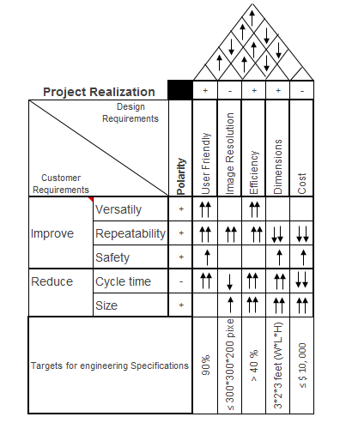

Table 2.3 - House of Quality, understanding design constraints with respect to Targeted Engineering Requirements and Customer Needs to the project’s realization.

### 2.4.6 Existing system

As seen in Figure 2.1, the condition of the existing violate several electrical and optical standards. Not only it is a bulky system assembled on a 4 x 4 feet optical table, it is also a system that has been extremely underused for it was fabricated to etch six crystal glass at the same time. In short, it was designed and constructed for mass production or simply for quantity over time effectiveness as it takes approximately one and a half to finish engraving one glass. The current system put at risk of electrocution and potential laser damages whoever is using it. As safety is one of the main customer need, it is imperative that our group address the proper wiring and proper shielding for stray reflecting beam that could continue putting the user in danger. The future system comparatively to the new system will be assembled on a smaller space area, 3 feet by 3 feet, also shielded with proper material that will serve as a filter for the 532 nm wavelength the laser will be operating at. These changes will most certainly meet the optical and electrical standards and satisfy the size and safety our customer requested.

### 2.4.7 Software Standards

In software development, being able to understand and follow software standards used by other software developers is what can separate a mediocre developer from a great developer. It is also an crucial part of the software that is designed. Software standards are used to allow for easier understanding when reading someone else’s code as well as allowing for software applications to connect to each other. It is for these reasons that our software application will follow many software standards. We want the software that is designed to be easy to understand, easy to use for the end user, and most importantly easy to modify and connect to if any changes are desired in the future.

One of the most widely used software standards is the different type of file standards. Within our project we are using many different file formats. The first being the STL or stereolithography file format. This file format is used by computer aided design software to create 3-dimensional objects. It is extremely popular and is one of the main files used in 3-dimensional printing and 3-dimensional design today. STL files represent 3-dimensional objects by using triangles. The vertices of the triangles, along with the face normal, are stored within the STL file. STL files come in both ASCII and binary versions. The binary STL file is more commonly found and used due to it being more compact, although it is much less human readable.

There are other file formats used within our software design including PNG, JPG, BMP, SVG, and other optional formats. Explaining these formats is not an important part of the project, but it is important to note that we are still using these commonly found formats within our project.

Another important standard that we follow in our software design is the use of the programming language called G-code which can be summarized as being a programming language that has instructions for movements. These instructions are most commonly used for moving motors. G-code has many variants but it mostly follows a certain style and function guidelines. It is mainly used in 3-dimensional designs such as 3D printing and CAD designs. First implemented in the 1950s at the Massachusetts Institute of Technology, G-code has gone through many revisions and changes.

For the programming and code layout of the entire software architecture, we will follow style guidelines for the programming language chosen. Each programming language has its own standards that software developers follow. For example, Python has PEP8 which is something that almost all Python developers use to allow for easier code readability and code structure and layout. PEP8 specifies code styling from comments, naming conventions, white space, variable names, class names, and much more. Following a style guideline is one of the most important things when writing code because it allows for others to much more easily understand and read code. This allows for the others to write code to use the code created. Therefore, it is crucial that we follow the most popular and widely used programming style for whatever programming language we choose to use within our project.

Another standard use within our software project is the RS-232 interface standard. RS-232 is a standard for serial communications which is used to communicate between two different ports. This standard was more commonly found before the introduction of the universal serial bus (USB). It used to be the choice for peripheral connections and easy communications between computers until it was phased out by USB. The RS-232 interface standard does not really specify the digital signals used within the communication, but instead specifies the physical hardware connections used. These include the pin layouts, pin polarities, and voltages used in the connection itself.

It is important to note that many of the software standards used in 3D printing and the like are not official standards created and maintained by organizations. Instead, these are standards created and accepted by professionals and hobbyists alike. Therefore, there may be different variations of the standards but they all follow a general purpose.

### 2.4.8 Optical Standards

Designing a product from a phenomenal idea comes with its own challenges in the real world. These challenges can be several, and among these standards in summation is a giant. Respectively to our project, we were able to find these standards in regards of our optical section of our project. These standards help our future engineers to be aware and reconcile the industrial developments in our project realization. Below we will explain how standards found with respect to optical elements in our system design and assembly.

American National Standards serves as a guide to help manufacturer, consumer, and general public. It implies consensus of those substantially concerned with its scope and provisions. The American National Standard Occupational and Educational Personal Eye and Face Protection Devices is a document that has been reviewed under the American Society of Safety Engineers and authorized by the United States government. The ANSI Z 87.1 was approved on June 19, 2003 and was Effective on August 19, 2003. The ANSI Z 87.1 gives requirements for protections which includes selections, use, and maintenance of protectors as devices to minimize or prevent eye and face injuries. We will use this guide to associate many of the perspectives which applies to our project realization.

The standard ANSI 136.1 which also a standard under the American National Standards serves as a guide to the Safety Use of Lasers. The ANSI Z 136.1 was approved on March 16, 2007 by the American National Standards Institute, Inc. falling under the Laser Institute of America. As noted the ANSI Z 136.1 will in effect imperative in our understanding of use of laser in product fabrication in laboratories and industrial usage.

CDRH/IEC is another guide which abound to products which use laser rather in large manufacturing of consumer use. This section will be expanding such that it we show its importance in sections which applied to our projects as if it was for manufacturing or consumer use.

#### 2.4.8.1 ANSI Z 87.1

One of the customer needs for our project realization is safety. Safety respectively to the laser. It is imperative in our case and we can support that with the ANSI Z 87.1 standards. This standard which covers the Occupational and Educational Personal Eye and Face Protection Devices with respect to the type of laser in the vicinity of the product and the area the product is being developed. Before our group started to work on the project, we made sure to watch the Laser Training Video provided by the American Laser Institute. This was extremely important because we were able to learn about the type of laser that will be incorporating in our system. Also, it helped us research the appropriate material for to secure the perimeter of the project. The frame shielding in addition to appropriate personal protective equipment (i.e. Laser Goggles for 532nm and 1064nm) help us provide our customer a safety needed for the project. The ANSI Z 87.1 also provide us the information on test methods for many aspects of optical system measurements. This information helps our team to understand the scalability of work we have to do will working with a high power laser, precision optics, and potential hazards we might encountered. [44]

#### 2.4.8.2 ANSI Z 136.1

As the ANSI Z 136.1 standards serves as a guide to provide reasonable and adequate for the safety use of laser and laser systems from 0.18 microns to 1 millimeter, we also found far more applications aspects as we dig deeper. Our laser can operate at four different wavelengths. Selectively we will concentrate in 532 nm and 1064 nm. These two wavelengths are the projected that can be used for our purpose in the project. This standard helps us understanding as well hazards, applications, classification of lasers, and appropriate specifications and controls for each classification. The laser is used in a widely variety of field, biology, chemistry, etc. The ANSI Z 136.1 standard help us distinguish these sections as well as the use of laser in manufacturing products and industrial uses. In regards of our project, the ANSI Z 36.1 standards associate our laser as a Class 2 laser system for the output beam is with the margin of 0.4 microns and 0.7 microns which denotes also that Eye protection is normally afforded by the aversion response. However, our laser in itself is class 4 laser, a high-power laser, although he wavelength we intend to use is 532 nm or 0.532 microns. Thus, we found that because we are using a high power laser in our system we need to address hazards to the eye and skin from direct beam exposure, diffuse reflection and fire hazard, chance of production of laser generated air contaminants and hazardous plasma radiation. Thus as building system we must pay attention to these standards as they affect our safety and the safety of the customer in use of the system. [43]

#### 2.4.8.3 CDRH/IEC

The IEC which stands for the International Electrotechnical Commision also plays a role in developing standards that apply to manufacturers and users. To strictly concentrate on the user end for that is in alignment with our project. The specifications of the CDRH/IEC in many aspects still address the potential hazards having a laser in a system. Therefore, international laws among countries must be met in these regards. Although we are not manufacturer, but addressing the manufacturing aspect of these standards brings to light the industrial constraints for companies that have mass productions of laser etching machines and crystal glass interaction with laser light while etching. There is multiple aspects where the CDR/IEC play roles in our project, however due to the limiting factor that we are creating a system for a respecting customer we can conclude that we’re not strategically abound to the many standards of this standards while developing our project. [45]

In a brief summary, the use of lasers and optical elements are abounding to many standards. These set of standards can be subdivided respectively to safety and consumer use products. Laser Products standards divided in two branches, Manufacturer standards and User Standards we found are broken down as such: [46]

* Manufacturer Standards: By definition are requirements for laser products manufacturers must meet when developing, manufacturing, and selling products which incorporate the use of lasers. Some of these standards pertaining to manufacturing are: IEC/EN/CSA 60825-1, IEC/EN 68025-2, 21 CFR Parts 1040.10 and 1040.11, IEC/EN 60601-2-22, ISO 11553, to name just a few per our research.
* User Standards: These standards are guides for the safe usage of lasers and laser systems relatively hazards. Some of these standards are: ANSI Z136.1-6, IEC 60825-1 Section 3, and 60825-14.

### 2.4.9 Electrical Standard - IEEE Std 3007.3 - 2012

IEEE Std 3007.3 - 2012 is entitled *Recommended Practice for Electrical Safety In Industrial and Commercial Power Systems*. Much of what the standard offers is an understanding of electrical hazards and safety, why electrical safety practices are important, and safe electrical practices. Along with the discussion of safe electrical practices comes the discussion of protective methods and equipment. Discussion of these aspects are relevant to the project as the use of an AC power supply is being considered. The AC power supply will be a U.S. standard wall outlet, where its output is along the order of 110 - 120 VAC, delivered at 60 Hz. Since this will supply is sourced from many of the electronics, verification of its output will include measuring it which can become hazardous if the proper safety measurements are not taken.

Exposure to an electrical hazard translates to being exposed to unsafe conditions. Unsafe conditions are considered to be the “...poor physical condition of equipment or facilities” [42]. The current system very much presents unsafe conditions. As mentioned before and depicted in Figure 2.1, the current system has wires extending from one part of the system to another, exposed wires on the PCB. The most hazardous issue is that the main power line and motor drivers sit next to the laser ICE unit whose cooling system is prone to leakages. When operating the laser ICE unit, a user could possibly be electrically shocked. “Voltage levels as low as 50 V with low skin resistance and electrical current flowing through the chest area can cause fibrillation, which can in death” [42]. This is critical considering that the main power source for the new etching system is anticipated to be 110-120 VAC. In combination with the current system’s hazardous leakages, a person’s skin resistance could be decreased, leading to lethal electrocution.

Such unsafe conditions will be resolved by the new laser etching system by creating safer designs and practicing safety protocols during the testing and prototyping process. The new system will be design to minimize the need for wires to be extending from one part of the system to another. The printed circuit board will be integrated into the optics and motor subsystems altogether on the optical breadboard, eliminating exposure to open circuitry. If motor drivers are utilized, they will indeed be integrated into a single system with the motors.

After building a prototype, methods will be used to ensure safety of all team members. “Measuring, testing, and probing electrical system components” are just an example of where an individual can become exposed to energized components [42]. To ensure the prototype accurately represents the operation of the final etching system may require measuring the output of a U.S. standard wall outlet output. Testing its output with a voltmeter will require close physical contact to the outlet itself. Safety equipment such as “voltage-rated rubber gloves provide protection from hand contact with an energized source” [42]. Usage of such gloves will be critical in the testing process to ensure a sufficient level of safety for all project members.

## 2.5 Senior Design Project

In Spring and Summer 2015, four students form a group to successfully create a project for their Senior Design Project. This project was called Computer Controlled Laser Engraving System (CCLES). CCLES was a two dimensional computer numerical controlled laser etching system. To successfully create their system, they broke down into multiple subsystems which in the end formed the machine they wanted to create and did the tasks intended. The components of their system were, microcontroller, laser, and power supply which were assembled onto a frame. This frame, too, incorporated motors which are in place to move the laser in the respective coordinates for the laser to etch. Additionally, their system had a graphical user interface which by computer controlled was used to design, create, or upload the image to be etched. To explain and present the different between the CCLES project and our project, the Three Dimensional Laser Glass Laser Etching System, we will compare several of aspects and elements from both projects.

To starts we look at the resulting work both machine supposed to do. The CCLES generally was designed and constructed with the idea that system has the capability of etching two dimensional (XY) image, comparatively to our project, our aim is to generate three dimensional (XYZ) image. We can argue that the CCLES generated three Dimensional images, however this extra dimension which would be (Z) in that case happened to have a fixed planar value with respect to the other two dimensions. In our case rather, the generated or the etched image will without a doubt would have a three dimensional aspect, and it will be easily viewed through the medium, in our case the glass, the image is etched into. That is the extra axis has multiple planes or levels with respect to the two other dimensions. Furthermore, dissecting their system in comparison of ours, we can easily state that our system is more complex. Though their system has an electrical and a software portions which in many ways have similarities to our projected system. We would find similarities in voltages, a printed circuit board, microcontroller and software to control the mechanics and laser. We can still argue that our system would be incorporate complexity of both areas, electrical and software, that differ our project capabilities to give the user an experience which would be satisfactory in work quality. The language used to create software for both project, would be easily spotted by name and by logics used to create each program. Another aspect we looked into for our comparison is the optical subsystem of the CCLES and our 3D Glass Laser Etching System. The CCLES used a laser diode which has a wavelength of 440 nm and has an output power of 2 watts. Unfortunately, there was not much details mentioned in the category of their laser, also if the laser was a continuous wave of a pulsed laser. However, after watching a short video of their working prototype, we were able to conclude that their 440 nm blue laser diode was in fact a continuous wave laser. A small laser which was mounted next to a heatsink to control the temperature. Conversely, our system will be using a Class 4 laser. Our system will have a high power laser. Although our laser is rather old, it is pricier than their laser for it is more powerful. Our laser has well come with a water cooling system. In addition, our optical system is far more complex compare to the CCLES system. The CCLES system happened to have one lens, from understanding of their system and optical knowledge, the lens use in their system is used to help have a nice beam collimated at the etching plane of their system which in the case was a piece of wood. Our system in the other hand will use a cube of pure crystal glass to etched into, and in fact our optical system is composed of mirrors, lenses, and other optical elements to meet the requirements of our sponsor and to continue with the inherited system in our case.

We can go in great length to prove the distinction of our project to the CCLES project of the Spring and Summer 2015. In clear contrast, the CCLES project was definitely small and our etching system will in fact will be bigger in size. Also, in terms of safety although their system used a laser, the class of their laser has a lower safety risks compare to our system. Thus in conclusion, although the idea of both systems appeared to be similar, it is easily debatable to show their many differences which thereafter exclude many reasons which stands to show the exactness of our project to theirs.

## 2.6 Background

Since the invention of the laser, researchers and engineers have found numerous applications for the laser, among which laser induced damage in optics is one of them. Over the years, the understanding of having a laser focused in a glass medium, at some energy level, a portion of the glass medium can be damaged. This phenomenon occurs into the interaction of the light and the medium at the state of plasma. This scientific discovery allows us to create 3D Laser Writing into Glass, where an image can be programed to be engraved into a glass medium without having to damage the outer surface. Laser engraving has continuing to be one of the most flourishing technologies in industries and commercial manufacturing. It is used in fast prototyping in order to mark or etched objects. Laser Engraving process involved a laser controlled to ablate in bulk solid material which are followed by specific patterns. The many applications of laser engraving in industries varies from the creation of molds and dies, marking information such as names, serial numbers, and barcodes on silicon chips, etching an image beneath the surface of a solid material such as glass, and direct engraving of flexographic plates and cylinders.

During this process several parameters of the laser that are considered. They’re included the wavelength, the beam diameter, the repetition rate frequency (taking into account this is a pulse laser), the pulse duration or width, and the total energy when adding these parameters together. When the laser light interacts with the material at the damage site, temperature and absorption of the material at the respective wavelength are highly important to take into consideration. The main reason is the glass material, taking in consideration our material to use, will explode or the ablation at the damage site will extremely exceed the desired single damage site pixel. Thus, the major advantage of the laser as a potential tool to process materials is the precise ability to control the position in the material where and that the respective rate energy is deposited. The ability to confine a deposited energy to a specific area on a material’s surface is achievable by controlling the laser’s spatial intensity profile. The laser spatial intensity profile is the variation of intensity as a function of distance from the center of the beam, in a plane that is perpendicular to the direction it is propagating. Figure 2.4 is a representation of a fundamental Gaussian beam propagation and the Gaussian beam intensity profile of a laser determining the spot size.

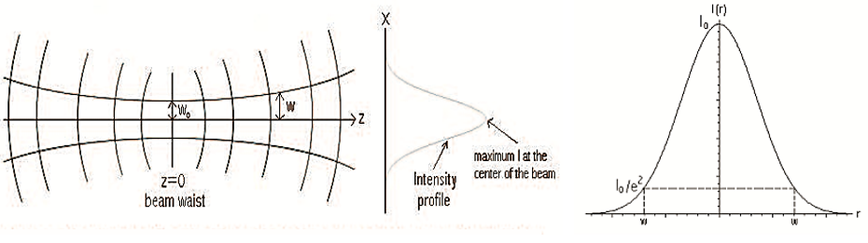

Figure 2.4 **-** Propagation of a fundamental Gaussian Beam illustrating the intensity profile, and variation of the spot size with longitudinal position and change in the beam curvature.

To control light propagation in materials, some of these predominant methods incorporated beam steering using a fixed or a galvanometer scanning mirror, beam focusing through telescoping or conversing optics, and beam shaping with homogenizers, amplitude masks, refractive elements, and diffractive optical elements. There exist more advanced optical devices which can be used such as spatial light modulator, deformable mirrors, and tunable acoustic gradient index lenses which allows real-time instantaneous modulation of the laser beam intensity profile on the surface of the material.

To further understand the light interaction with materials in the aspect of a laser light etching in glass, we look at the aspect of ablation. Laser ablation is the process of removing material from a substrate with direct absorption of laser energy. The term laser ablation in our context is relevant because laser ablation is usually associated with pulsed lasers. During the ablation process, depending on the material, thermal expansion occurs due to the material absorption mechanism. When using a pulsed laser, the typical threshold fluences can decrease as multiple pulse accumulate the overall defect at the damage site.

In short, the process of having a pulsed light etching into a glass material will also have a respective resolution depending on the laser beam profile, the pulse length of the laser, the repetition rate and the energy at which the laser is injecting at the damage site. In our project, as the laser is etching into the glass, there is nothing we can do to monitor the materials response or the perfect resolution for the rendering images, in characterizing the laser and perform preliminary process of etching in glass with the current machine. The pulse length, the beam profile, the output energy of the laser we will be using will be, will be determined such and inserted in the research section to reference the current system capabilities to the system we are designing and constructing.

As 3D Laser Glass Laser Engraving becoming a profitable market, multiple companies all over the world are creating advanced systems with advanced technologies to have higher performance in terms of time efficiency, resolution, repeatability, and are well safe, most of these machines, however, are extremely expensive. Comparatively to the system we will build, the commercially available are indeed way more expensive and way more complex in software system. As a senior design group, we are in the lack of funding and exclusively the time and knowledge to actually create a sophisticated system that can compete with the market value. Although we are pressing by time, knowledge at our level, the success of a prototype will bring forth the science, engineering, and the computer engineering and science knowledge our team members respective to our different major, a satisfaction of accomplishment and this project in future will serve as a reference and inspiration to bring different designs and capabilities of the power light interaction with materials and the usefulness of laser in multiple areas of engineering, medicines, communications, and much more.

# **3.0 Research**

# 3.1 Optical System Research

# 3.1.1 Types of Lasers

The acronym LASER stands for Light Amplification by Stimulated Emission of Radiation. The light of a laser differs from an ordinary light source from an incandescent light bulb for example. The laser light has several unique properties such has, having the same frequency and phase, and the fact that the laser light is from an optical amplification process which is a stimulated emission of electromagnetic radiation, see Figure 3.1**.** Another aspect of the light from a laser is that, the light of the laser is coherent. Additionally, the light from a laser is monochromatic, that is the laser light will have a specific wavelength of light that is being emitted. The spatial coherence of a light allows the laser to be focused at a specific spot, which gives ways for different applications such as laser cutting, marking, and laser engraving. [54]

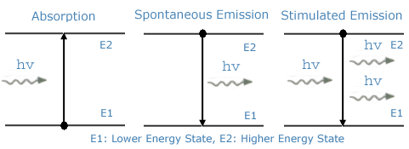

Figure 3.1 - Representation Absorption, Spontaneous Emission, and Stimulated Emission occurring in a Laser.

Over the years, various types of laser have been developed. The classification can be categorized by the physical and operating parameters. Therefore, lasers that are characterized according to the physical state of the active material are described as solid state, liquid, and gas lasers. Additionally, if lasers are subdivided by the wavelength of emitted radiation, the types of laser we would have are infrared lasers, visible lasers, UV and X-Rays lasers. We can also have continuous wave (cw) laser and pulsed lasers. CW lasers usually have an output power from attaining mW, these lasers are normally used for communications or bar code scanning, and up to kW which are in normally selections of military applications lasers. The other is pulsed lasers. In this case we the peak power of the laser would differ from cw laser where we can have pulse lasers with peak power as high as $10^{15}$ watts or 1PW. A pulsed laser can have the free running regime which are have their pulse length within ms. These lasers do consist of Q-Switching or Mode locking laser. We can also have mode locking pulse laser which their pulse length goes down to $10^{-15}$ seconds or femtoseconds pulse laser. Categorizing laser by their cavity length we can have laser with 1 microns cavity length up to km when taking the physical dimensions of the laser cavity into consideration. For the purpose of this paper, we will divide the different types of laser into three categories respective to the physical materials of they are made of. These include Gas Laser, Semiconductor Laser, Solid State Lasers.

Inspecting the parameters of a Gas Laser, we’ve found that their line widths are narrower as compared to solid state, semiconductor and dye laser. Also, Gas Lasers used very low density gaseous materials as their active media. The broadening mechanism of a laser linewidth plays a role in the type of laser we have. The broadening mechanism explain the linewidth is either homogeneous or inhomogeneous which would be referring into having a Lorentzian or Gaussian shape respectively. Gas lasers broadening mechanism is the Doppler Effect. Doppler Effect Classical is the results of different measured frequencies for the emitted radiation from the atoms as they are travelling away from tor towards the observer. In this case the observed frequencies will be in the range of $v^{*}= v\left(1±\frac{v}{c}\right)$ where “v” in this case represent the velocity of the atom propagating along the direction of the observation and “c” represent the speed of light. The Table 3.1 shows different spectroscopic properties of laser transitions and gas mixture composition in some relevant atomic and ionic gas lasers.

|  |  |  |  |  |
| --- | --- | --- | --- | --- |
| **Type of laser** | **He-Ne** | **Copper Vapor** | **Argon Ion** | **He-Cd** |
| Wavelength (nm) | 633 | 510.5 | 514.4 | 441.6 |
| Cross-Section [$10^{-14}cm^{2}$] | 30 | 9 | 25 | 9 |
| Upper-State Lifetime [ns] | 150 | 500 | 6 | 700 |
| Lower -State Lifetime [ns] | 10 | $$≈10^{4}$$ | ~1 | 1 |
| Transition Linewidth [GHz] | 1.5 | 2.5 | 3.5 | 1 |
| Partial pressure of Gas mixture [torr] | 4 (He) 0.8 (Ne) | 40(He) 0.1-1 (Cu) | 0.1 (Ar) | 10 (He) 0.1 (Cd) |

Table 3.1 - Spectroscopic properties of laser transitions and gas mixture composition in some relevant atomic and ionic gas lasers

When it comes to the most important class or category of laser used today, semiconductor lasers are at the top. This is because they’re not only in a large variety of direct applications they can be used for but also because they can be used as a wide variety as pump for other solid state lasers. As seen in Figure 3.2, semiconductor lasers for their active medium, require a direct band gap material and, respectively, the typical elemental semiconductors, for example, Si or Ge. The emission wavelengths for these specific lasers range from 630 nm to 1600 nm. The majority of semiconductor laser use the compounds of the periodic table group III-V as combinations. Other rare compounds for shorter wavelengths use the periodic table compounds from group II-IV. In short, semiconductor lasers are diodes that emit coherent light by stimulated emission. They are made of a p-n junction at the interior of a slab of semiconductor that is usually less than 1 mm in size. The excitation is provided through the flow of current in the device, and the end facet cleaved of the diode provide the feedback mirrors. The wide range applications of semiconductor lasers are in optical communication at the 1550 nm wavelength. [55]

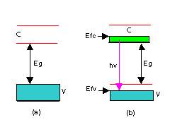

Figure 3.2 - Principle of Operation of a semiconductor laser

Solid State Lasers are typically lasers that have their species ions introduced to as an impurity in a transparent host material, for example, crystalline or glass form. This type of laser used high density solid as their active laser materials. From these specifications, semiconductors are not included in this category because their energy levels are very different. The ions of transition elements in solid state lasers are normally rare earth elements or transition metal which are commonly used as dopants materials. The advantage of solid state lasers is that they are normally forbidden electric dipole which allows them to have very long lifetime. An important fact to make about solid state laser is for the active materials, glasses are easier to fabricate but crystals have better thermal properties. The laser for our project is a solid state laser, Nd:YAG laser. A simplified schematic of the energy-level of the Nd:YAG can be reference in Figure 3.3. The solid state Nd:YAG laser is able to operate either at continuous waves (cw) or pulsed, and it can be pumped by either using an AlGaAs semiconductor laser or a lamp. In the case of our laser for our project, the Nd:YAG is a pumped by a lamp. Also, another aspect to mention is the fact that our laser is Q-Switched, not operating at mode locked. At Q-Switched an Nd:YAG laser is used ($E≈100 mJ$, $delta τ_{p}= 5 -20 ns, f=1-20 Hz.$ Q-Switched, the Nd:YAG laser can have four operating wavelengths, first harmonic second harmonic generation $\left(λ= 532 nm and 164 nm\right)$, third harmonic generation $\left(λ≈355 nm\right)$, and fourth harmonic generation beams $\left(λ= 266 nm\right)$. Also, Nd:YAG can be operated as mode-locked lasers which are commonly used in numerous applications.

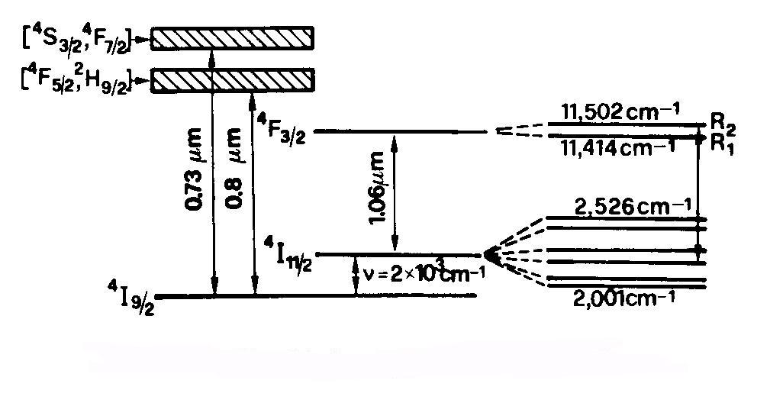

Figure 3.3 - Simplified energy levels of Nd:YAG

With the knowledge of several of these common, highly important and powerful laser. Our 3D Laser Glass Engraving System will be using a Nd:YAG laser which will operate at the second harmonic generation yielding to a wavelength of 532 nm. The following parameters of the selected laser will be further discussed in large in the following section. In short, to have a laser we need a lasing material. This material can be a crystal, gas, a semiconductor, or dye. We need a pump source. The pump source adds energy to the lasing material. Example of pump source are flash lamp, electrical current that will produce electron collisions, and radiation from a laser, to name a few. Lastly, we need to create an optical cavity that has to consist of reflectors to act as feedback mechanism for the light amplification.

### 3.1.2 Selection of Laser

The laser in our project is our biggest constraint. It is expensive and it is old. However, this is the laser we have to work with for it would require an extreme amount of money which would be higher than the sponsorship we received for the project as a whole. The Laser we get to work is Neodymium Yag (Nd:YAG) Laser. The ND:YAG Laser was invented and patented by Thomas M. Baer and Mark S. Keirstead in March 24, 1987. A neodymium YAG laser is laser that is pumped by another solid state laser diode that has high efficiency which result in compact, high-efficiency and long-lifetime laser assembly. The output of these type of laser is in the near infrared wavelength range, but that output can convert to wavelength in the visible spectrum using an internal frequency doubler. The polarization of the Nd:YAG laser beam is achievable by the stressing the YAG road before the frequency doubling crystal.

This section will depict the Nd:YAG Laser we have is from a Quantel Lasers. The system is called ULTRA CFR Nd:YAG Laser System. The laser system is an assembly of two major subassemblies: (1) The compact laser head, and (2) the power supply/ cooler which is also known as the Integrated Cooler and Electronics (ICE). The cooler in that comes with the system is important because the laser is inefficient by which denotes the laser generates more heat than light. In summary from the manual which comes with the laser, The ICE serves as a charging supply to the flash lamp rod. Also, it assists system timing, synchronization, controls and safety interlocks. The ICE also has controls and indicators that are essentials to run the system. The Laser Head, on the other hand, has the lamp trigger transformer and the Q-Switch driver for the laser.

The Laser has the capabilities to operate and have as output multiple wavelengths: 1574 nm, 1064 nm, 532 nm, 355 nm, and 266nm. These output wavelengths are achieved at different harmonic generation of the laser operation. For this process we will have the laser operate at the 532 nm wavelength. To make sure this laser has the capability to etch into the glass we will proceed with multiple experiments to determine the Beam Profile, the Pulse Linewidth, and use the current system to render an image into the same glass we’re planning to use for our project.

To test the capability of our laser we created a simple system, Figure 3.4, to capture the beam profile in addition to inspect the stability of the power of the laser and to observe the functionality of the laser. During this experiment we found the laser is not actually functioning as it should. The profile from Figure 3.5 (a-c),we found that the laser is in extreme critical condition and need to be calibrated. The actual beam profile for the laser has to look as seen inFigure 3.6. we have agreed and let our sponsor know about the condition of our laser. The laser will be sent for calibration such that it is ready for our project building and readiness for a successful project demonstration.

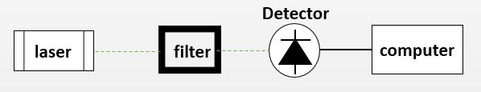

Figure 3.4 - Schematic to capture the beam profile of the ULTRA CFR Nd:YAG laser beam at 532 nm

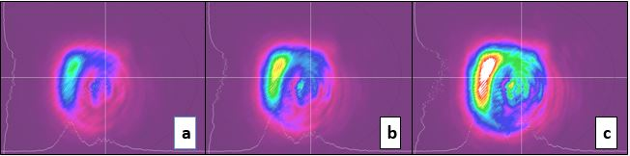

Figure 3.5 - Recorded Beam Profile of the current ULTRA CFR Nd:YAG laser beam at 532 nm, 5.5 energy level, and 20 Hz Repetition Rate Frequency

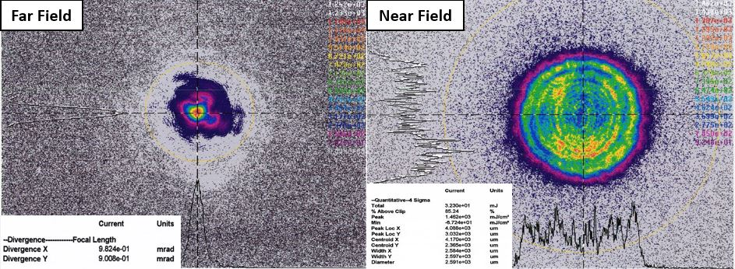

Figure 3.6 - Flat Top Beam Profile of ULTRA CFR Nd:YAG laser beam at 532 nm from last calibration from Quantel. From the Near Field beam profile, the beam diameter is 2.591 mm.

Although we have found out that our aging laser is in critical condition, suddenly; we have in the beginning of the semester used it to etch 6 glass for our customer with current system. We can further see explanation of this in the following section. We know that our laser has the capability to perform its tasks in the complete system, however it is needed that we make sure it is fully calibrated and have parts such as Rod O-Rings, Ultra flash Lamp, the pump cavity seal O-Rings, the 532 nm Crystal, the Q-SN Crystal, and the AR-Window checked and replaced respectively.

### 3.1.3 Etching with the Current System

To understand the capability of the laser we are set to use in our project we used the current system to etch different glass for our sponsor. The results will help show that the laser we have is still able to etch in glass rendering the image generated from the computer. Figure 2.1, shown previously, depicts the condition of the current system assembly our customer wants to modernize. It is also the same system we use without any changes to generate the etched image in the cube glass we also plan to use for our system. From the process were able to find some critical information about how the system run and why it is important for us to redesign and build a system such that will be more profitable for him.

From the current system the laser is set to run at 532 nm, 5.5 energy level, and 20 Hz pulse repetition frequency. The combination of these parameters yield to have the laser beam to have 30 mJ. Figure 3.7 (a) shows the setup process of the glass in the system and how the laser is pulsing in the glass. In these pictures we can see that the system is not stable when using just one glass to be etched, also the frame to hold the glass is not well designed such that the glass is not moving while the x-y platform is repositioning at the respective location for the laser to pulse in the glass. The following Figure 3.8 (a-b) showed a final product of an image that was etched in the cube glass. Figure a, show the glass is still in the etching frame that hold the glass. The laser at that point was turned off but not automatically after the engraving process was done. Figure 3.8 (b), shows a potential defect in the final product. The defect is the line that crossed the Pegasus. This is due the laser being offset but not at the correct focal distance. This also can be a results of the optical elements in the system that are misaligned and that are dirty. Figure 3.9, shows the software interface that the person who is controlling the system is using to maneuver the system. We can see that from generating a 2D and 3D images of such will take approximately 2 hours and 15 minutes. This is not only due to the complexity of the image that is being generated to be etched but also the time it will take to move the mechanical platform for which incorporate the XY-motors that move the cube. In this picture we rendered in the glass we have the Z-axis fixed at a position that led the pictures and texts to be etch having a two dimensional representation. The resolution of the pictures and texts were not calculated, however, this process was done such that we can determine the laser has the power to perform the respective tasks in the system.

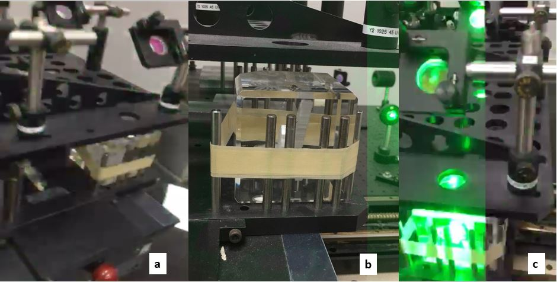

Figure 3.7 - (a) Cube Glass in etching position (b) Laser is on but not in focus to etch in glass (c) Laser is on and focused in glass, etching process is running

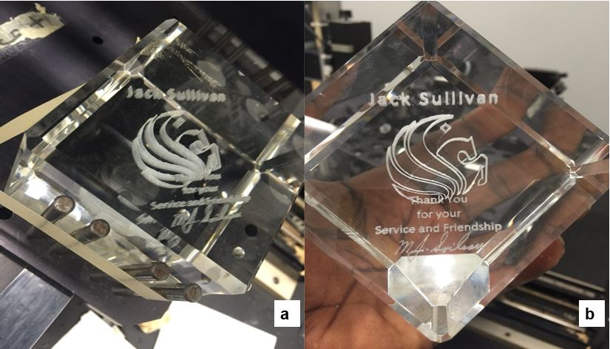

Figure 3.8 - (a) Etching is completed and the computer generated image is rendered in the glass (b) the image rendered in the glass was etched but with defects. The defect is due to the offset of the system not well calculated with respect to the focal point.

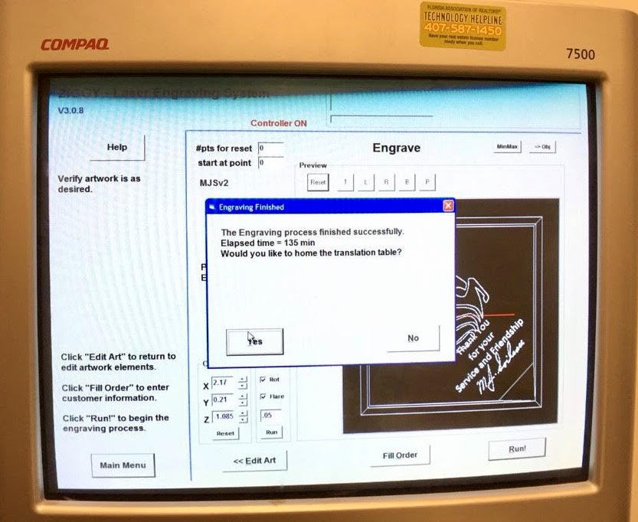

Figure 3.9 - This image is the Ziggy computer software (GUI) that is used to design and process the image to be etched in the glass.

To contrast the performance of the current system and the system we will be building, the future system will have to have an etching time that is relatively shorter approximately 40% the time of the current system takes to etch one glass. Also we can see from the figures above that the as the laser is pulsing in the glass there is so safety precautions that prevent the laser beam to interact with the user skin or eyes. One thing to mention in is that the image that is rendered in the glass was done as a single image which different pieces were put together. The XYZ distances were determined respectively such that the motion of the motors do not exceed the boundaries the laser light has to damage.

### 3.1.4 Cleaning Optics

The optical system in our project is comprised of a geometric optical system. This geometric optical system is composed of several optical elements which interact with the laser beam. Some of these elements serves to direct the light beam or affect the light polarization or simply shape the beam size. However, as the light interacting with these elements other effects are happening. The effects are absorption, transmission, reflection to name a preliminary few. The position and cleanness of these optics affects the performance of the optical system as a whole. In a system just like our which comprised of a high power laser, the risk of damaging optical elements is very easy. Optical elements which are in the open can be easily contaminated. These contaminations can be simple deposition of dust, fingerprints, layer of vapor deposition can increase the scatter off of the optical surface and absorb incident radiation, which can yield to have hot spots on the surface of optical element, resulting permanent damages. Many optical components that are specific to high optical power usually have some sort of coating, which particularly prone to this damages. Thus, an optical system as such must have the optical elements as clean as they could possibly be. This process in itself is not simple, and our system comprising of several high optical power elements which have been in the previous system for approximately or beyond a decade certainly need to be cleaned and analyzed before selected to be part of the system we will built. So how do we clean optical elements? As an optical engineering student and responsible to create the optical aspect of the system it is imperative to have maximum power at the etching plane in order to etch into the glass at the respective focal length.

Through many websites that sales optical components and books, a narrowed down strategy was developed to learn how to clean these optical elements and to preserve these elements until ready to build the system. Now this process must be very delicate. Handling optical can be very dangerous. Many of this optical elements are or can be broken into sharp materials. The cleaning procedures should be precautionary as follow: Proper Handling, First Inspection or Evaluation, Use the Right Tools and Methods to Proceed Cleaning, Proper Storage, and Cautionary Final Inspection.

Cleaning Materials:

* Gloves
* Lens Tissue Paper
* Dust-free blowers
* Hemostats
* Cotton Swabs
* Cotton Tips
* Reagent-grade isopropyl alcohol or methanol
* A clean container to store elements

Processing Cleaning Optical Elements:

1. Before dismounting Optics, put on gloves and set aside a clean work area.
2. Dismount optics.
3. Holding element from its edges, inspect or evaluate the surface to be cleaned by illuminating it with a high intensity light. The bright light will highlight dust particles.
4. Use the clean air duster, blow the surface to dislodge loose particles.
5. Place the optical component on a piece of clean lens tissue.
6. Use a single piece of lens tissue, from its edges fold the length in halves to one-inch width approximately. Following, fold this width in half, then dispense three drops of reagent-grade isopropyl alcohol or methanol, then fold the end.
7. Place the wet section of the lens tissue on the surface of the optical component.
8. Use index finger gently pressure from above the lens tissue, wipe across the surface.
9. Discard the “now contaminated” lens tissue.
10. Inspect the cleaned surface under high light intensity.
11. Repeat the steps 6 to 10 until the optical component surface is clean or it is determined the optical component is completely damaged.

Precautionary actions while cleaning optical elements:

* Reagent grade methanol is a high purity chemical. The dispensing container should be rinsed out with the methanol before filling. Always drip the methanol onto the material, never insert anything directly into the methanol in the container. This process eliminates the risk of contamination of the methanol sets aside for the cleaning process.
* Beware of dry lens tissue due for its abrasive to optical surfaces and will potentially scratch and damage optical component surface.
* Always be cautious, and hold the optical element its edge.
* Once an optic component is cleaned, install it or keep it covered.
* Once process is terminated or need to take a quick break, store cleaning materials in a clean, and covered area.
* Follow the University of Central Florida Environmental Health and Safety (EHS) training tips.

## 3.2 Software Research

## 3.2.1 Programming Language

When researching the main programming language for our software, we had many areas that the language had to cover to suit our needs. The first, and most important, being the libraries and resources available. The programming language needs to have a graphical user interface toolkit that is capable of implementing complex functions and operations within the application created. There also needs to be resources on analyzing 2-dimensional and 3-dimensional images and objects, as well as resources on 3-dimensional object printing. The second most important aspect of the programming language is the ease of programming in that language. Our project already includes many concepts that are new to all the group members and it is essential that the least amount of time is used in learning how to use a tool to create the final design, rather than the actual creation and debug of the final design. There are many programming languages that fit the criteria for being our main programming language. They include C/C++, Java, and Python.

The programming language that we chose and that meets all of our requirements is Python, a high-level, object-oriented, and interpreted programming language. Python is one of the most popular languages today due to its many attractive features for programmers and non-programmers alike. Python emphasizes readability and easy to learn syntax which allow for increased productivity. For these reasons, Python is ideal of Rapid Application Development (RAD) which is a method of time-efficient software development. Another bonus to using Python is that the main software developer of our group is experienced in using Python to develop applications.

Like many other popular programming languages, Python supports modules and packages, which allows for program modularity and a vast library. Python comes with a standard library that fits almost any of the needs for a software developer. Along with it standard library, Python’s popularity and status throughout the years has allowed for external libraries to grow in size. A quick online search for the different libraries that would be required for our project yielded many usable resources. These included requirements such as graphical user interface toolkits, 2-dimensional and 3-dimensional image/object analysis modules or programs, and 3D printer or engraving Python sourced programs and modules.

Lastly, Python is an interpreted language with interpreters available on almost all modern operating systems. This is an advantage because our software could potentially be used on almost any operating system that supports Python, depending on the libraries we choose to use in our software. [10]

### 3.2.2 Python GUI Toolkits

Python boasts a huge amount of available Graphical User Interface (GUI) toolkits or frameworks to create many different kinds of graphical applications. Here we evaluated the most commonly used toolkits in hopes to determine the most effective one to develop the user interface for our software. Each toolkit has its own advantages and disadvantages, but the attribute that we seek the most is the ease of learning how the toolkit works and the ease of developing an application with that toolkit.

#### 3.2.2.1 TkInter

Tkinter, short for Tk Interface, is Python’s standard GUI package that is built on Tcl/Tk, which are vetted frameworks used for multi-platform application development. It is a cross-platform package that provides many of the most commonly provided widgets as classes, as well as bindings to native platform technologies. Tkinter supports both Python 2 and Python 3 versions.

Tkinter is undoubtedly the most common toolkit used by Python developers. One of the advantages that Tkinter has is that due to it being part of the standard library, it is widely supported, it is backed by a large community, it is mature and stable, and there is a reliable amount of documentation available. Another advantage is that since it is part of the standard library it is available on any system with Python 2.x or 3.x installed, so there is no need to ensure that the required binaries are installed on a system to run a graphical application using Tkinter (Other than, of course, having Tcl/Tk on the platform). The best advantage of Tkinter is that it is easy to learn the tools provided by the toolkit and is therefore easy to develop simple graphical user interfaces.

The disadvantage that Tkinter has is that the look of the interface gives a rather outdated feel to it, although this can be fixed by using the tkinter.tkk module that provides a themed widget set. Another disadvantage that Tkinter has is that although it is easy to create simple user interfaces, the toolkit becomes cumbersome with large interfaces that have many complex functions. There are other toolkits that allow for the creation of large and complex interfaces without the difficulty that Tkinter may bring. [14]

Figure 3.10 that follows is an example interface created using the Tkinter toolkit:

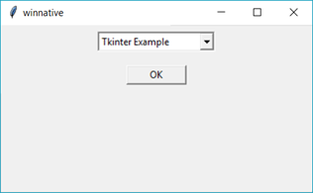

Figure 3.10 – Tkinter (Windows 10)

#### 3.2.2.2 wxPython (Phoenix)

wxPython is another commonly used GUI toolkit. Essentially, wxPython is a wrapper written in Python for another toolkit called wxWidgets that is written in C++. wxPython is cross-platform, open source, and is highly robust due to its base, wxWidgets, being a mature and well-developed toolkit from as far back as 1992. Currently, the original wxPython only support Python 2.x versions. However, wxPython Phoenix is under continuous development which restructures wxPython and brings Python 3.x support.

The most prominent advantages of wxPython include its large library of widgets and the available tools to create the code for desired interface. Because wxPython is based on wxWidgets, it has a vast library of widgets that are supported by a huge community that has written a great deal of documentation on it. This allows for an easier understanding of the way the toolkit works. To further ease the use of the toolkit, there are several applications, one being wxFormBuilder, that provide a GUI that constructs the code based on what widgets and events the user wants. Because of its support of a large library of widgets from wxWidgets, wxPython is capable of supporting a large application with many complex functions.

The main disadvantage of wxPython is that it does not support Python 3.x unless the other version, wxPython Phoenix, is used. This other version does not support the same amount of wxWidgets as the regular version does. Also, the wxFormBuilder and other code constructors do not support wxPython Phoenix. Lastly, wxPython is not part of the standard library so it will need to be installed on the target system along with its dependencies [15]. The following figure is an example interface created using the wxPython Phoenix toolkit:

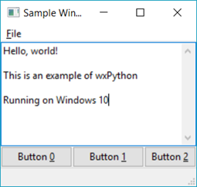

Figure 3.11 – wxPython Phoenix (Windows 10)

#### 3.2.2.3 PyQt

PyQt is a Python binding created for the cross-platform GUI/XML/SQL C++ toolkit called Qt, a very well-known and heavily developed toolkit. PyQt comes in two different versions, PyQt4 and PyQt5. Each supports either Qt version 4 or Qt version 5 with differences being in the Qt toolkit itself. Both Python 2 and Python 3 are supported by either version of PyQt. This framework is most popular for any serious application development due to how popular Qt is in other programming languages as well.

PyQt supports a vast library of graphical widgets and functions; over 620 classes are available along with functions such as network communication and web browsing. There are also code constructors that allow for code generation using a drag and drop interface, an example being the Qt Designer (Which can also be found inside the IDE Qt Creator). These can be used to quickly create a GUI without having to create the code from scratch. Another important aspect is that Qt allows the interface to be native, giving the interface a sleeker look. Also, PyQt is owned and developed by a company which allows for constant development and ensures stability and less bugs.

However, being owned and developed by a firm brings its own negative attributes. PyQt is only available under the GPL (General Public License) or under a commercial license which means that any code developed needs to be under the same license. This should not matter for our project. Another disadvantage is that PyQt is not in the Python standard library so it and its dependencies would need to be installed in the target system [16]. The following figure is an example interface created using the PyQt toolkit:

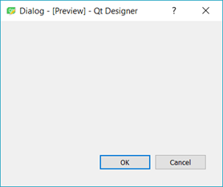

Figure 3.12 – PyQt (Windows 10)

#### 3.2.2.4 PySide

Much like PyQt, PySide is a Python binding created for the Qt toolkit. It provides nearly identical functions and widget support as PyQt. The main difference between PySide and PyQt is the licensing available. PySide was solely created so that it could do the same functions as PyQt but be under the LGPL (Lesser General Public License). Being under that license would allow for PySide to be used in just about any form without fear of needing a commercial license.

Any advantages that PyQt has, PySide generally has as well. The Qt Designer code builder can also be used with PySide which allows for the same efficient development of graphical interfaces. The vast library that Qt has is available for PySide, as well as the advantages that Qt’s brings such as the capability of having a platform native look.

There are generally no disadvantages to PySide other than that it may be difficult for some to learn the way Qt works, so it may take longer than usual to learn and create a usable interface. [17]

#### 3.2.2.5 Conclusion on Toolkits

We saw that there are a wide variety of toolkits available for Python. All of them are loaded with enough features and resources to develop the user interface required for our project. The simplicity of implementing what is needed is the major aspect of the toolkit that we want to use. Some toolkits come with a graphical designer that creates code based on the user interface that is designed within the graphical designer. The toolkits with these graphical designers are PyQt, PySide, and wxPython. These graphical designers drastically reduce the amount of time required to create the code for a user interface. However, some of the graphical designers only create Python 2.x code which would limit our project to using the older version of Python. Also, having the graphical designer generate the code for the user interface would not provide the same level of understanding as actually coding the entire interface from scratch. As we are required to implement all the functions within the user interface code, it is very important that we have a perfect understanding of the layout of the code. We also saw that Tkinter, which is arguably the simplest of the four toolkits that we saw, could be the best choice for the project. As our user interface will not need to be as complex as an actual full scale project application, we do not need to have a toolkit with an extremely large library of widgets and resources. Therefore, Tkinter would be the fastest and easiest toolkit to learn and implement.

### 3.2.3 3D Conversion

### 3.2.3.1 STL (STereoLithography) File Format

The STL file format is a combination of triangular representations of a three-dimensional object that has become the standard for many computer-aided design (CAD) software packages. Today, the STL file format is the most common file format found for 3D printing. [11]

In an STL file, a 3D object is represented by a series of triangles that together form the geometrical surface of the object. These triangles, when used in high resolution, can recreate the surface of almost any solid object. Thus, the x, y, and z coordinates for each corner of each triangle is stored within the contents of the file. Along with the x, y, and z coordinates of each triangle is the unit normal, a line perpendicular to the triangle. There is also x, y, z coordinates for the unit normal. Therefore, in total, there are twelve numbers stored for each triangle with each number being a single precision float.

There is a certain criterion that the triangles must follow in order to be valid within an STL file. Two vertices of each triangle must be shared with an adjacent triangle and the vertex of a triangle cannot be on the side of another triangle. Also, the coordinates of all vertices must be non-negative.

An example of what an object in an ASCII STL file is represented as follows. The first line of the file contains the word “solid” followed by the name of the solid. The next lines contain each triangle represented as a facet. The beginning of the facet contains the coordinates of the normal. Then, the “outer loop” of the facet begins which contains the coordinates of each vertex. The last two lines contain the statements “endloop” and “endfacet” to signify the ending of the triangle.

As our project involves the interpretation of a 3D object, we decided to use the STL file format as the main representation of the 3D object that we will be engraving. We made this decision based on the maturity of the STL format within 3D engraving and CAD software packages. There are tons of resources available on STL files and the amount of community support, from both professional and those who do it as a hobby alike, would allow us to find help for any problems that we may encounter in the construction and implementation of the prototype. Also, almost all 3D printing software packages support STL and many slicer programs, the ones that create instructions for the microcontroller to interpret and move the motors (G-code), take STL files as the input 3D object. Lastly, STL files are extremely simple to understand and to work with which is a huge plus for our project. [12]

#### 3.2.3.2 2D to 3D Conversion

As one of the requirements for our project is to be able to take in a 2-dimensional image and convert it to a 3-dimensional object, we needed to find methods to do so. Many 3D printing programs and the sort do not do the 2D to 3D conversion within the software. Instead, it requires the user to go through different means to create a 3D object. As one of the major goals of the software design is to automate the entire process and have everything done within the software provided, we needed to find the right tool that would allow us to implement the conversion within our software application written in Python. The following are two methods that were researched that would allow such functions.

#### 3.2.3.3 STL Tools Module

The first resource that could be used within our software program is the stl_tools module. The stl_tools module is a module that is used to generate STL files from plain text, LaTeX code, and 2D images. This module is found on github and is licensed under the Apache License. [13]

The requirements of this module include Python 2.7+ or 3.2+, Numpy 1.7 or higher, Scipy 0.12 or higher, and Matplotlib 1.2.1 or higher. Installing the module is extremely easy through pip. Running the command “pip install stl_tools” does the job. However, installing the other dependencies take a bit more work.

The STL tools module comes with three primary functions. The first being the numpy2stl function. This function’s main purpose is to read a numpy array and output a STL file based on the input. The required arguments for this function is the 2D numpy array, or image, and a string for the filename that will be used for the STL file. The optional arguments of this function are the scaling of the result STL mesh, the mask value that excludes vertices below this value from the resulting mesh, the ascii boolean that determines whether the resulting file’s STL format is ascii or binary, a boolean that sets whether surface normals are calculated, and the max width and height of the STL object.

The second function is the text2png function which is more of a helper function to convert text input as a string to a PNG file. The arguments required are the text or string to render and the filename of the output PNG file. The filename defaults to the input string if the filename is not specified.

The last function is the text2array which is similar to the text2png function in that it creates a PNG file based on the text input. However, after the PNG file is created, the image gets converted to a ndarray and the PNG file is deleted. This function takes the input of a string as the text to be converted and returns the 2D numpy array of the rendered text. This function is more of a helper function.

On top of these provided functions, a command-line script is provided to allow for an easy entry point to the functions of the library. This is extremely helpful because all the program would need to use the library is to create a subprocess command to open the command-line script with all the arguments required. This is not required for our program as our program can just import the module since they are both written in Python.The following images in Figure 3.13-3.15 are some of the conversions using the stl_tools module.

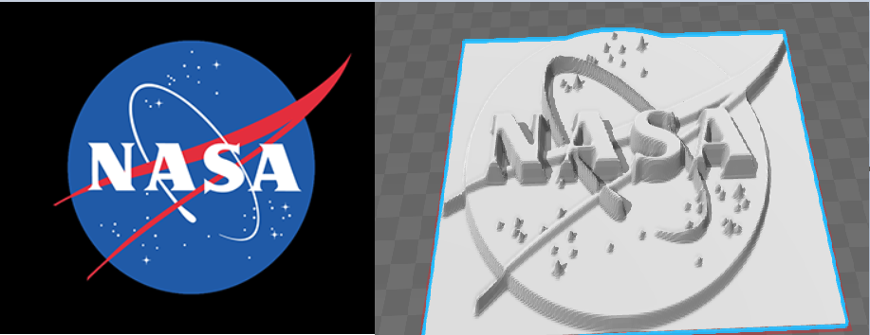

Figure 3.13 - Nasa Sample STL Conversion*

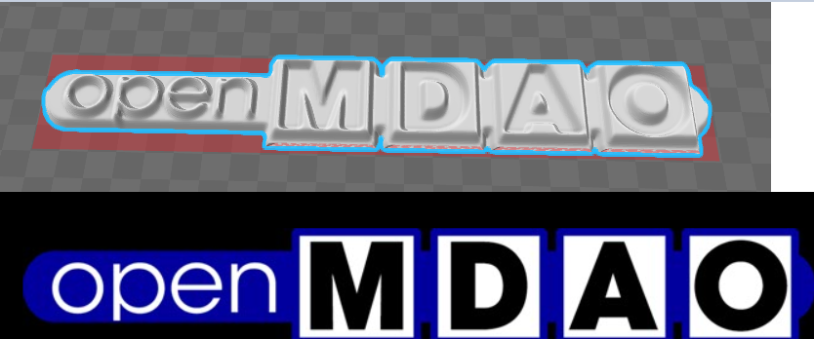

Figure 3.14 - openMDAO Sample STL Conversion (Open Source Image)

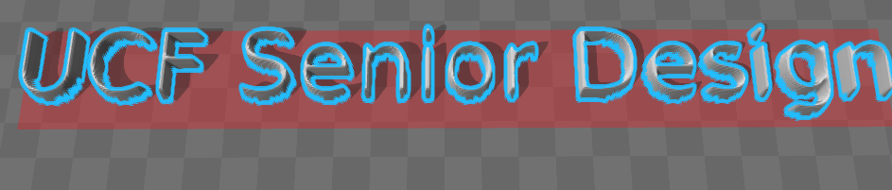

Figure 3.15 - “UCF Senior Design” Text to STL Conversion

\**NASA does not endorse nor sponsor this project*

#### 3.2.3.4 ImageMagick + Potrace + Blender

Another method to convert a 2-dimensional image into a 3-dimensional one is to hook up a series of programs that each carry out one of the steps in the procedure to create the 3-dimensional object. Unfortunately, we were not able to find an open source program that did all the steps required. We assume that we begin with a 2-dimensional raster image, such as a .png or .jpg, and we want to end up with a 3-dimensional object in .STL format.

The first step within the conversion process is to convert the 2-dimensional rasterized image into a vectored one. This step can be summed up as creating a bitmap out of a raster image. To do so, we begin with ImageMagick to convert the file format to a format that we can trace to create a bitmap. ImageMagick is a free and open source (Apache license) software distribution that focuses on converting, editing, and creating images. ImageMagick is capable of converting between almost all current image file formats. It can also be used in the command-line, allowing for easy integration to our software. There are also interfaces available on almost all popular programming languages including Python, so we have multiple options on how to integrate the program within our software application. [9]

We want to convert any 2-dimensional images that we have, most likely .png or .jpg images, to a .ppm file format. The reason why we want to do this will be explained in the next step. PPM (Portable pixmap format) file formats are basically bitmaps of an image. It is extremely easy to do so within ImageMagick. When installing ImageMagick, there is an option that places the keyword “convert” into the environment system variables, PATH, so that it can be accessed through the command line from any location. Using this convert keyword, we can specify the input file and format and the output file and format. There are also other optional arguments that can be provided such as resizing and scaling commands.

Here is a quick example of how the command can be used:

|  |
| --- |
| $ convert <input file> <output file>  $ convert input.jpg output.ppm |

This produces a file called “output.ppm” in the current working directory.

The next step in the procedure is the tracing of the bitmap to create a smooth image which allows for a much easier conversion to a STL file. To do this process, we decided to use Potrace, another open source program under the GNU General Public License. This program is also usable in the command-line which allows for easy integration within our software. Potrace is capable of inputting a bitmap file and outputting to a SVG (scalable vector graphics) file format. It is also incredibly easy to do so and the processing time is extremely quick. [8]

Here is a quick example of how the program can be used from the command line:

|  |
| --- |
| $ potrace -s <input file> -o <output file>  $ potrace -s input.ppm -o output.svg |

This produces a file called output.svg in the current working directory which will later be used to convert to a 3-dimensional object.

The last step within our process uses the program Blender, a free and open source 3D creation suite. The most important aspect of Blender is that it has an extensive Python API, allowing for us to write code directly within our program that uses Blender’s API. Blender comes with an extremely wide variety of functions. The function that we require is the importing of SVG files, extruding of 2-dimensional objects to create a 3-dimensional object, and then finally exporting the new 3-dimensional object to a STL file. All of these functions can be done using a Python script that uses Blender’s API and library to do so. Here is a quick example of what can be done (some optimizations may be possible when creating the monochrome bitmap image).

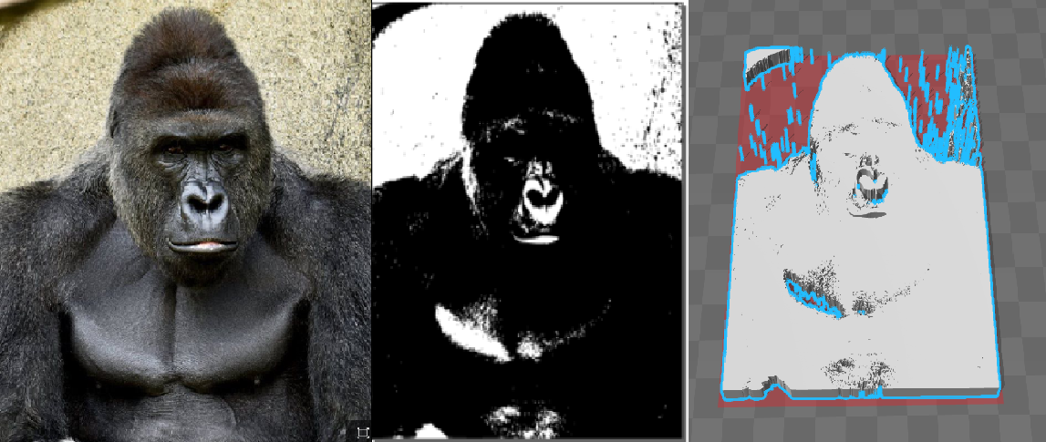

Figure 3.16 - Conversion process to an etchable 3D Object (Open Source Image)

### 3.2.4 STL Slicer / G-code Generator

Although a STL file contains information that represents a 3-dimensional object, there still needs to be a way for the object to be interpreted so that it can actually be engraved or etched into an object. In short, the points that represent the 3-dimensional object need to be translated into a sequence or control flow for the motors to move in a way that the 3-dimensional object is etched onto the glass. The way to to do is to translate the contents of the STL file into a format that contains instructions for the motors to move. One very popular implementation of something with a function such as that is known as G-code.

G-code is a programming language that contains information that is used to move and control motors. Thus, it is mainly used in computer numerical control (CNC) machines that create physical objects by moving motors in certain ways. It is extremely popular is 3D printing, engraving, and cutting machines. G-code’s instructions command the motors where to move, how fast to move, and what path to move. A single line can contain all three of these attributes. In a sequence, this allows the motors to move along a path so that the laser or whatever tool can carve, engrave, or etch along the path. Not only does G-code tell the motors where, how fast, and which path, it also takes other factors into consideration such as an x, y, and z coordinate system based on different metrics. G-code has many different implementations but as 3D printing has become more popular a same general standard has risen. [21]

One of the good characteristics of G-code is that it is human-readable. Therefore, it is easy to create and understand G-code created by a program. The following is a short example of G-code that draws a circle.

|  |
| --- |
| G17 G20 G90 G94 G54  G0 Z0.25  X-0.5 Y0.  Z0.1  G01 Z0. F5.  G02 X0. Y0.5 I0.5 J0. F2.5  X0.5 Y0. I0. J-0.5  X0. Y-0.5 I-0.5 J0.  G01 Z0.1 F5.  G00 X0. Y0. Z0.25 |

There are many different ways to prepare G-code with the most popular being the use of a slicer program. Slicer programs take a 3-dimensional image and slice it into layers. These layers are then translated into G-code. Slicer programs can be modified to create G-code that fits separate printers or motor systems. Therefore, slicer programs can be calibrated to fit the speed of motors, motor precision, and laser precision.

One popular slicer program that is widely used in 3D printing is Slic3r. Slic3r is a tool that can take in 3-dimensional object models, such as STL files, and translate those models into G-code instructions that are understood by the motor system. It is a free program that is licensed under the GNU Affero General Public License, allowing for us to incorporate its functions within our software design. [20]

Slic3r can also be used almost exclusively from the command-line, allowing for simple integration to our software using a sub-process call. All that is required for the command-line function to work is to supply the name of the STL file, the output location, and any other optional arguments. There are also other functions available from the command-line such as the repair function and the cut function. These may come out as being useful for future purposes.

The following is an example of how Slic3r can be used from the command line to take in an STL file and output it as G-code.

|  |
| --- |
| $ slic3r example_input.stl --layer-height 0.2 --output /path/output.gcode |

The output G-code file can be calibrated to fit our needs and be saved into a configuration file. This configuration file and be loaded into Slic3r so that all G-code that is created is compatible with our motor system and project design.

### 3.2.5 G-code Streamer

In order for the G-code to be transmitted to the motor system, there needs to be a way for the computer to communicate with the motor system. As the motor system is controlled by microcontroller, it is as simple as hooking up the microcontroller to a serial port, such as a USB port, and using a program to stream the G-code to the microcontroller. The microcontroller can then receive and interpret the G-code to control the motors.

There are many different programs that allow for streaming G-code to the microcontroller. The most common method to do so is using serial communications, such as USB, to transmit the data. These programs handle everything, from buffer overflow to line-by-line transmission of the G-code. Many programs are complex enough to come with a GUI to allow for the input of different settings. These settings include a 3D visualization of the G-code, feed rate, distance, and state modes.

However, we desire a program that does not require a GUI as we want to automate the entire process. One streaming program that is compatible with a very popular microcontroller, the Arduino Uno using the Atmega328, and does not require a GUI to operate is grbl streaming script. Grbl, which will be covered later on in the microcontroller firmware section, is a G-code interpreter that is integrated into firmware that is compatible with the Arduino Uno using the Atmega328.

The grbl streaming script is written in Python, which allows direct integration into our software. The grbl streaming script requires the PySerial module to communicate to the microcontroller using USB. The script has command line arguments for different options and allows for most options needed when streaming G-code. [34]

In order to effectively stream the G-code, the script uses a character counting scheme to ensure that the serial read buffer is full. This creates another buffer layer on top of the queue. Instead of waiting for a send response, the next G-code block is read from the read buffer layer above. This allows for much more efficient and better motions rather than having delays due to buffering.

### 3.2.6 RS-232 Interfacing

One of the goals of the new software design is to have control of the laser through the software. The older system was not capable of controlling the laser through the software, so the laser had to be activated manually immediately after executing the engraving process in the software. Our new software aims to activate the laser automatically when the user begins the engraving process. The laser being used in our design has the capability of having external control through serial communications. More specifically, the laser system uses the RS-232 interface standard as the means to have external control of the system. It is important to note that the RS-232 interface is also known as the EIA-232 standard. [18]

The RS-232 standard is a standard for the transmission of data through serial communication. It once used to be found in almost all computers and was the standard for all the common connections such as keyboards, mice, data storage, and other peripherals. The main definitions of the RS-232 interface are the physical components such as the pins and circuits within the connector and the electrical signal characteristics. [19]

In order for communication to be established using the RS-232 interface, certain characteristics must be met. For the most part, characteristics such as voltage levels and other physical connection attributes are handled internally. However, data and control signals must be defined by the software being used to handle the communications.

The electrical signal used to communicate can be set and modified using the PySerial module as described in the PySerial Module section. Within it, the different settings for data transmission such as baud rate, stop bit, synchronization bits, and how the data is framed. The RS-232 interface allows for data rates up to 20,000 bits per second, but otherwise allows the user to set their own settings for the data transmission for the interface. Therefore, the settings are set by the creators of the laser and the required settings will be set to fit those specified by the laser’s manual.

RS-232 interfaces have been phased out and been replaced by the extremely popular Universal Serial Bus (USB) standard. As virtually all modern computers have USB ports and almost none of them have an RS-232 interface, a USB to RS-232 interface active converter would be ideal for our configuration. If the USB to RS-232 interface conversion does not work, it is also possible to acquire a RS-232 serial port in the form of a Peripheral Component Interconnect (PCI) or Peripheral Component Interconnect Express (PCIe) expansion card.

### 3.2.7 PySerial Module

In order for us to hook into the RS-232 interface through our software program, we require the use of a module that allows for access to the serial port. Thus, PySerial is the module that we require. PySerial is an another free license module that is usable within our software.

PySerial provides the backends for Python to communicate with the serial port on all popular operating systems. Some of its features include access to port settings through its Python API, support for different byte sizes, parity and flow control, stop bits, and more. Thus, this module is perfect for us to be able to communicate to the laser through the RS-232 interface that it provides. PySerial is available on Python 2.7 or newer, including Python 3.4 and newer. [7]

PySerial has a requirement list that is extremely small. The first being, obviously, a version of Python that is supported. The versions supported are 2.7+ and 3.4+. The last requirement for PySerial is “Java Communications” (JavaComm) or a compatible extension for Java/Jython.

To install PySerial, it is extremely easy using Python’s pip install tool. The only command needed is “pip install pyserial” or “easy_install -U pyserial”.

It is simple to create code that allows for communication with the RS-232 interface. First, the serial ports need to be opened through the Python script. Secondly, the port interface and properties need to be configured to allow for communication between the script and RS-232 interface. Once this is done, the communication stream is now open and data can be send back and forth through the port. All of this can be easily done by creating classes and using the class methods. Within one of the main classes’ constructor, the settings for the electrical signal such as the baud rate, byte size, parity checking, stop bits, timeouts, and flow control can be set.

The full documentation of PySerial can be found on its website that provides information on all the classes and resources available within the library. There are also examples that show different types of interfaces being accessed by a Python script using PySerial.

### 3.2.8 Microcontroller Firmware

The last major part of the software design within our project is the firmware that runs on the microcontroller. When researching the firmware for the microcontroller, we knew that we needed a firmware that would be able to be installed on popular microcontroller chips such as Arduinos using Atmega controllers, as those would be the most commonly found microcontrollers and the one that we would most likely use. Another attribute of the firmware that we tried to find was the purpose of the firmware. A firmware that was specifically designed for 3D printing or any type of CAD printing would be an ideal firmware as it would have all the desired functions for us. The firmware would also need to be able to be configured and modified to suit our needs. Therefore, an open source firmware would be desired. The most important requirement for the firmware would be a built in G-code interpreter. This G-code interpreter must be able to move the motors after interpreting the G-code command.

One such microcontroller firmware that suits our needs is called Marlin Firmware. Marlin Firmware is a 3D printing firmware designed for RepRap printers based on the arduino platform. It provides all functions that we require such as motor precision and control, G-code support, customizability, and many more configurations. Marlin firmware is also open source and is licensed under the GPL license. This means that we are able to go into the source code and modify or add new features. It is written in C++ which allows for easy and quick code editing. It is compatible with a wide range of microcontrollers which gives us more freedom to choose a microcontroller for our design. The most popular ones being Atmel Atmega series.

Marlin firmware is known for being adaptable to many different 3D printer designs and configurations. This means that many of its features are configurable to suit the design’s specific needs. As our design is not strictly a 3D printer, we would need to modify some of the firmware’s configurations to be able to work with our design. One important feature that would need to be tested is the addition of laser control within the G-code interpreter. A quick glance through the source code showed that it could be possible, but the implementation of it would need to be thoroughly tested. [35]



Figure 3.17 - Marlin Firmware Logo (Open Source Image)

Another microcontroller firmware option that could be implemented within our design is known as Grbl. Grbl is another microcontroller firmware that is made for 3D printing and CNC milling designs. Unlike Marlin firmware that is designed to run on multiple platforms, grbl is only designed to run on vanilla Arduinos with the Atmega 328 microcontroller. Grbl is an open source free software that is licensed under the GPLv3 license. This allows us to not only include the firmware within our design but to also modify it to suit our needs. [34]

Grbl is written in C which is a language that all our team members are comfortable with. It also includes many different features, the most important being G-code interpretation. As long as the G-code follows current standards, the interpreter included within grbl is capable of doing arcs, circles, and helical motor controls. Along with the G-code interpretation, grbl includes complete speed and acceleration control. This with a look ahead of up to eighteen motor motions allows for a smooth control of the motors with no stuttering.

Grbl is compatible with almost all G-code streamers, so it is able to be hooked up to a host computer. The host computer would stream the G-code to the microcontroller and grbl’s interpreter would interpret and move the motors accordingly. However, if a host computer is not desired, grbl works with an SD card as the G-code input as well.



Figure 3.18 - Grbl Firmware Logo (Open Source Image)

## 3.3 Electronics Research

## 3.3.1 Power

## 3.3.1.1 DC vs. AC Power Supply

When providing power to electronic devices, there are only two options for power supplies: direct current (DC) and alternating current (AC). In some applications, both AC and DC supplies are used. In others, only one or the either is sufficient enough. In the laser etching system, AC power will be utilized to power the Laser ICE unit system that outputs the laser used to etch into a crystal glass. The Laser ICE is a high powered laser that is rated for 115 VAC @ 60 Hz, and consumes an apparent power of 400 VA. Providing AC power is ideal in this case due to such high operating electrical characteristics. Additionally, a constraint of the system is to recycle the existing Laser ICE unit. Therefore, powering the laser system with anything else is not an option.

All other powered electronics of the laser etching system such as the motors and microcontroller have much lower operating electrical characteristics. For instance, one of the microcontrollers that will be considered is the ATmega 328P. It is designed to operate on DC power that ranges between 1.8 - 5.5 VDC. Although it is easy to determine that a DC (or both) power supply is needed in this case, other important factors play a role in determining which to source. Table 3.2 below compares the advantages and disadvantages associated with using an AC or DC power supply from a general perspective and with respect to the customer’s requirements. The DC power supply in the project is assumed to originate from that of batteries.

|  |  |  |  |
| --- | --- | --- | --- |
| **Feature** | **Impact** | **Supply Type** | |
| **Direct Current (DC)** | **Alternating Current (AC)** |
| Cost | High | -Periodic battery replacement  -Reduction in voltage regulation components | -No periodic battery replacements  -Need converters and more regulation components |
| Erosion | Medium | -Possibly, if left in for extended periods, may increase cost long-term | -No erosion at power source |
| Circuit Damage | High | -No, power limits are predefined | -Possibly, when a power surge occurs (which is not likely) |

Table 3.2 - AC vs. DC Power Supply Based on Project Nature

With the intention of meeting the requirement of decreased long term cost, using a DC power source is not a likely option. Under the DC column of Table 3.2, it is apparent that using batteries as a source would create recurring maintenance costs in the future. Eventually, the batteries will need to be replaced once they die out. Replacing them will become a frequent issue considering that the desired average operating time for the laser etching is approximately 40% less than the current system’s runtime. This leads to the consideration of what is known as *burn-in* testing*.* “Burn-in is a test in which a system or component is made to run for an extended period of time to detect problems” [1]. Although the burn-in process is geared towards testing if components can perform for extended time frames, it can also be used to determine if a set of batteries would last in an hour and twelve-minute etching process (with two-hour runtime for current system). Over the average expected time frame, the motors will be considered as *high power consumers* since they are being constantly used over the entire runtime. It is important to note that for any motor being used, it will be accompanied by a motor driver. Table 3.3 below shows an example of the power consumption of a suitable stepper motor and its driver.

|  |  |  |  |  |
| --- | --- | --- | --- | --- |
|  | | **Voltage Rating** | **Current Rating** | **Power Rating** |
| **Motor**  **Option** | Nema 23-Bipolar  StepperOnline  (340 oz-in) | 24 - 48 VDC | 1.8 A/phase | - |
| **Driver**  **Option** | G201X Digital  Step Drive  GeckoDrive | 18 - 80 VDC | - | 1 - 13 W |

Table 3.3 - Anticipated Power Consumption During Runtime

The motor option is suitable for driving the motor presented. The motor option presented is a bipolar stepper motor that sources its needed power from the driver itself. Therefore, only the motor driver needs to provide a power supply. If an etching operation actually lasted 1 hour 12 minutes (1.2 hours), the G201X Digital Driver would need to source up to (assuming 36 VDC operation) $(13W)/(36VDC)*1.2hours =.4333 Ah$. Although a current supply rating could be easily achieved, batteries to achieve a voltage of 36 VDC can become costly.

The only benefit in using a DC power source (batteries) is that there will be an avoidance in power surges, which may exist when using AC power supplies (a U.S. Standard wall outlet source in this case). Otherwise, an AC power supply may be more advantageous. Referencing back to Table 3.2, the only disadvantage is the possibility of a power surge occurring that will sporadically send high amounts of voltage and current to the system. Due to the likelihood of this happening being so low, an AC power source will most likely be chosen for the laser etching system.

In terms of cost, using an AC supply will increase it due to the need of stepping down the voltage present at the output of a U.S. standard wall outlet. At an outlet output, there exists 110 - 120 VAC with a frequency of 60 Hz. In the U.S. this is standard. Stepping down the voltage to levels applicable to the electronics (motors, microcontroller(s), and motor drivers) will require an AC power adaptor (converting AC power to DC power) and voltage regulators (furthering downsizing of the DC power). The team is highly considering the AC power supply option considering that these increases in cost will not be recurring, unlike the cost of periodically replacing batteries.

#### 3.3.1.2 Power Conversion

All of the electronics comprising the 3-D Laser Etching System, except the laser unit, motors, and motor drivers, are operated on direct current (DC) power. However, the main external power supply is sourced from a U.S. Standard wall outlet, which is AC power. This power needs to be converted to a digital nature for the lower voltage electronics, providing a constant output voltage. This will be accomplished via an AC power adaptor, specifically for the microcontroller circuit. The maximum voltage among all of the electronics interdependent with the microcontroller will determine the minimum output voltage from the AC power adaptor. In the case of electronics that require operating voltage well below that of the adaptor’s output, simple voltage regulation will be utilized. Presented in Table 3.4 below are three options for AC adaptors.

|  |  |  |  |  |
| --- | --- | --- | --- | --- |
| **Vendor** | **Part Number** | **Input Voltage** | **Output Voltage** | **Max Output Current** |
| Parts Express | 120-1185 | 120 VAC | 24 VDC | 600 mA |
| Parts Express | 120-1165 | 120 VAC | 18 VDC | 600 mA |
| Sparkfun | TOL-09442 | 100-240 VAC | 12 VDC | 600 mA |

Table 3.4 - Comparison of AC Adaptors Suitable to Power Lower Voltage Electronics

Depending on the voltage needs when the system is being tested real time, the AC adaptor will be selected. The three presented options operate on similar me voltage characteristics, ~120 VAC. So the use of the main external supply will be upheld. Each option also has a common fixed output current of 600 mA. This amount of output current is considered to be sufficient considering the low power electronics needed for the system. For example, the ATmega 328P microcontroller may be used. Its maximum required operating current is 200 mA. A current draw of this magnitude is not likely, but in the event it's required, the AC adaptor selected will supply sufficient through the circuit where needed. This will apply to all electronics that reference the output of an adaptor. Additionally, components that affect voltage and current such as rectification diodes, resistors, capacitors, and voltage regulators are also considered in selecting the best and most fitting AC power adaptor needed.

Overall, the selection of an appropriate power adaptor is dependent on both voltage and current ratings of the electronics sourcing it. The adaptor must be able to provide a minimum output current equal to that of the total load current from each powered device. In the case of the etching system operating under maximum load conditions, the power supplied should meet the need of such conditions.

#### 3.3.1.3 Voltage Regulation

The final laser etching system is will be powered by two external DC power supplies: one for the motors and their drivers, and another for all other low voltage electronics (such as sensors) working with the microcontroller. Both supplies will reference the U.S. standard AC outlet supply for their requirements. Unlike the motor and drivers, it is likely that the system’s low voltage electronics will need various voltages to operate. This limitation is set by the low voltage device with the highest voltage rating.

Applicable characteristics for selecting the voltage regulators:

* Input and Output Voltage Characteristics
* Input and Output Current Characteristics
* Footprint: Additional External Components
* Cost and Efficiency
* Topology

The input and output voltage characteristics are important considering that the electronics before and after the regulation stages have their own operating electrical characteristics. The voltage requirements for a microcontroller is typically 5 VDC. Hence, a five-volt regulator may be required. Essentially, the voltage input of the regulator will be the output of the AC adaptor, while its output will be the voltage rating of the device receiving its output.

Input and output current characteristics are also an important consideration. The microcontroller is considered a low power consumption device; hence, only a small current supply is needed for its operation. Typical microcontroller current requirements lie in the milli-ampere (mA) range. The system’s motors each will require higher power consumption in terms of current compared to that of the microcontroller(s). Hence, why they are provided their own power electronics separate from the low voltage electronics. Since the AC adaptor will provide power for all low voltage electronics, it needs to also supply a sufficient amount of current to cover all of the electronics’ needs.

To achieve the desired voltage and current requirements, two regulator categories are considered: linear voltage regulation and switching voltage regulation. Although each method achieves the needed practical results, they have their own advantages and disadvantages. In particular, footprint, cost, and efficiency characteristics mentioned earlier for selecting regulators are to be considered. Varying topology architectures of each type will also be considered.

It is anticipated that a sufficient voltage and current output of the AC adaptor is 12 VDC and at least 500 mA. These values are determined based on the low power ratings known of microcontrollers and the constraint that any sensors selector will operate below the 12 VDC threshold. Since the microcontroller selected will require ~5 VDC and use low currents, standard linear regulation (explained later) will be sufficient to step down from 12 VDC However, any type of linear or switching regulator would achieve this, but the determining factor between choosing one over the other is based on energy dissipation. “A linear regulator works by taking the difference between the input and output voltages, and just burning it up as waste heat. The larger the difference between the input and output voltage, the more heat is produced” [2].

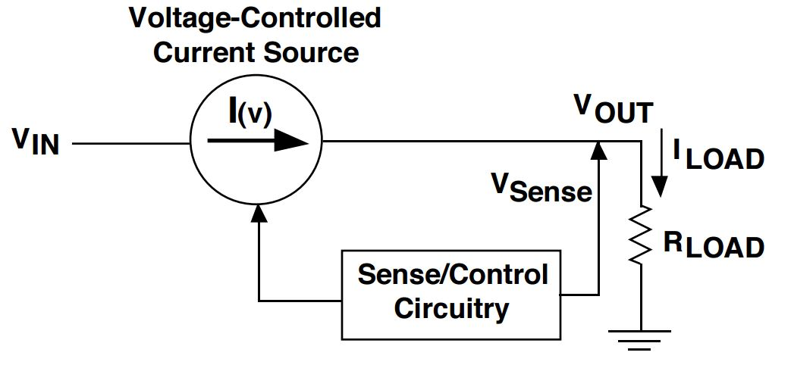

Figure 3.19 - Linear Regulation Functional Diagram (Courtesy Texas Instruments; Reprinted with Permission from Texas Instruments) [3]

$$Power Wasted (Watts) = (Input Voltage - Output Voltage)*Load Current$$

Power Loss Equation for Standard Linear Voltage Regulator [4]

The input (12 VDC) and output (5 VDC) of a linear regulator will produce a 7 VDC difference. Of the microcontroller options considered (each discussed in a later section), the minimum and maximum required operating currents are anticipated to be up to 6 mA (ATmega32U4) and 9 mA (ATmega328P). This current range is based upon the assumption that our system will require an operating frequency of 8 MHz with a 5VDC supply. Via the power loss equation, power wasted from the linear regulator will be between 42 mW and 63 mW, respectively, between the two microcontrollers. These amounts of power loss are not enough to cause a critical dissipation of heat to the surrounding circuitry. However, the final etching system will be enclosed inside a laser optics protection box. In the event laser etching operation times are lengthy, there may be a buildup of heat. A solution to this potential problem is using a heat sink. Heatsinks, however, can become large in size, leaving a large footprint and requiring a larger PCB.

This leads to the investigation of using a switching regulator, specifically one known as the buck converter to step down voltages. In general, switching regulators have the advantage of not causing large amounts of heat dissipation. This is directly related to the fact that they work “by taking small chunks of energy, bit by bit, from the input voltage source, and moving them to the output” [4]. By this method, a switching regulator is more advantageous in terms of efficiency compared to using a simple linear voltage regulator that is designed to dissipate energy not being utilized. Other comparisons between linear and switching are summarized below in Table 3.5.

|  |  |  |
| --- | --- | --- |
| **Regulator Property** | **Regulator Type** | |
| **Linear** | **Switching** |
| Buck (step-down) | Possible | Possible |
| Other Regulation  Capabilities | No | Boost  Buck/Boost  Inverting |
| Efficiency | Low Vo/Vin | Approx. 95% Usually, High |
| Output Power | Several watts depending on thermal design | Large power possible |
| Noise | Low | Switching noise exists |
| Design | Simple | Complicated |
| Parts Count | Low | High |
| Cost | Low | High |

Table 3.5 - Linear vs. Switching Regulators (Permission Requested from ROHM Semiconductor)

However, the final laser is meant to also be of low cost. A linear regulator is highly inexpensive, usually costing less than $1.00. On the other hand, a switching regulator, due to its complex design for higher efficiency, may cost a few dollars. Table 3.5 above also shows an increase noise susceptibility for switching regulators. If a critical amount of noise exists, additional components may be required for implementing application such as low pass filtering. This again will lead to increase in cost.

### 3.3.2 Microcontrollers

#### 3.3.2.1 Relevant Capabilities

In general, the final laser etching system consists of the user being able to take a 2-D image and etch a 3-D version of it into a pure crystal glass. The system’s interpretation of the 2-D image is strictly a matter of software capability. However, physically rendering (laser etching) the 3-D image into a glass is a matter of controlled motor movement, placing the laser’s focal point at specific locations inside of the glass. Therefore, the microcontroller(s) needs to have the capability of controlling each motor by stopping and moving them at various or constant speeds. The overall system knows exactly where the focal point of the laser needs to be located prior to that information reaching the microcontroller. The location of all points to be etched inside the crystal glass are stored in a file. Each line of Gcode instruction will be streamed to the microcontroller via its serial. For each Gcode instruction streamed, the microcontroller then interprets it and moves the 3 motors accordingly. Aside from embedded capabilities that interface the software with the hardware, each microcontroller is desired to have an operating voltage of approximately 5 VDC. This is important as it will serve as a constraint in selecting appropriate voltage regulators to power the microcontroller(s). In addition to the aforementioned capabilities, Table 3.6 that follows summarizes all needed features of the microcontroller(s) being used.

|  |  |  |
| --- | --- | --- |
| **Feature** | **Purpose** | **Priority** |
| 6 PWM Channels | Two for each motor driver | High |
| Serial (UART) capability | Communication method for getting g-code instructions | High |
| Operating Supply Voltage ~ 5 VDC | Compatibility with 5 VDC regulator specifications | High |
| 32 KB Flash Memory | Sufficient space for Gcode interpretation software | Medium |
| Multiple ADC and DAC channels | Interface for potential sensors | Low |

Table 3.6 - Microcontroller Relevant Features

#### 3.3.2.2 ATmega 328P and ATmega 32U4

As described earlier in the relevant capabilities needed, it is imperative that the selected microcontroller have a Universal Asynchronous Receiver and Transmitter (UART) capability and a way to control motors. Methods for controlling the motors is dependent on the type of motors and their respective drivers (if any). Many motors are controlled using PWM signals. If this is the case, the microcontroller being used will need at least 3 pulse-width-modulation (PWM) pins to control all 3 motors. Per its datasheet, this microcontroller provides 6 PWM pins as part of its peripheral features. Additionally, one serial port is available to utilize UART communication for the microcontroller to directly interface with the user’s computer for chip reprogramming and access to g-code instructions related to the 3-D image to be rendered. Table 3.7 that follows compares the ATmega 32U4 and ATmega 328P microcontrollers in terms of their PWM pins, UART port, and other characteristics.

|  |  |  |
| --- | --- | --- |
|  | **ATmega32U4** | **ATmega328P** |
| Operating Voltage | 2.7 - 5.5 Vcc | 1.8 - 5.5 Vcc |
| PWM Channels | 8 | 6 |
| Serial Port (UART) | Yes, one port | Yes, one port |
| Flash Memory | 32 kBytes | 32 kBytes |
| Max I/O Pins | 26 | 23 |
| ADC channels | 12 | 8 |
| Max Frequency (5 VDC Supply) | 16 MHz | 20 MHz |

Table 3.7 - Comparison of ATmega32U4 and Atmega 328 MCUs (Datasheet information presented in Appendix B - Datasheet Information)

The operating voltage of the ATmega 328P is between 1.8 - 5.5 VDC. A sufficient supply of 5 VDC can be made via voltage regulation if the power supply used for all low voltage electronics exceeds 5 V. So for additional sensors that have similar operating voltages, they can be utilized as well. Operating at 5 VDC also provides more flexibility in the microcontroller’s operating frequency. The maximum operating frequency of ATmega 328P, 20 MHz, requires a supply voltage between 4.5 - 5.5 VDC. Applying 5 VDC to the microcontroller will allow for utilizing any operating frequency while eliminating the need to apply higher voltages. Additionally, the microcontroller provides 32 KB of flash memory.

The ATmega 32U4 microcontroller is very much similar to that of the ATmega 328P. As depicted in comparison Table 3.7 above, is peripherals include 8 PWM channels, an operating voltage range between 2.7 - 5.5 VDC, UART capability, and 32KB of flash memory. So it meets all the same requirements as that of the ATmega 328P. Overall, either microcontroller meets all high priority requirements given earlier in Table 3.6, including the requirement of flash memory capacity.

### 3.3.3 Motors

Motors are very essential to this project; the purpose of the motors are to either move the platform or the laser beam. Dr. M.J. Soileau has given the team the opportunity to either choose where to attach the motors. A motor serves as an electrical machine that converts electrical energy into mechanical energy.

The first task at hand is to decided which type of electrical motor to use. Motors come in different options, an electrical motor can either be alternating current (AC) motor, or direct current (DC) motor. The building of a motor is very intricate, within each motor there are several essentials to the building block of an electrical motor.

For the construction of an electrical motor, the bases are a stator, rotor, air gap, and windings. The function of a stators are permanent magnetic fields that are created housing coils that are on the interior and exterior of the motor. The function of a rotor which is also called armature is to use in support to the rotating coils, the coils are not visual to an assembled motor it is encased within a housing to prevent the coils from further damage. The function of an air gap is the distance between the rotor (armature) and the stator, the distance must be a small as possible the less space between them increases the magnetizing current that is needed, so the motor can operate at a low power factor. The bigger the gap decreases the magnetic current which decreases the performance of the motor. The function of the winding is that it is placed at the center of the motor where wires are placed on the coils, they are usually copper wires that either create or receive electromagnetic energy. Each wire must be insulated wires, in some occasion different material are used outside of the copper wire that are usually thicker and can carry more electrical load, the type of wire that usually is aluminum wire, this wire must also be insulated as well.

After analyzing the essentials needed to make a motor we went on to the next steps to analyze what are the different types of motors that have all those capabilities listed. There are several different types of AC motors and DC motors. Within DC motors it is driven by direct current, the torque is produced by the current flowing throughout conductors/wires of the core within the magnetic field within the stator which allows movement. Within the DC motor family there are several types of motors:

* Brushed
* DC Shunt-wound
* DC series- wound
* Pancake
* Permanent Magnet
* Separately Excited
* Brushless
* Stepper
* Coreless/Ironless

DC motors are usually having high performances rating and efficiencies.

Within AC motors it is driven by alternating current (sine waves), within the AC motor family there are several types of motors

* Synchronous
* Universal
* Induction
* Shaded-pole

The first option we are exploring in regards to the placement of motors is connecting the motors to move the platform, currently the system is built with the platform being moved.

#### 3.3.3.1 Servo Motors

Servo motors are small sized motors that makes major difference (major torque for the size) Figure 3.20**.**

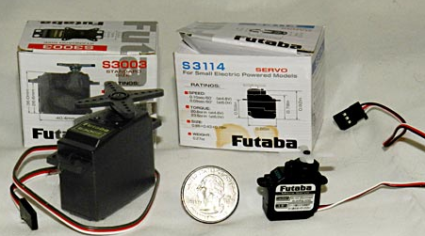

Figure 3.20 - Servo motors, compared to a quarter it they are very small in size (Permission Requested from Science Buddies)

Servo motors can be found in toy cars, radios airplanes and even in home electronics. Several of our everyday uses of many electronics use servos, such as DVD players. In order to control a servo motor is by sending an electrical pulse of variable width, or pulse width modulation. Usually servo motors turn at a 90-degree angle in both directions, controlling my electronics through this.

Servo motors are usually charged through the use very high current causing the servo to overheat since they are all usually DC motors. As stated above it can receive its power from a battery, from there the motor receives a signal as a command and it adjust its position signal. Since the battery is the source of the power it is usually attached causing the motor to rotate at very high rotations per min (RPM), with the fast speed it results in a low torque. Proportional control is a very important concept to understand especially when trying to calculate which size motor is need. Proportional control is: “The motor’s speed is [proportional to the difference between its actual position and desired position. So if the motor is near the desired position, it will turn slowly, otherwise it will turn fast” [22]

Within the servo motor there is an option to have a neutral position, which is the position where the servo gears can complete turn 90 degrees in either directions clockwise direction or counterclockwise direction.

Some key aspects of the servo is that for every 20-25 milliseconds the servo expects to receive a signal that will tell it how much it should turn and in which direction, which will be programed by the software giving out that information. Servos move on command to the direction and how much that it was programmed, but with an outlier is put into place that goes against the direction and movement of the servo, it does react. The reaction that the servo gives out is it tries to reach maximum amount of force which is also called torque rating, if that is not reach the servo stalls and don't move until another signal tells it to move which can be viewed in the image the pulse length is longer.

There are several different types of servo motor, Positional rotation servo, Continuous rotation servo, Linear servo. In Figure 3.21 that follows, it is shown how a positional rotation servo motor is the most popular.

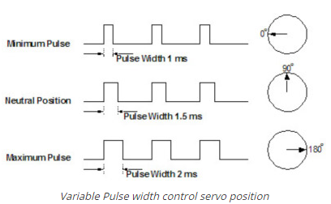

Figure 3.21 - Positional rotation of servo motor (Permission Requested from Jameco)

Rotating at a total of 180 degrees, it cannot between to any degree higher than this because of a preventative system in place. The next motor which is the continuous rotation servo motor, unlike the positional motor it can rotate the complete 360-degrees and in either clockwise or counterclockwise direction. The last type of more is the Linear servo motor comes with additional gears and is very similar as the positional rotation servo.

The essential aspect is making sure that the correct technology is able to give signals to all servos. Through research the common aspect that is shared is the arduino microcontroller is able to send signals to the servo being able to send pulse width modulation through the open software microcontroller.

The matrix I am using for finding which servo to us is the servo must need between 4.8- 6.6 Volts, Torque 190-340 oz.-in, Speed of 0.05-0.70 sec/60 degree and weight of 5-140 grams.

Within these parameters there are several of options that meet near the requirements are as follows:

Option 1:

The S9372SV S.Bus HV Torque- Programmable Car Servo

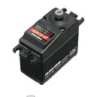

|  |  |  |  |
| --- | --- | --- | --- |
| Volts | Torque | Speed | Weight |
| 7.4V | 342 oz.-in | 0.06 sec/60 degree | 2.47 oz. |

Option 2:

S3306mg ht/ HS1/ 5 scale: FUTM0021

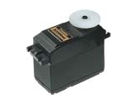

|  |  |  |  |
| --- | --- | --- | --- |
| Volts | Torque | Speed | Weight |
| 6.0V | 333 oz.-in | 0.16 sec/60 degree | 4.6 oz. |

Servo motors are very durable motors that can do the job. Analyzing both options Option 1 is closer to the 20lbs/in scale we are looking to obtain but the drawback on this is that it does require more voltage to power the motor, on the opposite side the torque is responsive at a quicker rate. For Option 2, it is just below the target weight we are looking for. The weight of the table is adjustable therefore it is possible of choosing such servo. It also requires less voltage but the speed is slightly slower than Option 2.

Overall with servo motors it is a viable option to choose from. Servo motors have powerful impacts with its small size, but on the downfall is that for a servo motor is not necessarily a precise motor. Movements are not controlled for this project we need very precise motors to etch into the glass. With this understanding it made us look into different motors, that lead us into stepper motors.

#### 3.3.3.2 Stepper Motors

There are several types of motors that we could have chosen from, but through past experience and some research we narrow down to a couple.

The stepper motor is an DC motor that moves in precise discrete steps, therefore it is not continuous. As for how the function of a stepper motor there are many functions on how it is used. A stepper motors have multiple coils that are grouped by phases, as energy is added to the servo in each phase it rotates which results into one step.

The way a stepper motor operates can seem to be complicated. Ideally a stepper motor would have no friction which would result in the torque equaling to the current multiple by the number of turns of wire in the winding, which results in inductance which results in proportional to the motor speed. By analysis of the ohm’s law the current results to being the inverse of the speed by such analysis the torque is the inverse of the motor speed. Within the stepper motor the ideal speed is zero, at this point when the stepper motor is zero you would get the maximum torque. Meaning that the precision of the motor increases since the torque is at maximum value and the speed is low. Also at the point the speed is zero of the stepper motor the current would go to infinite (maximum) since it is also inverse of the speed.

In the Figure 3.22 above is a visual on how the torque vs the speed of the stepper motor. Through this you can also the affect the current has in result of the speed of the stepper motor. Showing that at lower speeds we do get a higher torque and ideally we would like that to happen but that also inversely causes more damage to the motor. The current is still flowing through the motor even when it is not in use, and in effect it causes the motor to heat up. Which in result we would have to set the torque to the “rated” torque level at its maximum torque for when the speed is zero to prevent it from further damage. In result in most stepper motors a cap is already set for the user, so that the faster the motor turns the less the torque is and it contributes to power loss. If current is set to higher than the rated value that is given in the data it in results can also have negative impact on the motor, the current should be set to double of the current power output. To get higher torque at an earlier time then for it to decrease exponentially, or to get a torque that increases linearly then plateaus at a certain point there are different options that we can take.

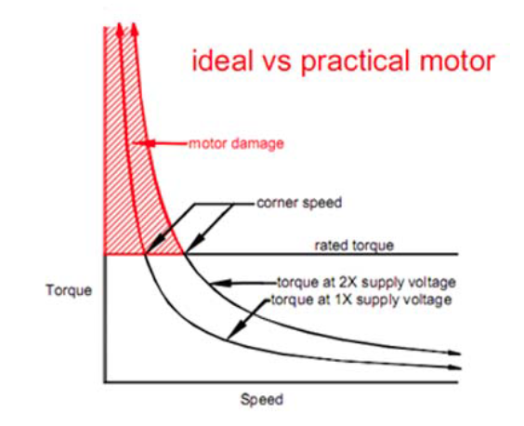

Figure 3.22 -Ideal motor vs a practical motor. When speed is low, motor is in higher risk of being damage (Permission Requested from Gecko)

There are aspects we can use in order to make sure that the motor remain within the rated torque range which would be done with the Driver, which would be further discussed in the next section.

Other things we must take into consideration of which using the stepper motor is that when voltage and power from the driver is added to the motor it creates a phase lag to the motor each adding a 90 degree lag each, which in total creates a 180-degree lag. With this lag the driver should that is being purchased should compensate to a certain degree of that effect onto the motor so the motor does not stall.

The power of the motor is a result of the input voltage power divided by the square root of the motor inductance. In result if the power is change than the torque value changes as well, example if the power is triple then the torque value triple as well. The power is the torque times the speed. In Table 3.20 shows the effect of increase in motor power, and therefore it increases power supply voltage as well as the heating of the motor.

|  |  |  |
| --- | --- | --- |
| Motor Power | Power supply voltage | Motor Heating |
|  |  |  |

Table 3.20 - Results if the power is increased then power, and heating is affected

Usually motors come as Bipolar motors (4 wires) or Unipolar motors (6 wires). They are different aspect you can do wiring the motors to the drivers that will change how the power is affected. Either Full-winding or Half-winding connections are options to connect them to the driver which basically means the wires are connected in series (Full-winding) or parallel (Half-winding). For Half-winding connection gives at least double the amount of power voltage out then the Full-winding connection, following the Full-winding connection there is 4 times the inductance needed. Depends on how the motor is connected to the driver will determine on what to set the driver current delivery to the motor. 8 wire connect motor is also another stepper motor type which is not as common as the 4 wires or 6 wires connection. Figure 3.23 as follows depicts 6-wire connections.

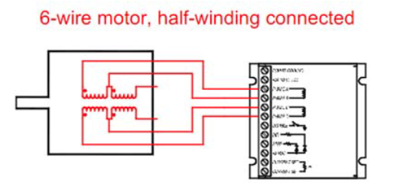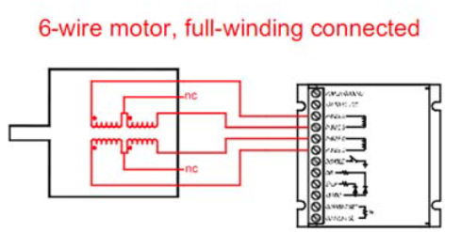

Figure 3.23 - Different type of connections for motor to drivers which include half-winding to the left and full-winding to the right (Permission Requested from Gecko)

There are many factor in choosing the right stepper motor for our project. The first thing is to determine how much weight we are looking to move, how many watts we are going to use, and how many inches per second we want the server to move. Also the amount of watts is needed:

$$\frac{Heaviest object(lbs)*Inches per mins}{Normalizing constant }=Watts$$

IPM= Inches per minute = 1000

Normalizing constant = 531

Heaviest object= 20lbs

Therefore, the amount of watts we would need for our stepper motor would be

$$Watts= \frac{20*1000}{531}=37.664W$$

Next item to consider is the size of the motor that we want. Stepper motor comes and many different sizes as we increase in the size of motor we also increase the amount of power that a motor is giving out. With that comes the most important aspect is the torque, the size of the motor will depend on the torque that we need to complete our project. As we stated above the heaviest object we will be moving using the motors will be 20lbs.

$$Torque=\frac{Current*Applied Voltage*Effincieny of motor*60 }{Revolution Per Min*2Π}$$

Preceding the torque, next item on the list to consider is the amount of revolutions, as the revolution is being increase we lose off on torque and speed. The goal is to find a motor that does not need high revolutions to turn the motor so that torque is not being lost in the process. Next items are the, Gearing, Shaft style, Wiring and Unipolar or Bipolar. Each of these are limited in our control and are not as important as the main items that we went into details for.

Within research we learned there are several pros of using a stepper motor:

* Precise
* Repeatable
* Speed controllability
* Max torque at low speeds

Below are the stepper motors choose from with the amount of watts, torque that we need.

Stepper motors:

|  |  |  |  |  |
| --- | --- | --- | --- | --- |
| Motor:  Type/Brand | Model | Power Rating | Maximum Current | Torque |
| Stepper: Nema | 23 CNC | 18 – 80 VDC | 1.8A/Phase | 2.4Nm(340oz.in) |
| Stepper: Nema | Dual Shaft 34 | 24-60 VDC | 2.0A/Phase | 2.2Ncm(312oz.in) |
| Stepper: Rob | Bipolar Motor | 12VDC | 0.33A/Phase | 320nNm(32.57 oz.in) |

The most common stepper motor brand is the Nema. Nema has a full range of motors from very small motors to very large motors. Another brand we came across are Rob motors which are not as popular as Nema but is another vital option. All these motors come in a close range of the type of motors we may need to complete our project target goal to move at least 20lbs of an object.

Power supply is very vital to contribute to a well function stepper motor. When choose the correct power supply there is some things to take into consideration. Depending on how the motor is connected to the driver either Half-winding/Full- winding determines on which power supply to choose. Since we need three motors the proper steps to take is to add up all the current source, for example **1.8A * 3 motors= 5.4 Amps** for the three motors per phase, when we wire it in Half winding the rule of thumb it will use 2/3 of the of the rated current therefore in this example it will use 3.6 Amps per phase for all three motors. For Half-winding 2/3 of the amps will be used, Full-winding 1/3 of the motor’s rated current needs to be supplied from a power supply.

#### 3.3.3.3 Servo Drivers

“A motor driver is a little current amplifier; the function of motor drivers is to take low-current control signal and then turn it into high-current signal that can drive a motor” [40].

When a driver is added to a motor it adds more value to the output we will receive on the motor. As stated above the motor has areas where it can be damage when speed is low and the torque goes to infinity. In steps the driver that regulates the amount of current that is given to the motor to control it at a rated torque. In Figure 3.24 below displays how the torque limited motor affects the power supply and the supply voltage.

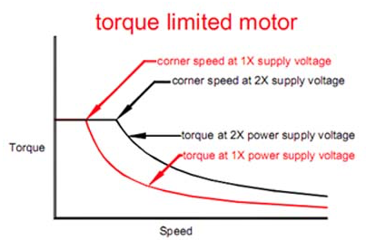

Figure 3.24 - Torque limited motor (Permission Requested from Gecko)

There is another effect of adding the driver, which is the voltage that comes from the voltage adds another phase lag to the motor. As stated above adds to make a 180-degree phase shift to the motor. Depending all the driver but most not if all will compensate to a certain extent to reduce the degree of the lag that is coming from the driver. The motor drivers as well plays a role into the precision of the motors. When determining which drive to use there are a couple of items to do:

* Choose a stepper motor
* Calculate watts needed per motor
* Determine the maximum steps pulse frequency
* Compatibility with chosen motor

We have analyzed many different drivers that would be compatible our stepper motors. The top three motors that was analyzed that are compatible are Gecko, LinerStepper, and Slam driver. Each of this drivers have different pros and cons. But the items we focused on the most on where if the power rating, the current out and the power the driver which these items have major effects on the motor's output. The Gecko driver has a range for the power rating which gives us the option to change the amount of output power it gives, and the same goes for the current, the reason why this is very essential is because in the future if the weight of items change we would like to use the same driver and there would be a possibility that the motor would require more current or power, having that flexibility is also a plus. For the LinerStepper driver is has a power rating of 36V, maximum current of 1-3A and Power output of less than 75 Watts. For the Slam driver it has a power rating of 36 V, maximum current of 2-3 A and a power out of 200 W.

Drivers:

|  |  |  |  |  |
| --- | --- | --- | --- | --- |
| Motor Type/Brand | Model | Power Rating | Maximum Current | Power |
| Gecko | G201X | 18 – 80 VDC | 0-7 A |  |
| LinerStepper | LinerStepper | 36V | 1-3 A | <75 W |
| Slam | Slam | 36 V | 2-3 A | 200 W |

When using a power supply, it is very important on how to wire the drivers to the power output. It is best practice when using multiple drivers to use the star method as displayed below. Which is to share a common ground for all drivers, and same goes for the positive end, to share the common node. Which is displayed in Figure 3.25 of how power distribution of the power supply

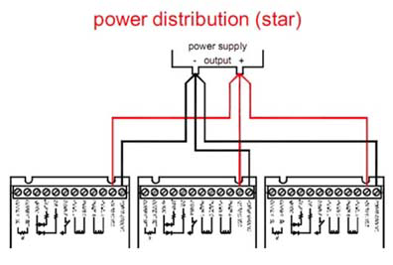

Figure 3.25 - Power distribution guideline (Permission Requested from Gkeco)

#### 3.3.3.4 Linear Encoder

An optional feature we have consider is a Linear Encoder. One of the concerns with the motors, is there is a possibility of the motor skipping a step. When etching into the glass it is very important that each step is processed and executed at the proper output area. There are a couple of ways to manage the steps, our precisely know at which point we are with each step. That will be done through a Linear Encoder which is “a sensor, transducer or redhead paired with a scale that encodes position” [40]. Linear encoders could either be set as an absolute, or incremental. With absolute, for every position there is a discrete and unique code for each position, causing no position to have the same code. For the incremental it follows the same curvature as a cosine or sine wave, therefore have multiple points have the same output code.

There are several different types of Linear Encoders;

* Optical
* Magnetic
* Capacitive
* Inductive
* Eddy Current

The ones we will focus on are the top two linear encoder which is the Linear encoder optical, and the Linear Encoder Magnetic. For the linear encoder optical it is the most precise encoder, one of the major concerns is the collect of dust surrounding the optics. With that knowledge as a user we must take precaution and make sure that dust is not collect nears areas of optical range. Next encoder is the Magnetic Linear Encoder, which consist of the red- head and magnetic scale which self-adhesive. Magnetic encoders are usually used in areas that are prone to dust/ debris or any harsh environments that an optical encoder cannot withstand. They are only two way linear encoders are applied, either as a measurement system, or motion control. Measurement system examples are laser scanners, calipers and etc. For Motion control examples are servo motors, pick and place machine, machining tools and etc. The linear encoder for motion control helps provide data for high speed moving operations so that each action per machine knows the exact location/ step it is at in the process. Overall the main goal of having a Linear Encoder device is so that while etching, if there is chance that the machine turns off in the middle of the etching process or the motor skis steps the device can send a feedback to the computer. That back will notify the computer exactly at which position it is located within the etching design and allow it to pick up from where it left off. There are several options to the choosing a linear encoder. RLS is a company that design, produce and supply advance rotary and linear motion sensors. From RLS there are several Linear Magnetic Encoders;

Option 1:

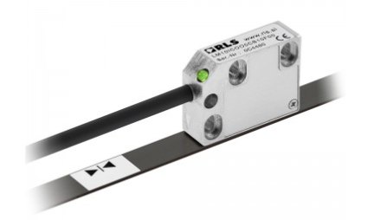

LM10, which is a magnetic Linear encoder. Like many if not all magnetic encoders, the LM10 is built for harsh environments. This encoder can travel up to 100m, it speeds up to 80 m/s and capable of resolutions up to 7 m/s. The LM10 also is shock, vibration and pressure resistant.

|  |  |  |
| --- | --- | --- |
| Reading Length | Resolution | Reading speed |
| 100mm | .244 µm to 250 µm | 80 m/s |

Option 2:

## 

Easson GS10- 200, which is an optical encoder. Which was stated above the optical encoder is more precise giving back an accurate digital feedback. This encoder is usually used for measurement tools and machine tools. Since it is an optical encoder, unlike the magnetic encoder it is not built for harsh conditions. With this encoder above the key specifications are as listed:

|  |  |  |
| --- | --- | --- |
| Reading Length | Resolution | Reading speed |
| 200mm(8”) | 0.005 mm | 60 meter per min |

With option 1 and 2, there are some key differences, starting with the LM10 reading range in 100mm shorter than the Easson GS10-200. Ideally having a magnetic range reading length to be longer than the optical is better to help with precision, since a magnetic linear encoder is not as precise.

In addition to the specs, both of the linear encoders would need to be compatible with our current software of choosing. One of the program we will be using on the software aspects is Arduino an open source software, in which we can both of the linear encoders can be coded with the Arduino.

#### 3.3.3.5 Motor and Driver Power Supply

As stated previously is very important on how the drivers are being power. For choosing a power supply there are some key factors we have to take into consideration:

* Current
* Power supply type
* Voltage

With those 3 aspects will help narrow down which power supply to use. First factor is the current as stated above the current, which is based on the motor rating.

If choosing the following option:

|  |  |  |  |  |
| --- | --- | --- | --- | --- |
| Stepper: Nema | 23 CNC | 18 – 80 VDC | 1.8A/Phase | 2.4Nm(340oz.in) |

With the current phase being 1.8A/Phase and it is wired half-winding to the driver it will therefore draw ⅔ of the rate listed which would be 0.866 A for one motor. But since we are using more than one motor and drivers what is required is to add up all the currents for the motors including the drivers to determine which power supply current is need.

|  |  |
| --- | --- |
| Amount of motors | Total current per phase |
| 3 | 3*0.866= 2.598 |

|  |  |
| --- | --- |
| Amount of drivers | Total current per phase |
| 3 | 3*67% = 2 A |

Which therefore makes the total current to be about 5A that is needed. If the motor is wired with the driver in parallel, also following the star method mentioned above.

For the voltage aspect of the power supply it is a dependent aspect. The voltage depends on the inductance rating of the motor which will tell us how many turns a stator turns. To find out the maximum voltage the following formula is required with the motor’s inductance in milli-henries = L:

$$Voltage Maximum = 32 * \sqrt{L}$$

Using the same motor, the inductance for a single motor is 17mH +/- 20% therefore:

$$Voltage Maximum = 32 * \sqrt{17} = 131.9 V$$

For a motor the maximum voltage is 131.9 V if it is weird in parallel, which can be achieved through a switching power supply that allows to go up to that amount of voltage that is needed We would need about 194.4 Watts coming from the power supply in order to supply the amount of volts needed to power all three servos, even though the calculated value is given to us in Volts the same calculation gives us the amount of what’s needed through research it says “ Driving Voltage x Motor Rated Current x No. of Motor x (1.5~2) times”[41] .Which in this case will give us about 194.4 Watts, according to the data sheet for majority of the servos the recommended voltage is 24-48 Volts to receive optimal performance from the motors. It is feasible to use as low as 12 Volts for the servos but the lost in this case would be the loss of heat from the servos. As stated above there is a particular way to connect the drivers to the power supply. Which in Figure 3.25 shows as the star method, this method would make sure that the power distributed amongst the drivers onto the servo is sent out correctly.

There are several options in choosing the correct power supply. The goal is to choose a power supply that has enough watts as calculated from above as well as voltage. The options are listed below

Option 1:

Switching Power supply for CNC Router:

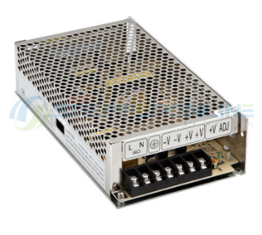

|  |  |  |
| --- | --- | --- |
| Power Supply | DC OUTPUT | EFFICIENCY |
| 150 W | 24V 6.5A | 85.5% |

Option 2:

Switching Power supply for CNC Router:

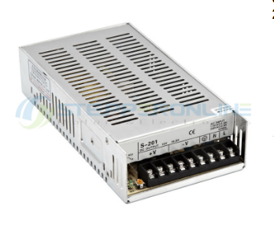

|  |  |  |
| --- | --- | --- |
| Power Supply | DC OUTPUT | EFFICIENCY |
| 201 W | 24V 8.3A | 83% |

Option 3:

Switching Power supply for CNC Router:

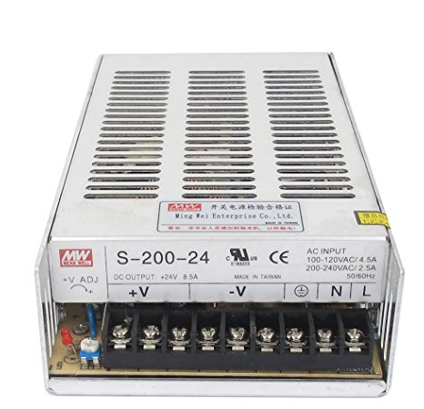

|  |  |  |
| --- | --- | --- |
| Power Supply | DC OUTPUT | EFFICIENCY |
| 200 W | 24V 8.5A | - |

# From in depth research I narrowed it down to three drivers that would be best fit for our project. For option 1, the power supply would give just below the maximum power supply that is need of about 200 W which can inhibit the performance of the drivers and most importantly the motor. The DC output voltage would be enough voltage as well enough maximum current needed for the motors. Option 1 would be a valuable option, as well as the efficiency. For option 2, the power supply would be more than enough power needed to power all three motors that are needed. For the DC voltage of 24 it gives the recommended amount as well as for the current of 8.3 A. This power supply is 83% efficient. The last option that was looked at was for Option 3, that as well as the others it is a switching power supply. This power supply produces 200W which is above the amount that is needed. The DC Output is 24 V and 8.5 A which is the recommended amount for the maximum motor. In regard to the efficiency that data was not provided based off the other power supplies I would strongly suggest that it is the same.

## 3.4 Mechanical Frame Structure

Like the current laser etching system, the new system needs to be capable of positioning a laser beam in three dimensions (X, Y, and Z). It is decided that the X and Y dimensions will make up the two-dimensional plane solely dedicated to the etching glass. Essentially, the XY plane will move the etching glass as needed so that the laser’s focal point (focal point is where the etching process occurs) can etch the desired image. Via the software, each three dimensional image will be divided, or *sliced*, into layers that will be etched one at a time. So for each layer making up the image, the Z axis will be positioned and fixed so that the laser’s focal point will etch only the corresponding layer. While fixed at any one layer, the etching glass will be moved throughout the XY plane to etch the layer. After any given layer of the image is completely etched into the glass, the Z axis will reposition to begin the etching process for the next available layer to be etched.

For the etching process to occur as mentioned above, the part of the mechanical frame in which the Z axis motor is mounted on needs to be stationary. This is due to the fact that the laser beam performing the etching process is dependent on the position of the optics that produce the beam. If the laser beam is integrated onto the XY plane, then the position of its focal point will not be able to change relative to the plane. Hence, it will not change relative to the etching glass and will remain in a single spot, causing unwanted damage to the glass.

In addition to the positioning requirement of the X, Y, and Z axes, the overall structure needs to be able to withstand a weight of 20 lbs. as mentioned previously in the mechanical specifications. So when choosing a frame to use, the frame’s weight bearing specifications needs to be considered. This is critical considering the possibility of rapid speeds in which the XY plane and the Z axis will be moving. In the following two sections, two options of frame structures are considered with respect to achieving the needed capabilities of the XY plane and the Z axis.

### 3.4.1 XY Stage - Option 1 Velmex BiSlides

Velmex, a company that specializes in the design of linear positioning systems, has available a system known as the BiSlide system. A BiSlide is a one dimensional positioning frame that can provide a high accuracy in positioning. Although the frame is designed for one dimension, it can be mounted on top of a second frame of its kind. This allows for a second dimension to be created. The integration of two of these frames are considered as an option for the X and Y dimensions that will move the platform holding the etching glass. Below in Figure 3.26 is a picture of a single BiSlide frame.

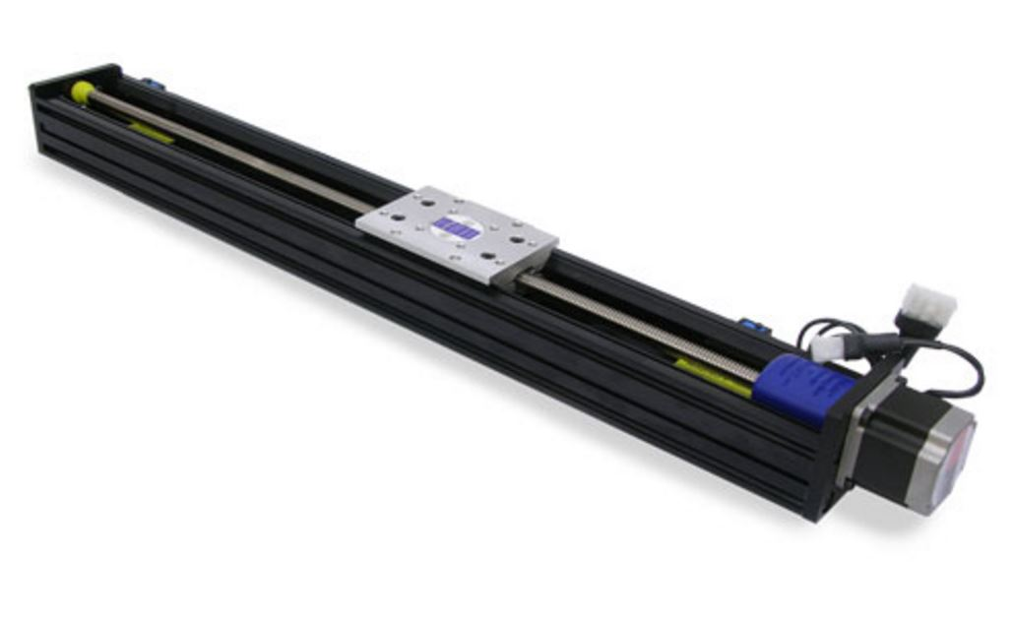

Figure 3.26 - Velmex MN10 Precision Lead Screw Model, One Dimension (Permission Requested from Velmex, Inc.)

As you can see in the image, a slider piece exists on the frame that has freedom to move linearly over a certain distance. The actual distance the slider can move is dependent on the needs of the laser etching system. Velmex has available various travel distances for the MN10 model shown above. Table 3.8 and Table 3.9 below show the overall specifications of this model.

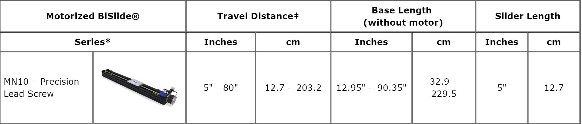

Table 3.8 - Velmex MN10 BiSlide Physical Characteristics (Permission Requested form Velmex)

|  |  |  |
| --- | --- | --- |
| **Motorized BiSlide Frame** | **Static Load** | |
| **Load Capacity** | **lbs.** | **kg.** |
| **MN10** | | |
| **Normal Centered** | 300 lbs. | 136.1 |
| **Thrust** | 200 lbs. | 90.72 |

Table 3.9 - Velmex MN10 BiSlide Load Characteristics (Permission Requested from Velmex)

The total length of the BiSlide needs to meet the mechanical constraint of 2 ft. Its total length (with the motor) will consist of the slider length (5 inches), travel distance (10 inches), motor length (~4.1 inches), and additional length contributed by the base. In total, excluding additional base length, the frame will be at least 19.1 inches. This leaves 4.9 inches for additional base length contributions that don’t consist of the travel and slider lengths. Although there is no way to predict the additional length from the base, it's anticipated that 4.9 inches will be sufficient room for error to meet the overall constraint of 2 ft. When considering the Y axis by mounting a second BiSlide frame onto the first, the same length specifications are considered. In the direction of this axis, the extra 4.9 inches will be enough for the additional base length contributions such as travel and slider lengths.

Table 3.9 shows the maximum dynamic loads in which each BiSlider can handle. It shown that each frame can handle a static load of up to 300 lbs. when normally centered. A static load is one that does not vary in weight. This is important considering that the etching glass’ weight will not vary during the etching process and is constrained to be no more than 20 lbs. A third BiSlide frame could also be utilized for controlling the Z axis as well. Referring back to Table 3.9, the static thrust load capacity is up to 200 lbs. This type of load is also constant, but its direction is parallel to the rotating axle of the frame. It is assumed that any one motor will be subject to a maximum of 20 lbs. There the frame will also be able to handle the possibility of 20 lbs. static load thrust.

Overall, a depiction of the XY frame configuration is shown below in Figure 3.27. In the event the MN10 BiSlide frames are used, this is the configuration that’s needed for the laser etching system.

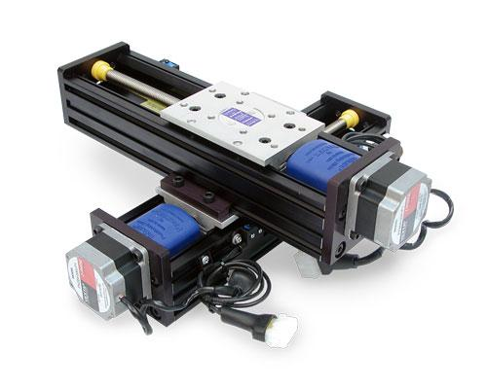

Figure 3.27 - Motorized XY BiSlide Configuration using MN10 Series (Permission Requested from Velmex)

### 3.4.2 XY Stage - Option 2 InteLiDrives BSMA-080

InteLiDrives, another expert in the design of precision XY table solutions, provides a second option for consideration. The advantage of using the BSMA-080 platform is its versatility to be used with various motor sizes. In particular, NEMA 23 size stepper motors may be used for the laser etching system which may be the official motor stepper size used for the new system. Its travel surface area that contributes to how far the the etching glass can travel in the X and Y direction are between 200 mm x 200 mm and 600 mm x 300 mm. The X and Y platform shown below in Figure 3.28 using the BSMA-080 is similar to the Velmex BiSlides configuration. Table 3.10 that follows provides a short description of its physical characteristics.

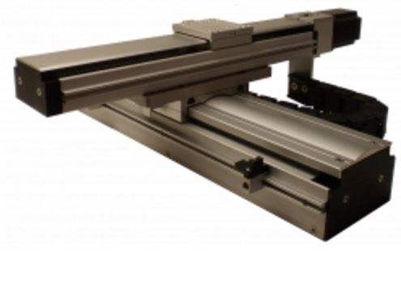

Figure 3.28 - InteLiDrives BSMA-080 XY Platform (Permission Requested from IntelLiDrives)

|  |  |
| --- | --- |
| **Stroke X x Y** | 200x200 mm to 600x300 mm |
| **Motor Mounts Possible** | Nema 23, M60 |
| **Repeatability** | +/- 5 microns |
| **Accuracy** | 20 microns / 300 mm |
| **Load Capacity** | 10 kg (~22.05 lbs) |

Table 3.10 - BSMA-080 XY Platform Capabilities (Permission Requested from IntelLiDrives)

This solution has smaller maximum loading capabilities compared to the Velmex configuration, but it still meets the desired specification of being able to move 20 lbs. Unlike the Velmex solution, the high accuracy in achieving desired position is apparent. High positioning accuracy is important considering that the laser is of high energy. So if the laser is placed in the wrong position, it will quickly create an undesired etched spot inside of the glass. This will merely degrade the quality of the final image being produced.

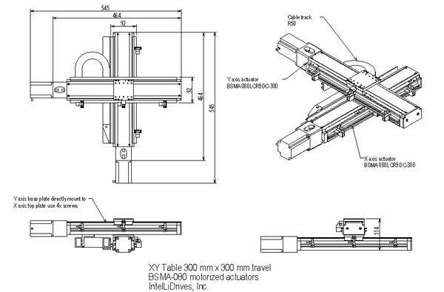

Figure 3.29 - BSMA-080 XY Platform (Permission Requested form IntelLiDrives)

The BSMA-080 dimensions are also promising since it meets the physical requirements of fitting within a 2ft by 2 ft surface area. The approximate dimensions are shown above in Figure 3.29. The maximum length and width of the platform is 545 mm (~1.79 ft). Based on the diagram, the motor size is accounted for, leaving the platform a possibility over the Velmex option.

3.4.3 Safety Shielding Assembly Materials

As one of our customer needs is safety, this section is about the safety that is respectively to the optical part of the project. When working with high power laser, the risk of eyes and skin damages are highly possible. To minimize these risks, in addition to wearing proper protective gear, goggles, when using the system, we are making sure that an assembly around the whole system is in place. This safety shielding will be specifically in place to prevent stray laser reflected and propagated beam not coming in contact with the eyes of the user and everyone else in the surrounding of the 3D Laser Glass Etching System. The Safety Shielding Assembly will be made from opaque Teflon which will act as a filter around the entire system. Thus, as the laser is pulsing to etch in glass, the stray beam reflections will be absorbed by the surrounding materials such that the beams do not pose a threat to the safety of the user.

The dimension of the shielding will be 2.0 x 3.0 x 3 feet, width x length x height, respectively. The shielding will be subdivided in two sections: (1) the complete optical and mechanical system and the glass to be etched, and (2) the electrical board and the drivers for the motors. This will certainly remove the maximum risk the current system has which can cause electrocution and laser interaction with the user skin and eyes and others in the surroundings.

## 3.5 Scanning Mirror Approach

Scanning Laser Direct Writing is an actual system use in several experiment in for 3D multilayer Microstructures (Figure 3.30) [46]. One of the approach presented to rebuild the 3D Laser Glass Etching System is to use a Scanning Mirror. This approach is intended to meet the size and time efficiency our customer is looking for. This approach would help integrate experimental procedure to our real life system. I have found that they are companies who are using this scanning mirror system rather than using XY-axis motors rotation and Z-axis for laser depth in their marketable products. To realize this system and successfully make it work for a long time, research publication and improvisation must be made to adapt to the fund we are provided, the time constraint we are facing, and the limited knowledge we have. [56]

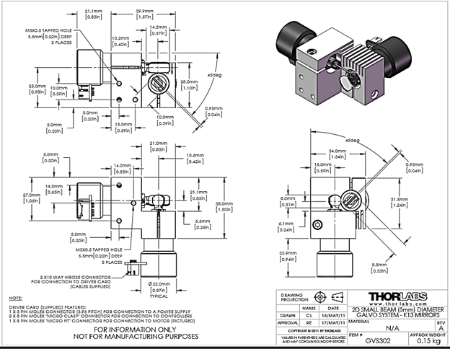

Figure 3.30 - Galvo Dual-Axis 532 nm and 1064 nm from Thorlabs [56]

The experiment I proposed to follow in order to redesign and fabricate our current system is as followed:

*A laser diode-pumped, high repetition rate (~ 100 KHz), nanosecond pulse duration of 3rd harmonic Nd: YAG laser BL8-355Q operating at a wavelength of 355 nm was used at the light source. The laser produces a maximum average power of larger than 400 mW at 20 KHz. The output energy can be adjusted by varying the pump diode current or by altering the repletion rate. An x-y-z-θ stager was built to translate a sample in four degree-of-freedom. The laser light is directed through a 2-axis Scan Head is as follows: the laser beam passes through and is steered by a set of x and y mirrors that are coupled to galvanometers. The orthogonal arrangement of the x and y mirrors directs the beam down towards the workpiece and over the length and width of the scan field. Field distortion is compensated with an F-theta lens after the two-mirror system. This enables both a large scan field (100 x 100 mm2) and a small spot size (~5 µm). Scanware laser scanning control software developed by Nutfield Technology was used to generate the desired micro-patterns, as seen in Figure 3.31. [57]*

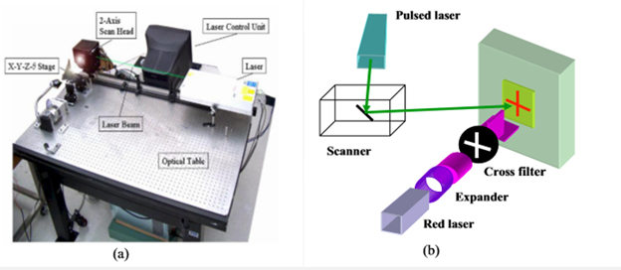

Figure 3.31 - (a) Photograph of the scanning laser direct writing system. (b) Schematic diagram of the experiment setup for multi-layer alignment. [46]

With the same approach of this experiment, our laser would have the capabilities to pair up with a scanning mirror from Thorlabs, GVS 302, in a designed optical system such that we can have high performance and resolution of end products. Briefly I will describe the scanning mirrors capabilities and applications, and show a potential optical design for the system we would aim to assemble.

As seen in Figure 3.32, the GVS 302, scanning Galvo system is a board level, mirror positioning system, design for integration into OEM or custom laser beam steering applications. It is a dual-axis (XY) system with two mirrors and motor assemblies, an X-Y mountain bracket, two driver cards and two heat sinks. The driver cards are features a reasonable size footprint, fixings for easy mounting to the heatsink and analog command signal interface. The Dual-Axis System is built with high Power dual band for 532 nm and 1064 nm which is a right selection for the wavelength we are intended to use for our system. Some of the typical application for the scanning systems include laser scanning, laser spectroscopy, and laser marking.

Galvanometer is a system with a precision motor with limited travel, and within the range of less than 360 degrees of mechanical degrees of freedom. Its acceleration is strictly proportional to the current applied to the motor coils. With an applied current the shaft of the motor rotates through an arc. To stop the motor shaft from rotating, an applied voltage of the opposite polarity is applied.

The benefit of a galvanometer in our system will be its accuracy and speed while steering the beam. The mirror is attached to the end of the actuator and deflects the light beam over the angular range of the motor shaft. The mirror in the Dual-Axis has a K13 coating, operational at 532 nm and 1064 nm, with a damage threshold of 5J/cm2 at 1064 nm, 10 ns pulse.

The GVS302 in our system would has an operational voltage of 125 Volts. The XY-axis mirrors operate on a 10-volt peak-to-peak input voltage. The system repeatability is 15 µrad, linearity is 99.9 %, maximum mechanical angle is ±12.5 º. It cost $2,431.00 with all accessories included. The operation our system with the beam steering mirror approach will be dependable to a large degree, programing the drivers to rotate at the XY-position. Our Z-axis would be a motor that levitate with respect of depth or third point on the vector point for each etching point: x: width, length, and z: height. The image below denotes the schematic for the system.

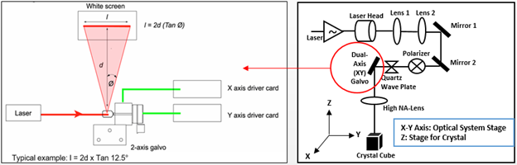

Figure 3.32 - Galvanometer, Dual-Axis Thorlabs, for beam steering (XY).

The steering beam coming from the output of the galvanometer will then go through a high numerical aperture (NA) lens. The high NA lens will give us a nice Gaussian beam, 100 µm diameter approximately, before hitting the crystal glass. I believe this approach would be cost efficient, time effective, and size reductive compare to using two motors to move the linear stage the crystal glass will be mounted on. In contrast, this ideal proposed design is a reverse of the current system which has three motors. Two motors are perpendicularly crossed to move the linear stage for the optical system and the platform for the crystal glass, where the Z-axis is where the laser is position such that the focal point is calculated for etching. The galvanometer steering beam system will rather scan the pulse beam from the laser as the mirrors moved respectively to the XY vector position, and the Z-Axis will simply move at the layer to have either depth or simply the position of (x, y, z) position the laser pulse has to hit. The constraint of this system would be integrating the scanning mirror in our system such the drivers are program to move respectively to the position to etch. It would be an extra work as well to integrate these command such that the laser is respectively pulsing at the right spot, but also to make sure that angle from the scanning mirror coupled in the high numerical aperture lens such the power out of the lens is consistent.

# **4.0 Design**

# 4.1 Software Design

# 4.1.1 Software Design Summary

In order to create the software design for our project, there are many different factors that influenced the different features and the overall design of the software. Many of these factors came from the requirements and specifications placed by the sponsor of the project. The main and most important factor that influenced the design is the automation of the process. In order to create a more modern and easier to use software program, compared to the older and outdated software in the older system, the main focus was to automate the process and have everything be achievable using a single software application.

Since the previous software application had to have different steps done outside of the software design, our goal was to eliminate this hassle. For example, the previous software had to have an image put into Paint, be sized a certain way, saved as a monochrome bitmap image, and finally put into a Matlab script that extruded the file and created a. Obj file for the 3D etching. Our goal was to put all these steps inside the software that we designed. Even better, having all of this automated so that the user only needs to do the minimal steps was a major goal. The final software design achieved in removing many of these manual steps and allowed for a very easy and automated flow with little required user input.

The entire software design can be divided into three major areas, the first being the graphical user interface which is what the user interacts with. The second being the base or back-end of the software. This part deals with the control flow of the entire program up to sending the G-code to the microcontroller. The last area of the software design is the microcontroller. This part involves the firmware installed on the microcontroller along with the G-code interpreter found within the firmware. These three major areas are key to the software design and the designs of these areas allow for almost complete automation of the software (like shown in Figure 4.1).

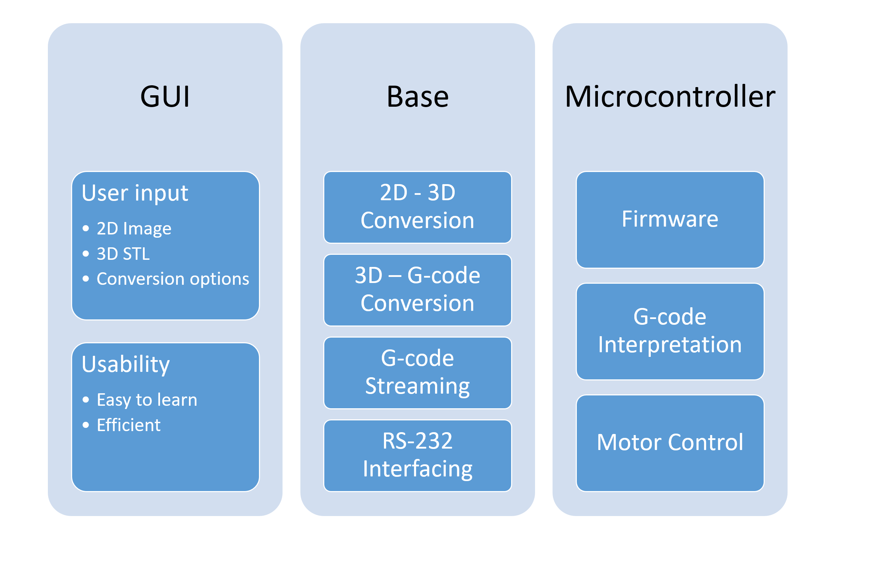

Figure 4.1 - Major Areas of Software Design

The graphical user interface is the front-end of the software application. This is the area where the user interacts with the software. All user input and user feedback occurs in this area. The design of the GUI takes into consideration two major parts. The first being the user input. Since the software application requires an image or object to etch, this is the area where the user can input a 2-dimensional image or a 3-dimensional object. If the user decides to input a 2-dimensional image, then the user has the option to configure the 3D conversion settings. Otherwise, the settings are defaulted to the most optimal for all images. If the user only inputs a 3-dimensional STL file, then the conversion process is skipped.

The second major focus of the GUI design is the usability of the GUI. There are many things to consider when creating a GUI in the industry. Since we are time constrained, we only focus on the two most important parts. The first is the ease of learning of the GUI. This is done by having as few options as needed. If the user wants more configurability, then they should be allowed to have, but the default GUI should show the most minimal style possible. This goes into the other part which is the efficiency of the GUI. In order to have an efficient GUI, any extra information that is not needed should not be implemented in the design. For these reasons, the GUI design only was required and is going to be easy to use.

The base of the software is what the architecture is made to function around. This part of the software design carries out all important functions. These functions include the 2-dimensional to 3-dimensional conversion process, the 3-dimensional object to G-code slicing process, the G-code streaming process, and the RS-232 interfacing. As such, this area of the software design is crucial is making the entire engraving process to work.

The base of the architecture connects with the GUI. By taking in the inputs from the user through the GUI, the base of the software does the actual 2-dimensional to 3-dimensional conversion. The conversion process creates a STL file that is automatically hooked to the G-code slicing process. Once the user initiates the engraving process through the GUI, the slicing process begins on the STL file. Once it is completed, it is sent to the microcontroller through the streaming program.

The final major part of the software design is the microcontroller. The microcontroller contains a specialized firmware that is used for 3D printing. This specialized software contains a G-code interpreter that interprets the G-code into actual motor commands and movements. The interpreter interprets the G-code that is being streamed to it line-by-line. One line is processed and carried out before carrying out the next line. By continuously receiving, interpreting, and processing the G-code instruction, the G-code moves the motors to create the etching into the glass cube. Once the etching process is completed, a signal is sent back to the host computer to indicate the success or failure of the etching process.

The following Figure 4.2 is a summarized flow diagram of how the software design works as a whole:

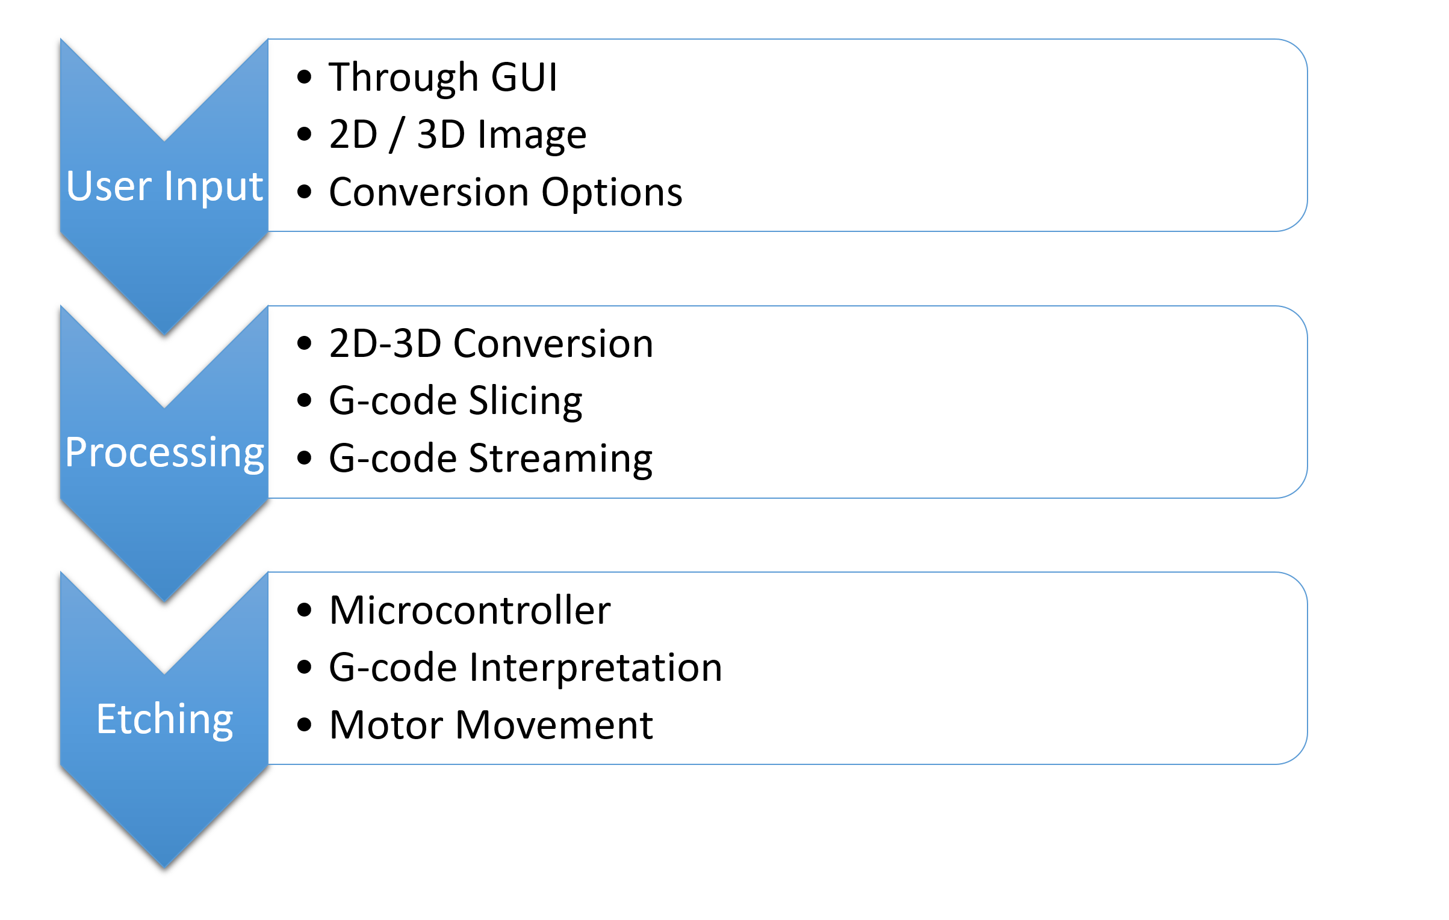

Figure 4.2 - Software Design Flow

### 4.1.2 GUI Design

The graphical user interface (GUI) is the main part of the software that the user interacts with. It is the front-end of the software and it is where all the user inputs are provided along with all the software feedback. Since it is where the user is able to control the software, the design of the GUI needs to be simple and easy for the user to comprehend. However, it must also have all the options to allow for as much customizability as needed.

When designing graphical user interfaces, there are some important principles to follow. The most important ones being clarity, aesthetics, ease-of-use, and efficiency. Since our project design is heavily time-constrained and we do not have a large software team working and developing the interface, some of the principles will have to be sacrificed. For example, a larger emphasis will be placed on usability and configurability than on aesthetics and clarity. The design will mostly be minimalistic and have only the required capabilities for the software to function. If there is any time to make modifications to the GUI so that it is more aesthetically pleasing, then we will do so.

The first step in the design of the GUI is picking the right architecture or framework for us to use to develop the code and the design. As our focus for the design process is to be able to spend the least amount of time actually creating the design rather than testing and modifying it, we chose to use wxPython Phoenix. We chose this framework because it provides us the resources to create a GUI that not only has a native look and feel to it but has many different ways to implement what is desired. We also chose the Phoenix variant of wxPython because of its compatibility with Python 3.5, our choice version of Python. Using this framework, however, means that we will need to install it and all its dependencies on the system.

To start with the design of the GUI, we looked at all the different inputs that the user would need within the GUI. We then separated the inputs into required inputs and optional inputs. The following is a list of all the known inputs for our software:

* Required
  + 2D or 3D image or object
  + Etching start
* Optional
  + Conversion Details
    - Extrusion Depth
    - Color Accuracy
    - Image size
  + Imagemagick command line arguments
  + Potrace command line arguments

As seen from above, the only required inputs is the image or object that is going to be etched on the glass and the beginning of the etching itself. Every other option is optional and can be defaulted towards the best known configuration. As our project aims to automate the entire process of 2D to 3D conversion, it is best that we keep the required inputs as minimal as possible.

The software architecture is designed around these inputs and the GUI itself is as well. Each of these functions will have their own designs using different widgets from the wxWidgets library that is accessible through wxPython.

It is important to note that the software itself will not have effective error handling as we are time constrained. This may be an area that can be evaluated further on if there is available time. Otherwise, any errors that occur during any of the processes may end in a critical failure of the program.

Another necessary feature that the GUI will consist of is all the licensing information that we are required to have in our software due to the use of open source programs. Many of the open source programs used in our software require disclaimers and license information to be available to anyone that uses the program.

The following (Figure 4.3) is a general flowchart of how the graphical user interface is fits within the entire software design.

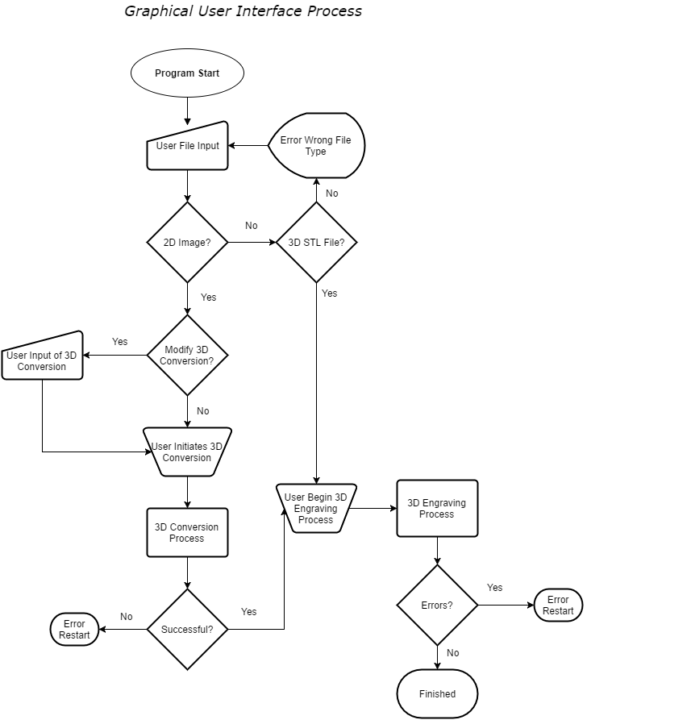

Figure 4.3 - GUI Flowchart

To summarize the flowchart, the GUI will require the user to give a file as input. This file can either be a 2D image such as a PNG or JPG or a 3D STL file. If the file given as input is not one of these files, then an error will pop up requiring another file. If the file given is a 2D file, then the user has the option to either modify the 3D conversion settings or just choose the recommended settings for the 3D conversion. The user then initiates the 3D conversion process. Once the 3D STL file is created, or the user had already input a 3D STL file, then they have the option to initiate the 3D engraving process. This process will be covered in another section. The 3D engraving process will either complete successfully or terminate with an error.

### 4.1.3 3D Conversion

The research on 2D to 3D conversion yielded in two different possible methods, one using the stl_tools module and the other using several tools, such as Imagemagick, Potrace, and Blender, together. Our final design on 2D to 3D conversion will include both of these methods. The first being for any text input to 2D image conversion and the second being any 2D image to 3D conversion.

It is important to note that all tools being used are able to be used either by the command line or by the program’s Python API that is available. This allows for us to incorporate all the tools within our software so that it can all be automated within a single software application.

For converting any text to a 2D image file, the stl tools module will be used. This module supports everything that would be required on creating the 2D image file based off the text input. Firstly, the module takes the text and converts it to a png image. That png image can then be used with the other tools in the process of creating the 3D STL file. The only restrictions with this is that only text can be input and not text with an image.

To generate the 3D STL file, our design makes use of three different tools. The first being Imagemagick conversion tool. This tool is capable of converting between almost any raster image formats. This tool will be used to take common 2-dimensional raster formats such as PNG or JPG files and converting them to a monochrome bitmap image. Since Imagemagick has many different command line arguments, the configurations that result in the best bitmap image will be used for all files as default. However, if the user wants a certain configuration that they know is best for the type of image that they have inputted, then they have the option to change those configurations.

After Imagemagick converts the 2D raster image (PNG, JPG, etc.) to a monochrome bitmap image, the next program, Potrace, will take that bitmap and trace it to create a vectorized file that is much smoother than the bitmap image from Imagemagick. Much like Imagemagick, Potrace has many different configurations that result in the output of different images. The most important one being the size of the output image. This will be the place in the software where the 3D output image will be modified to make sure that it fits within the dimensions of the glass. The user can also configure other options such as how the tracing occurs if they desire. Otherwise, the defaulted best options for general tracing will be used. The output of Potrace creates a SVG file that will be then input into the next program on the next step.

The final step in the 3D conversion process involves the open source 3D suite Blender. Blender’s purpose in the conversion process it to finally output a STL file. In order to do so, Blender needs to import the SVG file created by Potrace in the previous step. That SVG file is still a 2-dimensional file, but it can now be modified in Blender to create a 3-dimensional object. Using Blender’s extrusion tool and capabilities, the image can be extruded to a certain depth and then saved and exported as an STL file.

In order to use Blender, however, we will be using its Python API to hook into its functions. Almost of capabilities of Blender have been made so that they can be used through the Python API. Therefore, all we need to do is import the library to our Python program. The following is a diagram of how the 2D to 3D conversion process works:

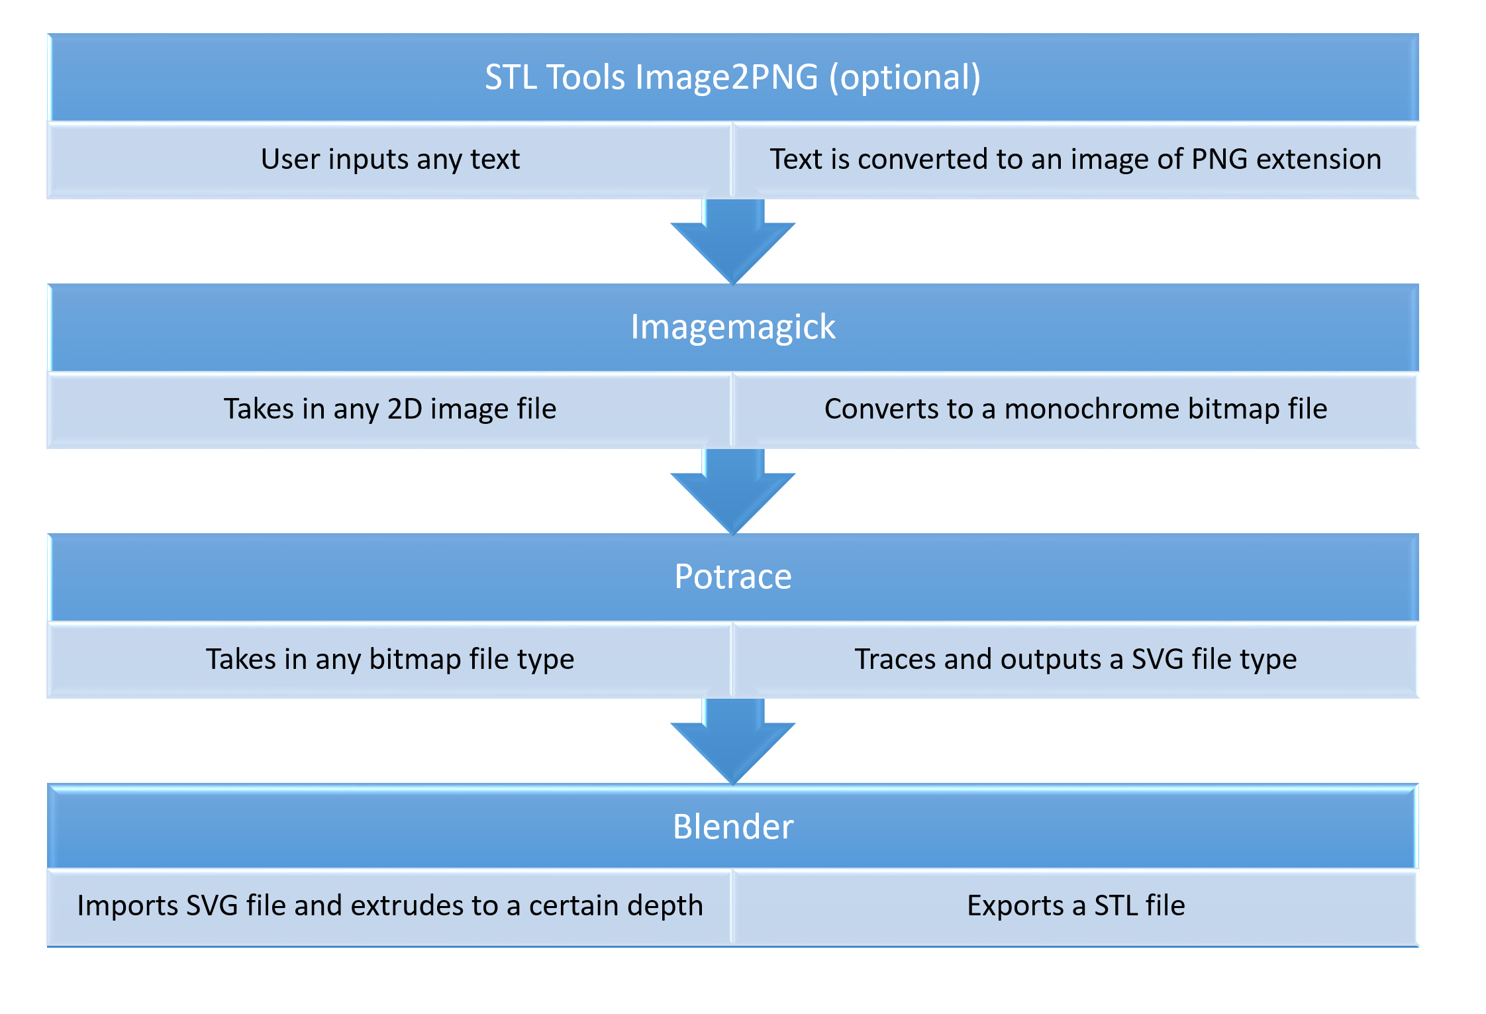

Figure 4.4 - 2D to 3D conversion Process

In general, the process begins at Imagemagick (unless text is the starting point in which case Image2PNG is the starting point). Imagemagick converts the 2D image to a bitmap image. That bitmap image is passed onto Potrace which traces and smoothens out the bitmap image. Potrace outputs a SVG file that is taken into Blender. Finally, Blender extrudes the SVG image by the desired depth and the result is exported and converted to a STL file. The STL file that is created at the end of the process is ready to be sliced and constructed into G-code by a slicer program.

### 4.1.4 G-code Construction and Streaming

In order for the 3D STL file to be translated into G-code so that the object can be etched into the glass, a program called a slicer has to be used. Slicer programs “slice” the 3D object into layers. These layers are then translated into G-code language, which is language that will be used to send movement instructions to the motors. These movement instructions move the motors in a certain way so that the laser pulses and etches the 3D object into the glass.

The slicer program that will be used in the project is known as Slic3r. It is a community driven and open source program that is known for being one of the staple programs in the 3D printing community. The purpose of this program is to cut the 3D object into horizontal layers or slices and use those slices to generate paths for the motors to move so that the object can be etched. These paths are then converted into a standards compliant G-code that will be interpretable by the microcontroller that controls the motors. A G-code file will be output which will be grabbed by the streaming program.

Slic3r includes an important feature that made it the choice slicer program for our project. That feature is command line slicing. Slic3r comes with different configurations and is able to be executed through the command line. This allows us to easily integrate the functionality of the program into our software design. Since slic3r comes with many different features, we can be assured that any requirements that come up during the prototype construction can be addressed by the extra features that Slic3r has.

After Slic3r creates the G-code required, we need to make sure that we can use the G-code by sending it to the microcontroller. In order to do so, we need to send it through serial communications (USB) which is the main way that the microcontroller communicates with computers. This can be done using specialized programs that stream the G-code to a microcontroller with compliant interpreters.

Since our software application requires non-GUI components to be used, we are using a G-code streamer that is simply controlled by the command line. There are tons of different G-code streamers that are compliant with the firmware and interpreter that we are intending to use, and there is even one created by those who developed the firmware that we are intending to use. This streamer is written in Python and is completely functional from the command line.

It is important to note that we chose the firmware and interpreter that is compatible with many different streaming programs so that if there are any issues with the streamer that we use, it can be easy to find another compatible streamer.

The following diagram is a general summary of the how the G-code creation and streaming process occurs within our software program:

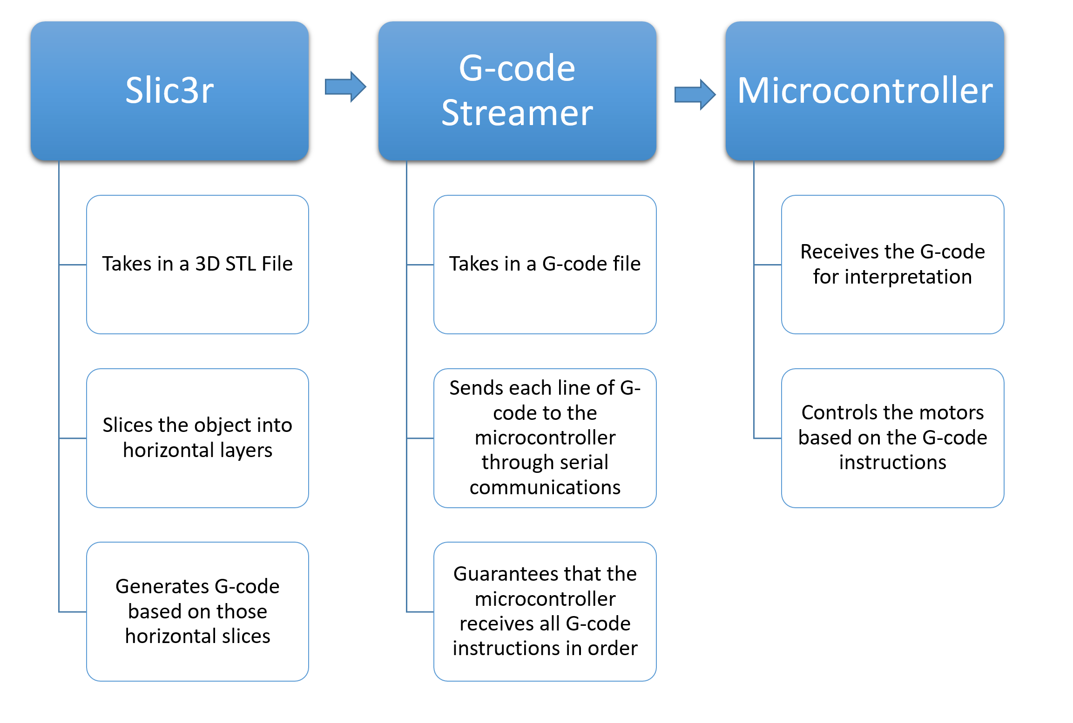

Figure 4.5 - G-code creation and streaming flow

The way that the microcontroller receives and interprets the G-code that is being streamed will be covered in the next section.

### 4.1.5 Microcontroller G-Code Interface

The firmware that we are using in our design is designed to work on our choice microcontroller, an Arduino that uses an Atmel Atmega 328. From our research, we found two firmwares that come packed with a G-code interpreter and many features for 3D printing such as motor control. We decided to use Grbl, the open source G-code parser and interpreter and motor controller due to its effectiveness and ease of implementation.

Grbl is written in C which will run directly on the Arduino. According to the grbl descriptions, it is able to maintain up to 30 kHz stable pulses. It can also accept any G-code that follows standards. With look-ahead and future planning, grbl is able to make motors move in smooth and constant motions, allowing for our design to have smooth and effective engravings. Grbl operates at 115200 serial baud rate, allowing for efficient communications between the host and the microcontroller.

Since grbl is written in C and is completely open source, we are able to make any modifications needed to the interpreter and to the motor controls. This will be necessary in order to incorporate the RS-232 interface to control the laser from within the program. The current plan is to have the interpreter calculate the distance between the points and from that determine whether the laser needs to be toggled while the motors move that distance. This is to prevent any unwanted engravings in areas of the glass that are meant to be left blank.

There are a few steps in order for grbl to be installed on the Arduino. The first step is to acquire the source code for grbl. Then, using the Arduino IDE, load the grbl library and compile the grbl library. Finally, upload the compiled code to the Arduino. At this point the Arduino contains the grbl program and is now ready to receive the G-code through the streamer.

The connection between the computer and the microcontroller can be described in the following fashion. The computer is the host that contains the G-code file with all the information. The microcontroller is the receiver that receives and interprets the G-code into actual motor movements. In order for this host and receiver communication to work, they are connected by USB.

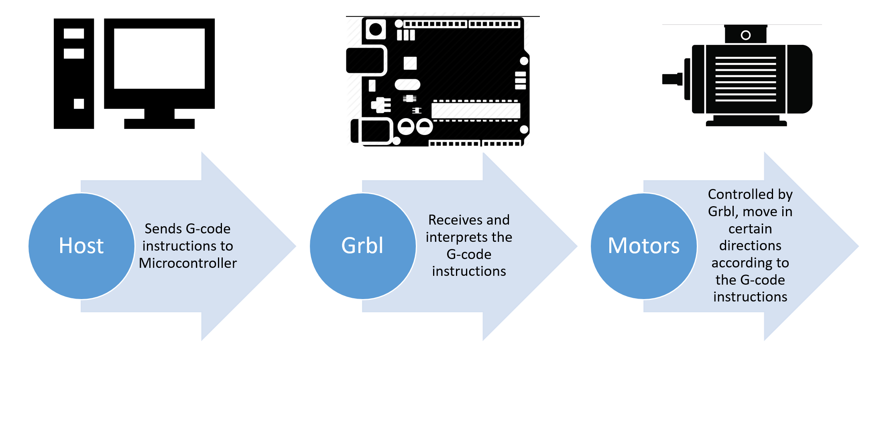

Figure 4.6 - Host to Microcontroller Flow

### 4.1.6 RS-232 Interface

The RS-232 interface is serial communications interface that allows for communications between two different hosts. The laser that we will be working with has a RS-232 interface that allows for control of different functions of the laser, such as the powering capabilities.

The older software tried to establish communications using the RS-232 interface but it was not successful. The laser had to be manually started when the engraving process was initialized in the software. Instead, in our design, we are at least trying to make it so that the software turns the laser on when the engraving process begins. This can be easily done with using the computer’s USB to communicate with the RS-232 interface. All that needs to be done is to connect to the RS-232 interface using pySerial, and then send a signal to turn on the laser when the etching process is initiated, so immediately before the G-code streamer is initialized.

At the best possible implementation, the laser can be turned on and off through the G-code interpreter. In the older system, there were areas of the glass where the laser had pulsed and etched as the motors moved across long distances. This left what appeared to be fragmented lines in the etched object when looked closely enough. To prevent this, the plan is to have the G-code interpreter calculate the distance and time required to move the motors to the next spot where the laser etches. If the distance or time to get to that place is longer the time until the next pulse, the interpreter sends a signal to turn the laser off and then turn it back on when the motors arrive at the correct location.

This approach, however, would require an extra serial communication to be added to the microcontroller. It would also require complete modification of the microcontroller interpreter. Whether or not this can be achieved in the constrained time that we have with the project is unknown. At the best scenario, both of these functions can be implemented. If not, even the easier and fallback case will meet the specifications that were specified at the beginning of the project. Figure 4.7 that follows depicts the two possible scenarios.

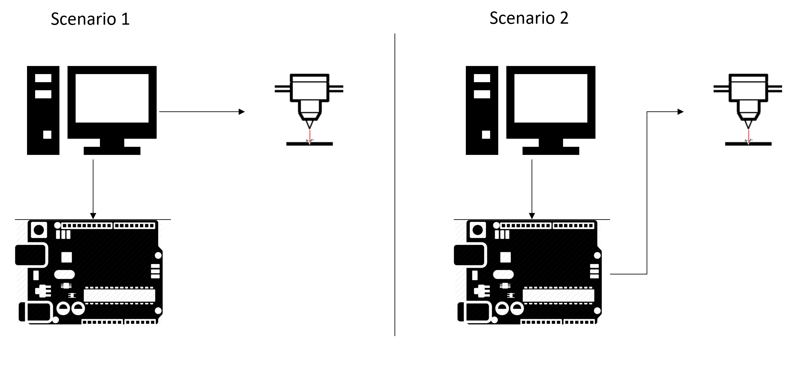

Figure 4.7 - Possible RS232 Interfacing Setups

As seen from the Figure 4.7, scenario 1 represents the scenario where there is not direct control of the laser from the microcontroller. The laser is turned on when the computer begins streaming G-code to the microcontroller.

Scenario 2 represents control of the laser from the microcontroller. The laser’s on/off capabilities are controlled by the microcontroller and are based on the G-code instructions. More specifically, the distance or time required for the motors to arrive at the next destination.

### 4.1.7 Laser Engraving Process

The laser engraving process is the complete functionality of the system. It incorporates how the electrical, the mechanical, the optical, and the software communications comes together. In terms of software, this process is mostly about how the G-code is streamed to the microcontroller, how the microcontroller receives and interprets the G-code, and finally how the microcontroller controls the motors with respect to the G-code instruction interpreted. However, this part of the software also relies on the laser engraving system to make sure that it is calibrated enough to effectively etch into the glass.

The laser engraving process begins at the host computer. After the G-code is created from the 3D STL file or object, a G-code file is created with all the G-code instructions required for the motors to move in order for the laser to etch the right object into the glass. This file’s contents are streamed to the microcontroller through serial communications using the USB port. The streamer takes care of any buffer overflow and makes sure that it is continuously streamed to the microcontroller at a rate that is smooth but not overwhelming for the microcontroller. At the beginning of the streaming process, a signal is sent from the host computer to the laser system through its RS232 interface to turn on the laser and configure it to begin etching.

As the microcontroller receives the G-code, the firmware which is running the G-code interpreter analyzes each instruction, as well as any upcoming ones to predict future motor movements for smooth flow, and carries out the instruction. The first parts of the G-code file will have preliminary instructions to reset the motors and prepare it for the etching process. Afterwards, all the following instructions will contain instructions for the motors to move in certain forms. Depending on how the slicer took the 3D STL file and created the G-code, some of the instructions may contain straight and fast movement instructions while others may contain round movement instructions.

The microcontroller continuously interprets the G-code received and sends signals for the motors to move. As the G-code is structured for the motors to move the glass to etch one horizontal layer at a time, the movements of glass is mostly in the x and y axis. After a layer is finished, the z axis motor moves the platform to move onto the next etching layer. The motors smoothly move the glass so that the laser pulses and etches the points into the glass. Eventually, the object is etched into the glass and the G-code streamer terminates by sending an exit signal. Once the streaming is finished, the laser is turned off through the software and the RS232 interface.

This is a summary of the steps taken by the software to complete the etching procedure:

1. G-code streaming and microcontroller communications initialization.
2. G-code begins streaming to microcontroller and laser is turned on through RS232 interface.
3. Each G-code line is received by the microcontroller and is interpreted by the firmware.
4. The G-code instruction is translated to motor movements by the firmware.
5. This G-code interpretation process continues and the etching process goes by horizontal layers.
6. The final point is etched and G-code termination instruction is received by microcontroller to signal end.
7. Laser is turned off through RS232 interface and etching process is completed.

This entire process relies on the laser to constantly pulse at a certain rate. The speed at which the motors move will be tuned to match a rate so that the laser is able to pulse enough points where needed. In order to eliminate any unwanted etchings like the previous system, the laser will be calibrated and the motors will move quickly across any locations that do not require an etching point by the laser. Therefore, this software process relies on the motors for correct movements, the laser for correct calibration for the etching, and the mechanical design of the platform for efficient movement.

## 4.2 Optical Design

## 4.2.1 Optical System Design

The optical system in of the project is a composition of optical elements which are in place to create a path for the laser beam to direct in the glass. As the system design is developed it is important to take into accountability the specifications and our customer needs. Our customer need addressed in this case is the decrease in size of the current system and as for our specification the system is designed to have a beam diameter of 10 microns as etching in the glass. Two approaches were taken while designing the system (1) using a single lens to yielding to our beam diameter in the glass (2) using a beam expansion with an addition of a subsequent focusing lens. The two approaches are demonstrated below.

#### 4.2.1.1 Single Lens Approach

The single lens approach is the concept of using a single lens in our system with other elements along the optical path. To determine the focal length and the lens diameter, we start looking into certain optical criteria that can be affected as we etch into the glass. Following the mathematical development below, we are able to look into these criteria which would lead to a single lens system as seen in Figure 4.8.

The laser light from the laser is a Gaussian beam, thus with a known wavelength, 532 nm, the beam diameter from the laser, also as the twice the beam waist, 2.6 mm, and the output beam diameter, 10 microns, we wish to have for etching we can determine the lens parameters.

$λ = 532 nm$; $beam wait from laser, w_{e}=1.3 mm$; $output beam in glass, w_{f}=5 μm$

We use the Gaussian Beam Propagation in free space to determine the focal length of lens we could use. $w_{f} =\frac{λf}{πnw_{e}}$ where “f” is the equation is our lens focal length and “n” represent the refractive index of the glass we are planning to use. [47]

$w_{f} =\frac{λf}{πnw_{e}}⇒ f=\frac{w_{f}{πnw}_{e }}{λ}$ solving for f: $f=\frac{(10×{10}^{-6}) (π) (1.5) (1.3×{10}^{-3})}{(0.532×{10}^{-6})}$ = 115 mm or 11.5 cm.

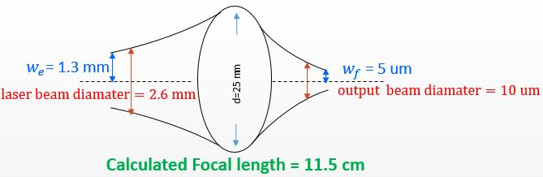

Figure 4.8 - Single lens with focal length of 11.5 cm capable of taking the laser 2.6 mm beam diameter and focus it to 10 um beam diameter. With the Assumption the Laser Beam is Gaussian.

#### 4.2.1.2 Telescoping Beam Expansion and focus lens

The telescoping beam expansion is a composite of three lenses. The first two lenses forming the telescoping beam expansion and this lens collect the collimated light and focus it at the target. To proceed determining the focal length of each lens in the system, the Gaussian Beam Expansion and the subsequent focusing lens are treated separately then combined for the entire system. [48] [49]

With the Same parameters as above, $λ = 532 nm$; $beam wait from laser, w_{e}=1.3 mm$; $output beam in glass, w_{f}=5 μm$, the calculations are proceed backwards from the focusing length, to the beam expansion respectively.

Determining the focal length we look at the depth of focus ($Δf$) equation with respect to our desired beam in the glass. With the desired beam diameter to be 10 microns a we will have a depth of focus of:

$$Δf=\frac{π}{2}{\left(\frac{2w_{f}}{λ}\right)}^{2}λ ⇒Δf=\frac{π}{2}{\left(\frac{2 \left(5×{10}^{-6}\right)}{\left(0.532×{10}^{-6}\right)}\right)}^{2}\left(0.532×{10}^{-6}\right)=295 ×{10}^{-6 }$$

This yields to have a depth of focus of 29.5 cm.

Continuously, the focal length for the subsequent focusing length we must state the magnification of beam from the collimated Gaussian beam expansion. This magnification is 4X the incoming beam radius or the laser.

$M=(4X) (1.3 mm)$ = 5.2 mm = $w_{L}$.

This is them the beam waist or beam radius entering he 31.5 mm focal length. [52]

Using that beam waist, we determine the focal length of the second length of the beam expansion telescoping system. The expression to find this focal length is as follows:

$f=\frac{w_{f}{πnw}_{L }}{λ}⇒f=\frac{(5×{10}^{-6}) (π) (1.5) (5.2×{10}^{-3})}{ (0.532×{10}^{-6})}=230nm, or 23 cm$

Thus, we will need an associating lens which will compose the telescoping system to expand the beam. Figure 4.9 and Figure 4.10 that follow now explain the relevance of the Gaussian beam expansion. [50] [51]

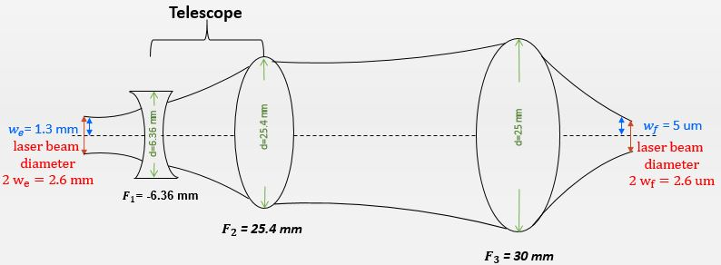

Figure 4.9 - Telescoping Gaussian Beam expansion and subsequent focusing beam. The lenses focal lengths are approximated to practical and marketable lenses from Edmund Optics.

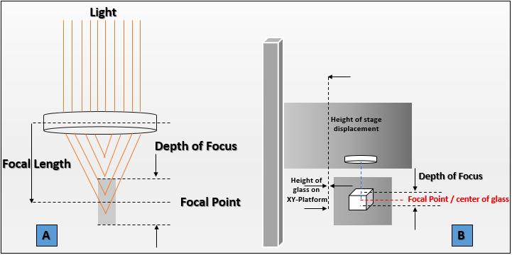

Figure 4.10 a-b - (a) Beam of light focusing through a lens, peak power of beam at focal point (b) Representation of etching schematic from focusing lens to cubic glass.

In theory determining the focal length for each lens are rough approximation for our system. Looking into the system engineering and design we look at the marketable lenses that are within the range of the specifications we are calculated. The Figure 4.9 shows the telescoping Gaussian beam expansion and the subsequent focusing lens. Also, in Figure 4.10 we are creating how the laser beam etching in the glass relationship of the depth of focus and the focal length with respect to the dimensions of the glass. Also figure shows the importance of the beam of light entered the lens, the depth of focus and the focal point at which the peak power of the laser beam to etch in the glass is which in our case is 30 mJ. Knowing the depth of focus from our beam waist in the glass also allows us to mathematically determine values for the image’s dimensions to etch in whichever the glass is. The dimensions of the glass will have an effect of the dimensions of the image to effect and how the depth of focus will change such that the focal point will be at the respective position for etching.

#### 4.2.1.3 Zemax Analysis

Using Zemax, is a software that is commonly used for optical design and analysis of imaging and illumination system, a beam expansion with a subsequent focusing lens is designed to compare the theoretical calculations and a practical system. This analysis help gained more understanding of the behavior of the system as the rays from the laser beam propagate through the lenses. This will also help gained information about the spot size of the beam before entering the glass, aberrations from the system, the lenses for the design and their respective distances.

To perform the lens system analysis, the information of each lens are inserted as seen in Table 4.1. The information is the glass type for each lens, their focal length, their radius, and at what position they are placed respective to each other. The distance of the incoming laser beam can vary but it is set in the system at 6 mm. This is possible because the laser beam would not diverge in as much before entering the first bi-concave lens. The biconcave lens and the convex lens are place two focal lengths apart. The distance between the second lens of the beam expander and the focusing lens are set to be at 30 mm apart but this distance can vary became the beam is pseudo-collimated. Figure 4.11 demonstrated the merit functions set for our system and Figure 4.12showed the spot size of the beam before hitting the glass, and Figure 4.13 show the diffraction encircled energy of our system.

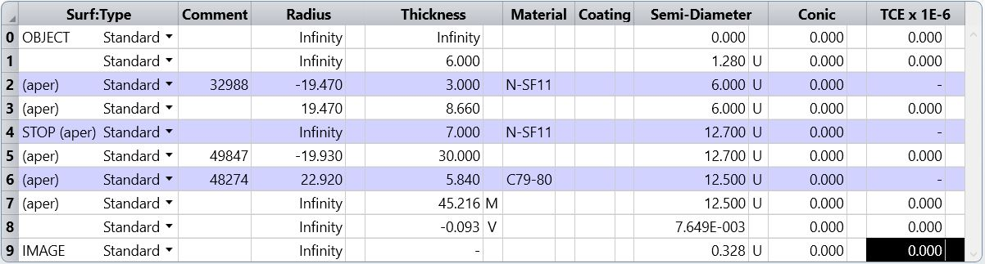

Table 4.1 - Input information for lenses and their respective distance.

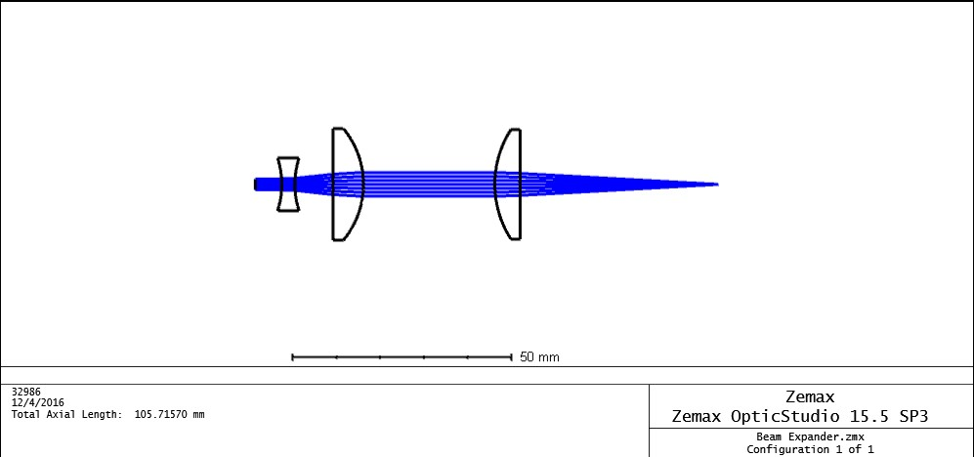

Figure 4.11 - Representation of beam Expansion and focusing lens

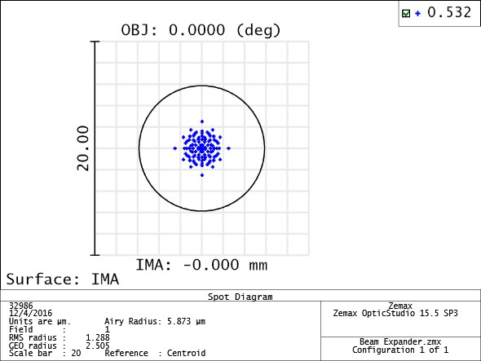

Figure 4.12 - Spot Diagram of the beam at the image plane. Airy disk radius of 5.873 um, and a beam RMS radius of 1.288 um

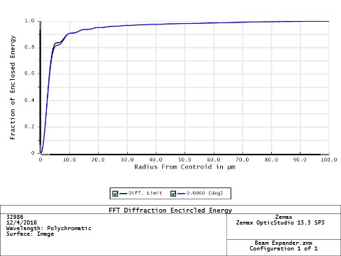

Figure 4.13 - System diffraction FFT Diffraction Encircled Energy.

The Zemax analysis showed that we can designed a system taking the incoming beam from the laser 2.6 mm diameter and we would be able to get a 3 microns size diameter beam to etch. The results of this analysis will be used to created our system and will be

implemented to respectively to meet our specifications in terms of resolutions or better.

As seen in Figure 4.14the final representation of the optical system is designed such that we have our system built around and above the XY-platform that will move the cubic glass. The system will comprise of bi-concave lens of focal length f= -12 mm and a lens diameter of d = 12 mm, a convex lens of focal length f = 25.4 mm and a diameter of d=25.4 mm to expand the laser beam and another convex lens of focal length f = 50 mm and a lens diameter d = 25 mm to focus the beam. This lens system will comprise also of mirrors to direct the laser beam path. The mirrors are coated mirrors for 532 nm wavelength and suited for high optical power system. Additionally, the system has a polarizer and multi-order quarter wave plate suited for Nd:YAG 532 nm. These two elements are used to conserve the polarization of the laser beam. The optical system is set to work collectively with the electrical and computer software such that the beam is directed to the cubic glass and the image rendered is etched. The energy of the laser will be monitored for optimal peak power at the focal point.

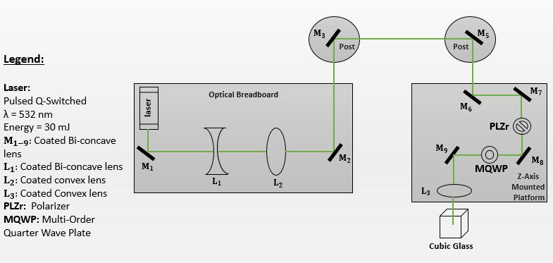

Figure 4.14 - Final Schematic representation of the optical system with its comprised elements.

## 4.3 Electrical Design - System Layouts and Schematics

## 4.3.1 Power Distribution

As noted previously, many of the electronic devices being used are far apart in terms of operating electrical characteristics. However, in general, the project will utilize a main external supply (U.S. Standard, up to 120 VAC, 60 Hz) to power its devices. The devices are split into three divisions: motor systems, low voltage devices, and laser unit. Each division will either directly reference the main external supply or require an intermediate DC source that references the main external supply.

Comprising the motor systems are Gecko G201X motor drivers and the NEMA 23 motors themselves. The laser etching system calls for 3 motors; hence, three motor drivers will be needed. Each driver will require its own DC source. A DC supply unit will be utilized to output at least 3 DC sources, one for each driver. The output of the DC unit will need to be sufficient enough in terms of voltage and current to allow the drivers to control the motors to desired performances levels during the etching process. Next, for the laser unit division, it will reference the main external supply directly. The unit is a recycled component of the laser etching system and operates on 115 VAC, 60 Hz. A direct reference to the main external supply is therefore appropriate. Finally, the low voltage devices will also require their own DC supply unit. In this division, this will be an AC adaptor that converts the external supply’s AC voltage to a predetermined DC voltage. The output voltage and output current characteristics of the adaptor shall be high enough to supply any low voltage electronics needed such as sensors and microcontroller chips. In the event a low voltage device requires less voltage than provided by the adaptor, simple voltage regulator or divider circuit will be utilized. Shown below in Figure 4.15 is the power distribution block diagram exhibiting the layout of how the three divisions of system devices will be powered.

Based on off the specifications and requirements needed to successfully run the drivers and the motors as well, option 3 that was stated above would be the best power supply for this design. This power supply produces 200 W as well as the DC Output of 24 V of 8.4 A. The power supply also serves as a switching power supply as well allowing us to operate at 191 VAC that is needed.

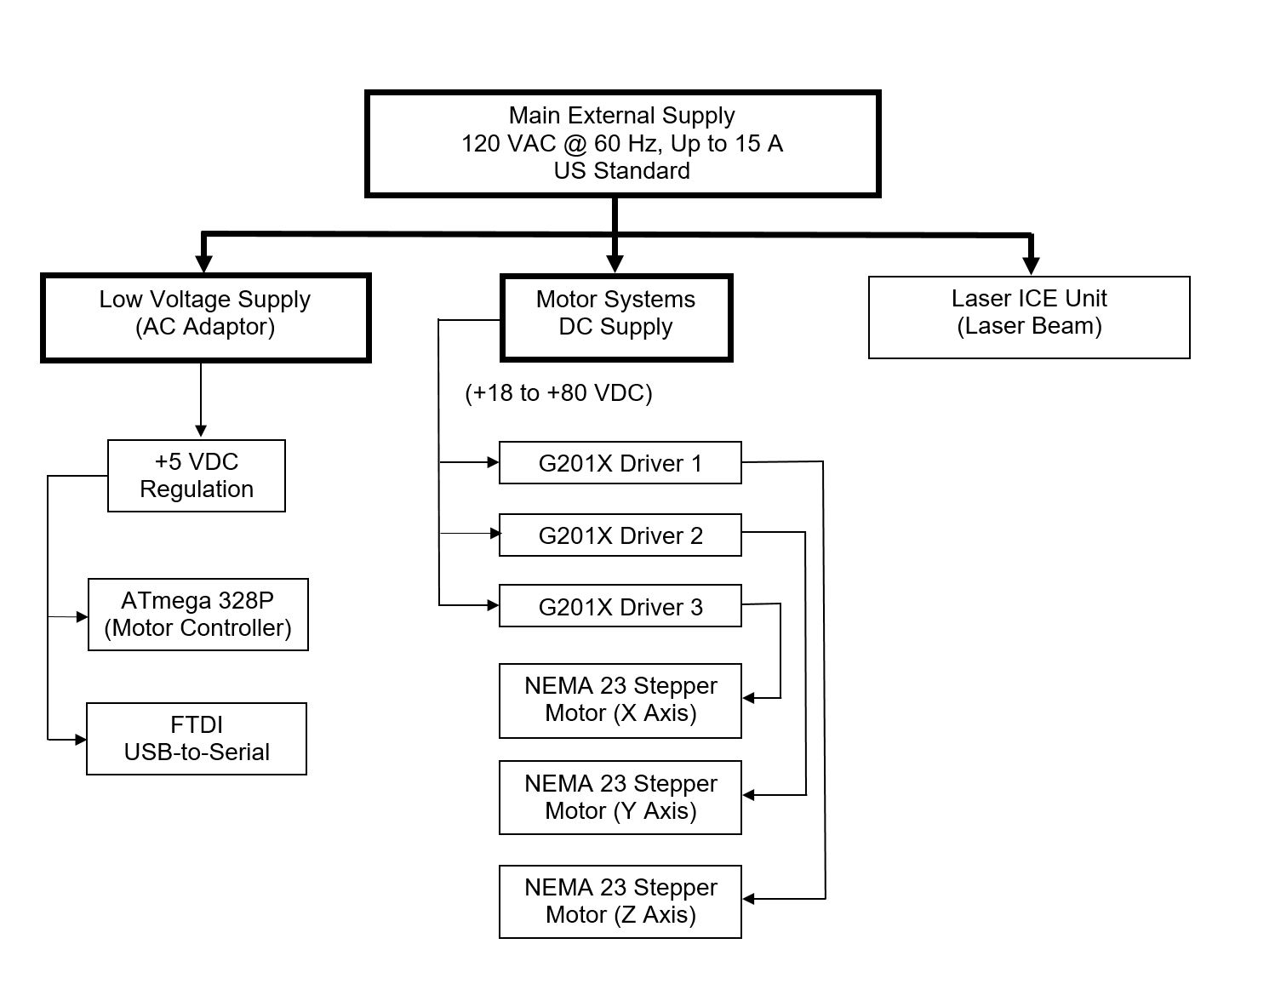

Figure 4.15 - High Level Power Distribution Block Diagram; Solid Black Lines are References to Main External Supply

In the section that follows, the schematics for the low voltage electronics are presented. The motor systems and laser unit divisions are not depicted via schematic, but a wiring connection is outlined later in the report.

#### 4.3.1.1 Voltage Regulation

The power distribution block diagram shows the overview of how the three divisions of devices will be powered. In the leftmost division, the ATmega 328P and the FTDI converter both operate at 5 VDC. The power distribution schematic that depicts their regulated power circuitry is shown below in Figure 4.16.

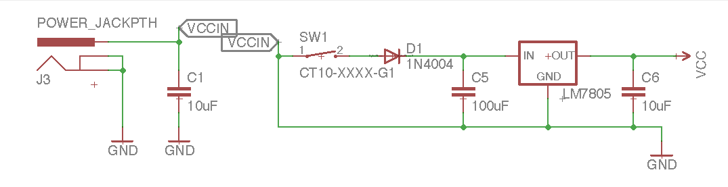

Figure 4.16 - Low Voltage Power Schematic, Supplying +5 VDC Regulated

As seen in Figure 4.16, the *POWER_JACKPTH* label indicates the incoming +12 VDC from the AC wall adaptor. A 10 uF bypass capacitor, labeled C1, is used to short any high frequency noise present at the adaptor’s output. The same concept is utilized with bypass capacitor C5 of 100uF and C6 of 10uF, at the input and output, respectively, of the LM7805 standard regulator. As you can see, the switch SW1 is mechanical. Its purpose to disconnect power to the ATmega328P and FTDI converter when needed, but including such a switch creates mechanical noise. The C5 capacitor will eliminate this noise. The C6 capacitor will eliminate any noise at the regulator’s output. Overall, maintaining the steady DC nature of the power for the sensitive low voltage devices is critical to avoid damaging them. If needed, we can increase the capacitance to control the voltage that is being outputted.

A diode, labeled D1 in Figure 4.16, is included as added protection against reverse polarity. In the event negative voltage is applied at *VCCIN* the diode will open the circuit, disallowing the negative voltage to enter into the regulator circuit. While forward biased (positive voltages applied), the diode causes an approximate 1 V drop. For example, if 12 volts is present at *VCCIN*, the voltage across capacitor C5 will be ~11 volts. This diode’s effect on voltage is negligible considering that the LM7805 regulator has a 2 V dropout. Based on the schematic design, the relation between *VCCIN* and *VCC* for proper regulation is as follows:

*(VCCIN - 1 V) $≥$ (VCC + Dropout Voltage)*

*(VCCIN - 1 V) $≥$ (VCC + 2 V)*

*(VCCIN - 1 V) $≥$ (5 V + 2 V)*

*VCCIN $≥$ 8 V*

It is also important to note that the LM7805 regulator is capable of sourcing 1.5 A of current. The ATmega 328P, powered at 5 VDC and operating at 8 MHz, consumes up to 9 mA of current. The FTDI converter, also operating at 5 VDC, is expected to consume little to no current. To calculate the power wasted by LM7805 regulator is as follows:

(Input Voltage - Output Voltage)*Load Current = Power Wasted

*~(9ma)*(11 V - 5 V) = .054 W = 54 mW*

Per prior research, when 0.5 W of power is wasted, then the heat levels become a concern. In this case, 54 mW is less than 0.5 W. Therefore, heat levels will not become a concern. Ultimately, the regulator is capable of sourcing enough current and while providing 5 VDC to ATmega 328P and FTDI converter without the need for heat sinking.

### 4.3.2 Motors, Drivers, and Laser Unit

The remaining two divisions (motor systems and laser unit) are external relative to the PCB design. In the middle division shown in Figure 4.15, the X, Y, and Z NEMA 23 stepper motors provide the mechanical strength to move the etching glass platform and the laser beam in a 3-D fashion. Their power is sourced from the G201X Gecko motor drivers. Each G201X driver can supply up to 7 A of current for each motor. However, each NEMA 23 motor is bipolar, drawing 1.8 A/phase. Despite, supplying sufficient motor current, each driver still needs a supply of 67% of the motor’s rated phase current. The calculation for required supply current is as follows:

*G201X Supply Current = 0.67*(Motor Rated Phase Current)*

*G201X Supply Current = 0.67*1.8 A*

*G201X Supply Current = 1.2 A*

Therefore, each G201X motor driver will require 1.2 A of current when driving their respective motor. This translates to the DC supply unit source +18 to +80 VDC with at least 1.2 A of current to power the drivers. In practice, powering the drivers and motors is based upon direct connection. The steps for proper power connection are provided later in the electronic prototype construction procedures of the report.

Finally, in the rightmost division of the Figure 4.15 is the laser unit itself. This unit outputs the laser beam that performs the etching inside of the crystal glass. It is built by its manufacturer to source power through a direct connection to the US standard wall outlet AC supply. This steps for proper connection will be provided later in the electronic prototype construction procedures of the report.

### 4.3.3 Communication and Control

It is decided that the ATmega 328P microcontroller will be used to take, as inputs, streamed G-code instructions and interpret the instructions. Based on the interpretation, the microcontroller will know how to control the motors, providing the proper 3-D movements to etch the user’s desired 3-D image. Overall, the software needs to have a hardware medium to travel across to network with the system. Such a path is shown below in Figure 4.17, depicting the hardware setup from the user computer to the ATmega 328P, and finally, to the motor systems.

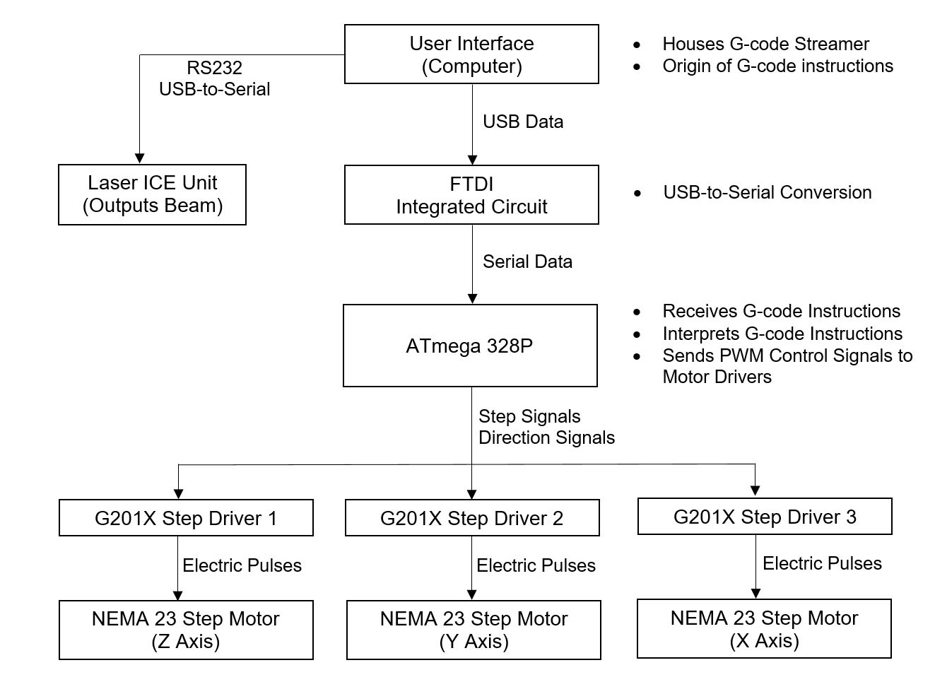

Figure 4.17 - High Level Communications Block Diagram

As shown above in Figure 4.17, the user computer is the source of the G-code instructions. The instructions are streamed in USB format to an FTDI integrated Circuit (IC). This IC is key in being able to communicate with the microcontroller. After reaching the FTDI, the streamed data is converted into serial format, a format in which the microcontroller can read and interpret. An additional benefit is that it may be used to reprogram the microcontroller’s flash memory during the development of the G-code interpreter. In the event the G-code interpreter needs to be updated, it can be uploaded again to the microcontroller. Shown below in Figure 4.18 is the schematic for FTDI usb-to-serial communication between the user computer and the ATmega 328P.

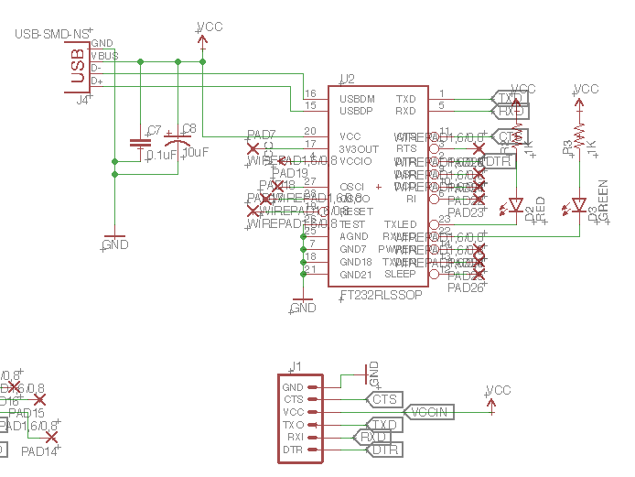

Figure 4.18 - FTDI Communication Schematic between User Computer and ATmega 328P; Unused Pins Labeled by Red X.

Shown in the top right portion of Figure 4.18 above, USB connections are utilized. A usb-to-micro usb cable will be used to connect from the user computer’s USB port to the micro-usb input of the FTDI device. The FTDI pins (on the right side) that are used include: TXO, RXI, DTR, VCC (+5 V), and GND. These 5 pins are also labeled on the header located at the bottom portion of Figure 4.18. When testing the final system in Senior Design II, after it is built, using a header will allow for rewiring the FTDI’s connection to the microcontroller. This adds the benefit of not having to remanufacture the PCB in case the wrong connection is made between the microcontroller and the FTDI converter.

Assuming proper FTDI and microcontroller connections, G-code can then be streamed. After receipt and interpretation of the G-code data, the microcontroller sends the appropriate PWM signals (step and direction) to each of the three motor drivers. These signals are geared towards controlling the motors as needed to achieve the desired 3-D movements. Shown below in Figure 4.19 is the schematic of how the ATMgea 328P will be used.

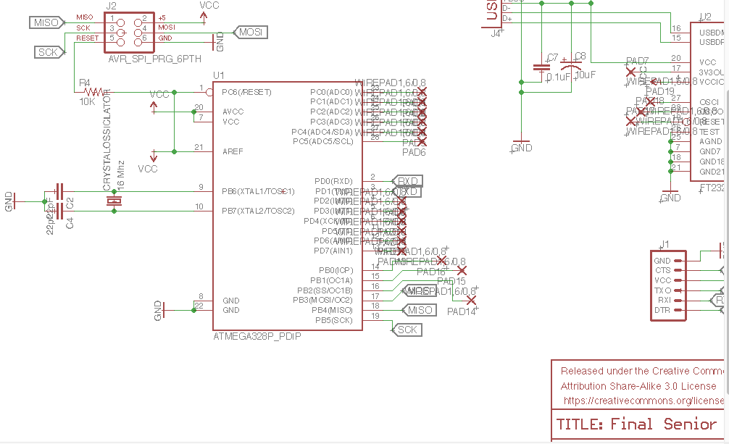

Figure 4.19 - Schematic for ATmega 328P Connections; Unused Pins Labeled by Red X

The ATmega 328P operates between 1.8 - 5.5 VDC. Every *VCC* label shown in the schematic serves as the desired +5 VDC output of the LM7805 regulator shown previously in Figure 4.16. A 16 MH crystal is included at pins 9 and 10 to provide an accurate clock source reference. Capacitors for the crystal are also included to produce a pure clocking signal for the microcontroller. Communication between the ATmega 328P, the motor drivers, and user computer occurs at its pins on the right side. There exists 6 PWM pins (5, 11, 12, 15, 16, 17), two for each G201X driver’s step and direction signals.

Each motor driver is built with its own ICs that use the step and direction signals to activate the appropriate electric pulses at the coils of each stepper motor. The combination of electric coils cause rotation at the motor’s rotors, leading to the physical movements of the XY platform and the laser’s focal point (on Z axis).

### 4.3.4 Final Electrical Design

Each of the schematics previously presented depict individual workings on the circuitry needed to power and communicate the various devices comprising the low voltage electronics. The overarching schematic (Figure 4.20) for the entire system is as follows:

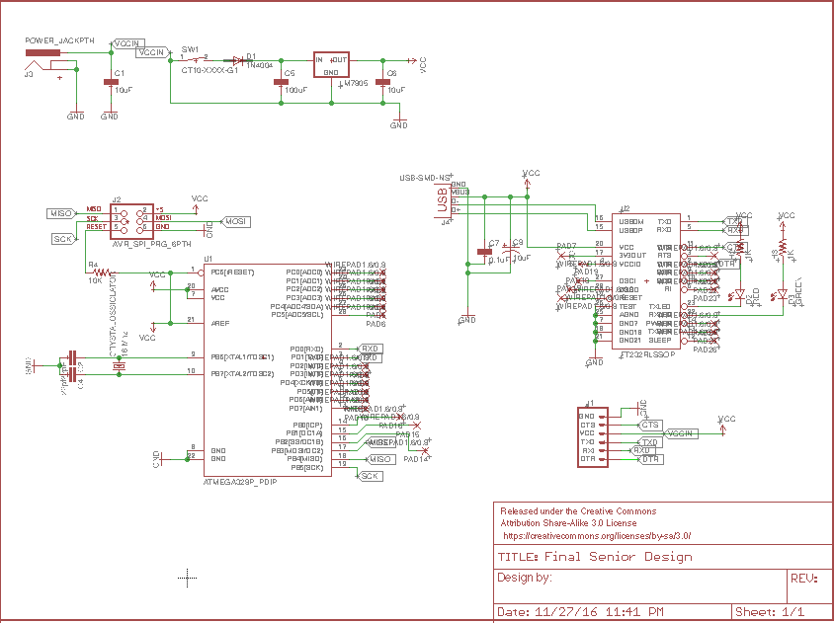

Figure 4.20 - Final Schematic for Low Voltage Electronics

This schematic will be used to generate the necessary files for sending to the PCB vendor for manufacturing. After receiving the final PCB in hand, all components will be available as through-hole to make soldering them onto the board an easy task. Figure 4.21 below shows depicts all of the main components that comprise the final system.

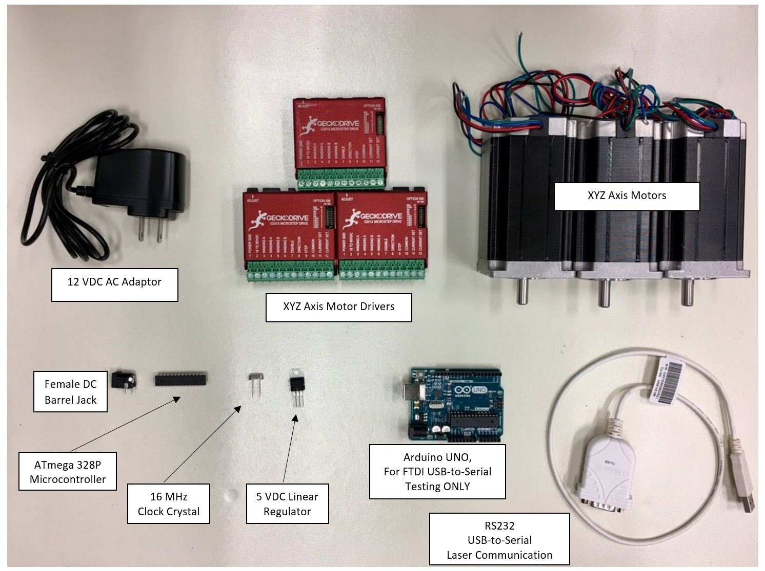

Figure 4.21 - Electronic components comprising the final system.

Figure 4.21 above shows all of the components needed to prototype and design the final laser etching system electronics. In practice, all components will require external components (resistors, capacitors, LEDS, diodes, etc) as needed to fully realize the final schematic shown previously in Figure 4.20. It is important to note that the Arduino UNO included is for testing purposes only. It is a temporary alternative for the FTDI USB-to-serial conversion link between the ATmega 328P and the user computer. It will not be a part of the final laser etching system.

## 4.4 Mechanical Design - XYZ Platform Selection

A successful output of an accurate 3-D image is heavily dependent on the 3-D movements capabilities of the motors and mechanical platforms of the system. As the motors provide sufficient torque, the mechanical structure should physically withstand the static and moving loads. Previous research provided two options of directional platforms: Velmex MN10 Model previously shown in Figure 3.27; InteLiDrives model shown previously in Figure 3.28. It has been decided to utilize the Velmex MN10 models based on two aspects: travel distance and load capacity. The project’s demands based on the following aspects:

* Load capacity: 20 lbs.
* Up to 8 in. of travel in each of the X and Y directions
* Maximum surface area: 2 feet by 2 feet

The load capacity and travel distance requirements allow the user the option for etching into larger sized glasses in the future. Either platform satisfies the two requirements, but the deciding factor is adaptability for the Z axis. The Velmex platform, like that shown previously in Figure 3.26, is available as a standalone product or it can be attached to a similar platform to create bi-directional capability. As a standalone product, it will be used as the Z- axis platform. The InteLiDrives brand is only available in a bi-directional configuration. Hence, the need for a Z-axis platform will not be satisfied without searching for an additional component. The Velmex brand is also important for meeting the constraint of 2 feet by 2 feet in surface area when mounted on the optical breadboard.

After constructing the XY platform, it will be equipped with an adaptor plate such as that shown below in Figure 4.22. The etching glass will sit on top of the plate during the etching process. The plate’s dimensions, depicted in Figure 4.23, comply with the desired travel distance of 8 inches and is large enough to hold the standard size (2.75 inches by 2.75 inches) glass being used for future demonstration purposes.

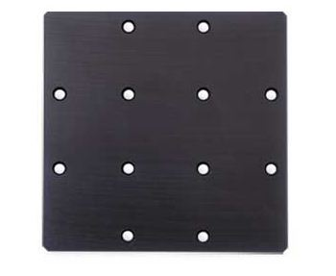

Figure 4.22 - Velmex MSPP-2 Adaptor Plate in which the etching glass will be mounted on top of (Permission Requested from Velmex)

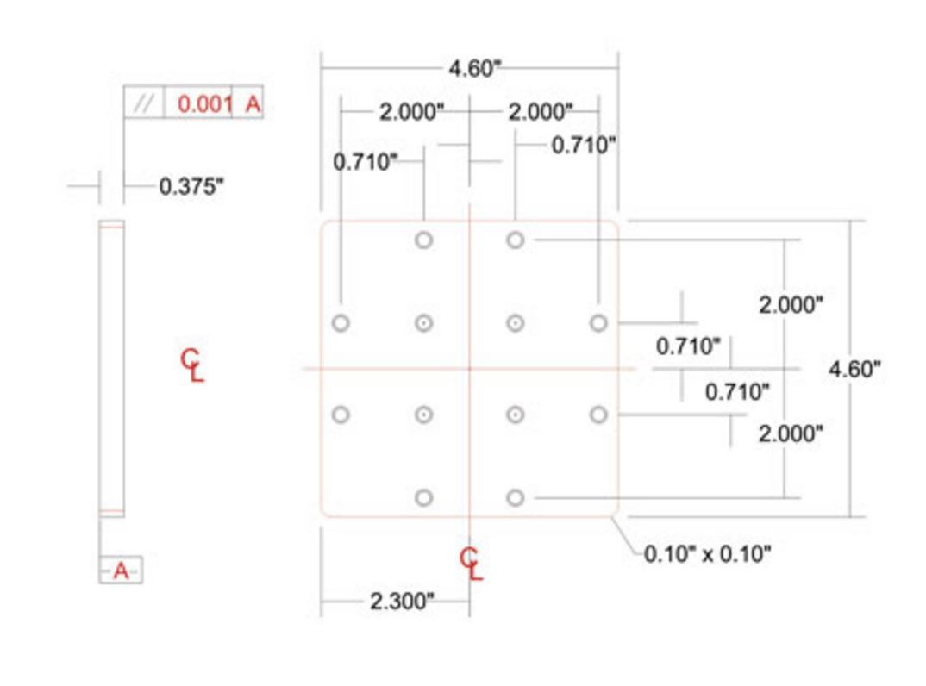

Figure 4.23 - Dimensions of Velmex MSPP-2 Adaptor Plate (Permission Requested from Velmex)

Overall, the final structure will look similar to the bi-directional configuration shown previously in Figure 3.28 for the InteLiDrives brand of platforms. The materials to construct the XY and Z platforms will be purchased accordingly to meet the desired physical demands of the system.

The XY-platform is set to have the cubic glass fixed and to be etched. The motors for the XY-axis will move the platform which the glass is set upon. To make sure the glass remains stationary two 90-degrees corner mount will be designed to stabilize the glass. As seen in the Figure 4.24the cubic glass while etching will be stable.

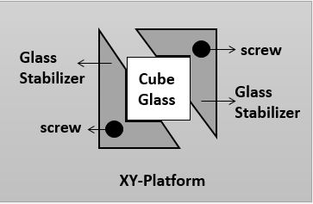

Figure 4.24 - XY-Platform concept of cubic glass stabilization.

# **5.0 Prototype Construction and Coding**

# 5.1 Final Software Plan

# 5.1.1 Coding Plan

In order for efficient and effective development of the software design, a final coding plan was created. This plan outlines the approach in which the programming itself will occur, along with all the planning stages, programming, and debug processes. The goal of this plan is to successfully and efficiently create a fully operational software application that meets all the requirements by the time that the prototype is to be presented to the professors, faculty, and most importantly the sponsor.

The first phase in the coding plan is to have a general layout of how the main software application will actually work in terms of code. This is the software application that will be running on the computer and is written in Python. This is a general overview of how the structure and layout of the GUI affects other functions of the code. For example, we know that the GUI will have action buttons that execute functions, such as input of a file will call a function that checks for the validity of the file and whether it is 2-dimensional or 3-dimensional. Another example is how a GUI button such as a conversion launch button will call the main function for doing the 2-dimensional to 3-dimensional conversion process.

Once the general layout of the code is created, then a more detailed plan of each part can be created. The development of the actual code will start at the very beginning of the software flow, so the graphical user interface and user input. This stage of the code will incorporate careful planning of the required user inputs, required outputs such as licensing and user information, and any additional information that would be desired. Once the general layout of the GUI is created, then the coding of the widgets can begin. The shells of the functions called by the widgets can be created to further ease the actual programming stage of the software.

After the general code for the GUI is created, then all that is left is to create the functions that the widgets in the GUI will be calling. These functions, such as 2D to 3D conversion and laser engraving beginning can each be written on their own. The plan is to start from the beginning, so the conversion and file checking process, to the G-code slicer, until the end of the main software application is reached, which is the G-code streaming function.

After the main software application is finished and tested, then the focus can be switched to the microcontroller and the firmware. This step is critical to the design due to this being the actual laser engraving process steps. The first step in this part of the plan is to ensure that the firmware is running correctly on the microcontroller. Sample code and G-code will be streamed to the microcontroller to ensure that the electronics, or motors, are hooked up correctly. This will also ensure that the firmware is correctly interpreting the G-code that is being streamed, as well as the motors moving correctly corresponding the G-code command.

Once the firmware is verified to be working correctly on the microcontroller, then the calibration process can begin. The firmware configurations will be changed to match the functionality of the motors. Along with the configuration changes, there could be possible source code changes to the interpreter. The configurations will allow for the motors to move at the correct speeds and movements in order for the laser to be correctly calibrated as well.

Finally, the last step of the coding plan is to ensure that everything is working together. The plans, which are outlined in the testing procedures section of this report, will be carried out. The software application will be properly bug tested for any possible errors. The etching process will be completely tested to ensure that the microcontroller and the firmware are operating correctly.

The following figure outlines the responsibilities for each stage of the software design which is an essential part of the coding plan:

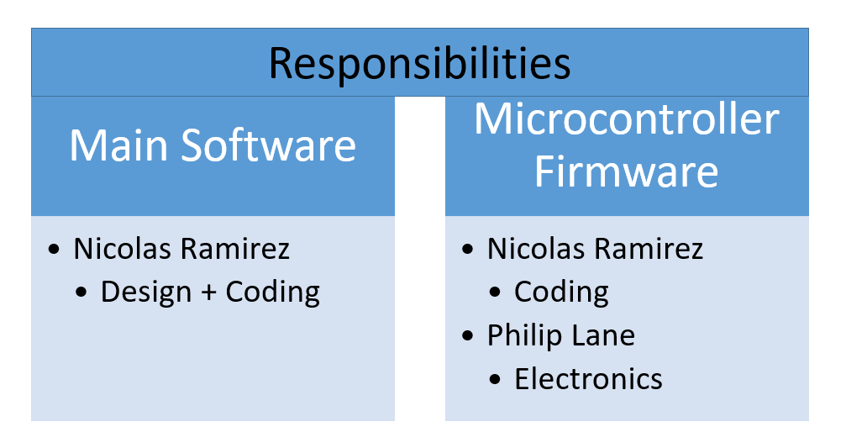

Figure 5.1 - Code Responsibilities (Coding Plan)

### 5.1.2 Source Control

An important part of developing code is to have an efficient way to keep track of different versions of the software created, otherwise known as source control. Source or version control allows for changes to be made to the code without worrying about making changes that are impossible to reverse. For example, if a change is made that introduces a bug, but the bug is not able to bed fixed, the software can be reverted to a revision without the change. Therefore, allowing for peace of mind in developing the software. The plan for source control is to use Git as source control and GitHub as the storage.

Git is a version control system that is free and open source licensed under the GNU GPLv2. It is an extremely popular version control system that is used many software development projects both in the industry and regular people alike. GitHub is an online project host that uses Git as its source control program. GitHub comes in both free and paid versions, the only difference is that the free version is open to the public while the paid versions offer private repositories. Many different companies use GitHub as the host for their software, especially if the software is open source. [35]

Since our software is not being made for profit, we are able to make use of many different open source software programs. Some of these programs have licenses that allow for free use, but have limits such as making sure that the programs that utilize the open source program are open source themselves. For this reason, we are hosting our software code and development on GitHub in a public repository for anyone to see, suggest modifications, or even fork projects from it. The source code will be available for all to see within this public repository. [36]

These are some of the licenses that some of the code will be using in our program:

* Apache License 2.0
* GNU GPL (General Public License)
* GNU LGPL (Lesser General Public License)
* MIT License

Having the software on GitHub also allows for keeping track of any changes that are made to the code. It can be used to make sure that enough progress is being made in the development process of the software design.

### 5.1.3 Choice IDE

There are actually going to be two integrated development environments (IDE) being used in this project. IDEs are development environments that allow for much faster, easier, and efficient code development by providing a wide range of tools. The most common are error detection and code completion. This allows for the programmer to not have to worry as much about the syntax of the code, but instead focus on how the code actually works and on code development.

These are the two IDEs to be used during the development of the software:

* PyCharm
* Arduino Software

The first, which is the main IDE, is PyCharm. PyCharm is a Python specific IDE that comes with a great deal of features. Some of them include code completion and suggestion, PEP8 analyzer, error detection, code navigation, refactoring, and built in version control systems. PyCharm has several built in version control systems and it includes what we will be using as a version control system. It also supports uploading directly to GitHub repository using Git. Another one of PyCharm’s great features is the debugging and testing tools. These tools can be used to efficiently and safely develop and test any code written within the IDE. PyCharm also comes with a customizable user interface and a great amount of plugins. The majority of the software will be written in PyCharm as the majority of the code uses Python as the main programming languages

The second IDE used in this project is the Arduino Software IDE. This IDE is going to be used because the microcontroller to be used is an Arduino based microcontroller. The Arduino Software IDE comes with all the necessary libraries for us to be able to compile and upload code to the microcontroller itself. It also has enough resources for the code to be developed within its environment. Therefore, the Arduino Software IDE will be used as the main IDE for the microcontroller’s firmware development.

## 5.2 Optical System Assembly

The optical part of the system is the entity which will serve as a pathway to the laser such that it will reach the material to interact with. Following the design schematic, each element will be mounted on the optical breadboard with the support of optical posts. The distance and angle between each element will be critically important such that the laser beam propagating does not diffract yielding to losing its properties. The optical system will be assembled around and above the XY-mechanical stages on the optical breadboard and on a platform controlled by the z-axis motor for depth and the image level focusing in the glass. In collaboration with the software commands, the electrical circuitry will move the motors with respect to the damage sites in the glass. The laser beam will be moved only in the z-direction, where the glass to be etched will move in the xy-direction respectively to the fixed axis where the laser is pulsing. The telescoping lens system is to decrease the size of the laser beam to 10 microns. The speed of the motors and displacement will respectively match the spacing between the pixels of the damage sites per number of pulse in time. Mirrors, a polarizer, and a multi-order quarter waveplate will be in place accompanying the telescoping lens system to control angles, and maintaining the light beam polarization from the laser. The optical system assembly is designed such that minimum elements are needed in the system which will give us a degree of freedom to minimize the size of our system. Also, the safety shielding will be built around it for safety and the risk of moving any of the optical elements in the system.

## 5.3 Electronics Construction

## 5.3.1 Power and Communication Connections

Making the connection from power sources to the devices being powered is critical to protecting sensitive electronics. The main external supply voltage will first be connected to each power supply unit for the low voltage electronics and the DC supply unit for the motor system. The laser unit employs direct connection to the main supply.

Recall that the electronics are divided into three divisions. The first division, low voltage devices, includes two devices that operate on 5 VDC. They are the ATmega 328P and FTDI USB-to-serial converter. It is critical that a steady 5 VDC is supplied at the inputs of this division. Devices such as the ATmega 328P microcontroller is sensitive and can be damaged in the presence of noise. Simple steps to properly connect and power the devices and circuits are as follows (in order):

1. Setup Wire Connections
   1. Per Figure 4.20, connect all external circuit components (crystal, resistors, diodes, capacitors, LEDs, Regulator) to their respective devices FTDI IC and ATmega 328P).
2. Setup Power Connections
   1. Connect the DC barrel jack to the circuit.
   2. Ensure the barrel jack’s positive “tip” pin is connected to the circuit’s positive voltage input.
   3. Ground all other barrel jack.
   4. Lastly, connect AC adaptor to wall outlet and insert its jack into the barrel opening.
   5. Connect the appropriate capacitors, diodes, and switches between the output of the barrel jack and the input of the LM7805 voltage regulator. Ensure an appropriate bypass capacitor is existent at the regulator’s output as well.

The second division of electronics includes NEMA 23 motors and their respective Gecko drivers. The steps, in order, for proper connection are as follows:

1. Connecting each NEMA 23 motor to a G201X driver
   1. Isolate the two wires that correspond to one phase of the motor.
   2. Connect these pair of wires to phase A of the driver; one wire for each phase A terminal.
   3. Repeat parts a and b for the remaining two motors and their drivers.
2. Connecting power to G201X drivers
   1. Connect positive terminal of power supply to positive terminal of driver.
   2. Connect the power supply’s NEGATIVE DC terminal to G201X driver GND.
   3. Repeat parts a and b for the remaining two motors and their drivers.

It is important to note that all power supply connections for each division of electronics need to have proper voltage outputs. If the voltage applied to any device is too high, the device may become damaged. For the laser unit, it can be assumed that it will have proper power connections as it connects directly to the main external supply. Verification of voltage levels for all other devices is discussed in section 6.3.2.2 Prototype Test Procedures later. Some test data is also provided.

5.3.2 PCB Vendor and Assembly

In Figure 5.2 is the final design of the of the PCB which was made in Eagle Cad the Fabrications parameters are listed below:

|  |  |
| --- | --- |
| Number of Layers | 2 |
| Board Width ( X dimensions ) | 3.937008 inches |
| Board length (Y dimensions ) | 3.1496060 inches |
| Board thickness | 0.061811 inches |
| Number of SMD Pads on top | 45 |

For the Assembly Parameters are listed:

|  |  |
| --- | --- |
| Number of Different PACKAGES | 15 |
| Number of through hole package | 32 |
| Number of other SMDs | 5 |

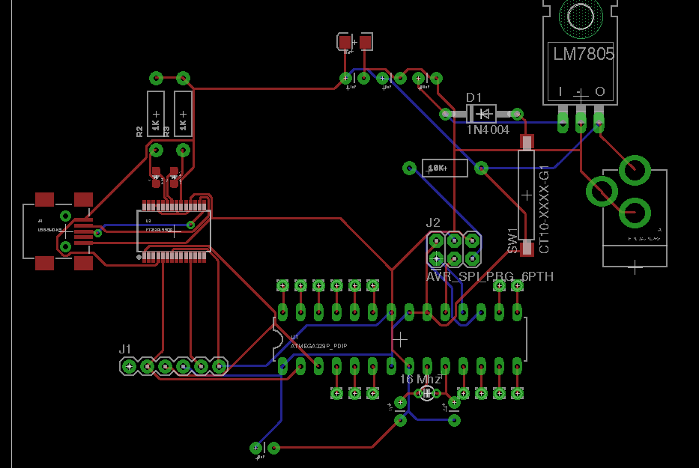

Figure 5.2 - Final PCB layout

Based off of our parameters for our PCB design in Figure 5.2 there are a couple of Vendors that we have found that would be capable of creating our PCB. Elecrow as well as PCBWay offers multiple packaging sizes of the amount of PCB we can produce through them depending on the layer size:

Option 1: Elecrow

## 

Option 2: PCBWay

## 

With both of these options both complete the task that is needed. The final decision is which company would get us our products sooner than later. Which based off of the results of its PCBWay would do that of shipping and handling is said to be 2-3 business days.

## 5.4 Final Mechanical Plan - XYZ Platform Structure

The mechanical components include mounting the XY and Z BiSlide platforms to the optical breadboard. For the XY platforms, an adaptor plate will be mounted on top where the etching glass will sit. The Z axis BiSlide platform will be equipped with a motor mount that holds the NEMA 23 stepper motor for that axis. All of these parts will be mounted using screws. The XY platform will not have any physical connection to the Z axis platform.

**6.0 Prototype Test Procedures**

6.1 Optical Specific Testing

For the system to work successfully, the optical system must work respectively to receive the commands from the software such that the laser beam could etch in the transparent glass. Just as every member in the complete system, the optical system must meet the set the requirements and safety standards. Below are the produces that will be taken in order to make sure that the in collaboration of the other system such that the complete project operate successfully overall.

### 6.1.1 Laser Operation

The operation of the laser at the great condition is extremely critical to the system. Although every other major component may work as they should, the laser is what does the work. Thus, these are the procedural steps that will be taken such that we know the laser is ready to perform its task.

1. Make sure Cooling System has water in the tank
2. Make sure the electrical power cable is connected
3. Make sure the cables connecting the laser and the cooling system are in the right configuration
4. Put on Safety Goggles
5. Turn on Key-Switch on the Laser Cooling System
6. Press Q-Switch
7. Press Turn-on Laser
8. Adjust the Energy level and Repetition Rate
9. Make sure the head of the laser is not covered
10. Use IR Card to track the Path of the beam through each optical element up to the etch station.
11. Assist with the RS-232 connection for software commands

### 6.1.2 Optical System Alignment

The alignment of the other optical elements is as crucial as the operating condition of the laser. The distances, angles, and cleanness of each element make the laser beam as able to etch into the crystal at the set focal point. To accurately align the optical system, we must consider each element respectively as the beam propagate through the system, from the laser to the etching section. Using techniques learned from the geometric optical laboratory, the manipulation of the mirrors mounts will proceed such that the laser beam is focused and not diverged from the optical path. This process is the most tedious while assembling and building the optical system for as the beam is propagating, it can easily diverge from the optical path as it is interacting with each optical element. It will be critical to make sure the beam size is not diffracting and not losing its power.

6.2 Software Specific Testing

6.2.1 Testing Environment

At the end phase of software development is the complete testing of the entire process. Although each part of the software is carefully tested during design, many bugs often come up when all the parts of the software come together. In order to detect, identify, and eliminate these bugs, a proper testing environment is needed. The testing environment described in this section allows these steps to proceed smoothly and efficiently. More importantly, the testing environment allows for an even better final product and revision of the software.

The first part of a good testing environment is to make sure that no background processes are running that could potentially interfere with the software application. This includes internet browsers and any other type of program other than strictly necessary programs. It is also good practice to disable any antivirus that could potentially flag the software as a false positive and prevent it from functioning. The software could be placed into the exempt or trusted programs of the antivirus, depending on how the antivirus itself works, but it can often not be enough to allow for smooth and uninterrupted functioning of the software application. Therefore, to be on the safer side, the antivirus program of the computer will be disabled when running.

Another important part of the testing environment is to make sure that the computer and operating system environment that the software is running on is stable enough to provide good service to the software application. For example, the computer needs to be fast enough and have enough memory to support the software. It also must be stable enough to make sure that any problems encountered through the software is not hardware related in terms of the computer itself. The RS232 interface will be using USB to connect to the host computer. In order for that connection and communication to be reliable enough for testing, the computer’s USB controller and physical connection must be flawless. This also goes for the operating system’s drivers to be stable enough so that no crashing or weird interactions occur during the software testing.

In order to properly test the microcontroller and the firmware running on the microcontroller, there are several factors that must be ensured to be working. Firstly, the entire system needs to be working as expected. The motors must be connected properly and must respond to any output from the microcontroller. Also, the laser system itself must be properly calibrated in order for the etching to occur on the glass, as that is the main way to ensure that the motors are moving correctly, and therefore the G-code is being interpreted properly by the firmware. The platform and staging must also be properly mounted and must be able to fit the glass without problems. Lastly, the microcontroller itself must be stable enough to run the firmware without any anomalies. This can be tested by running different test programs to ensure that the motors are properly moving.

If all of these environment requirements are met, then sufficient testing of the software will be able to be achieved. The results from the software testing will indicate whether or not any changes are required to the base code of the software. Overall, the software testing environment can be summarized as being stable enough to allow for sufficient debug of the software application without the potential interference of problems created by external sources.

### 6.2.2 3D Conversion: 2D to 3D

In order to properly test the 2-dimensional image to 3-dimensional object conversion, many different test cases will be used. Each test case includes a different type of image or text that is used to test different capabilities of the conversion process. Different contrasts, brightness, and shades of pictures or images are planned to be converted using the software. Along with that, different dimensions of the images to make sure that the conversion process resizes the image to a smaller size to be etched will be used. Lastly, different resolutions of the images will be used in order to measure the accuracy that the software is capable of converting.

The first set of testing involves the conversion process of text to 3-dimensional object. This set of testing involves inputting random sequences of words and seeing if the software does what is expected. In this case, the software is expected to firstly convert the text to a PNG image, then continue the process of creating and tracing a bitmap, and finally converting to a 3D STL file after extruding the image. This testing will also verify that any limits put on the length of the word or words input is enough to create a good enough 3D object that is suitable for etching.

The next set of testing involves using different images that have varying qualities. Firstly, images using different types of contrasts will be used. For example, an image with a dark background and semi-distinguishable foreground such as the following image will be used.

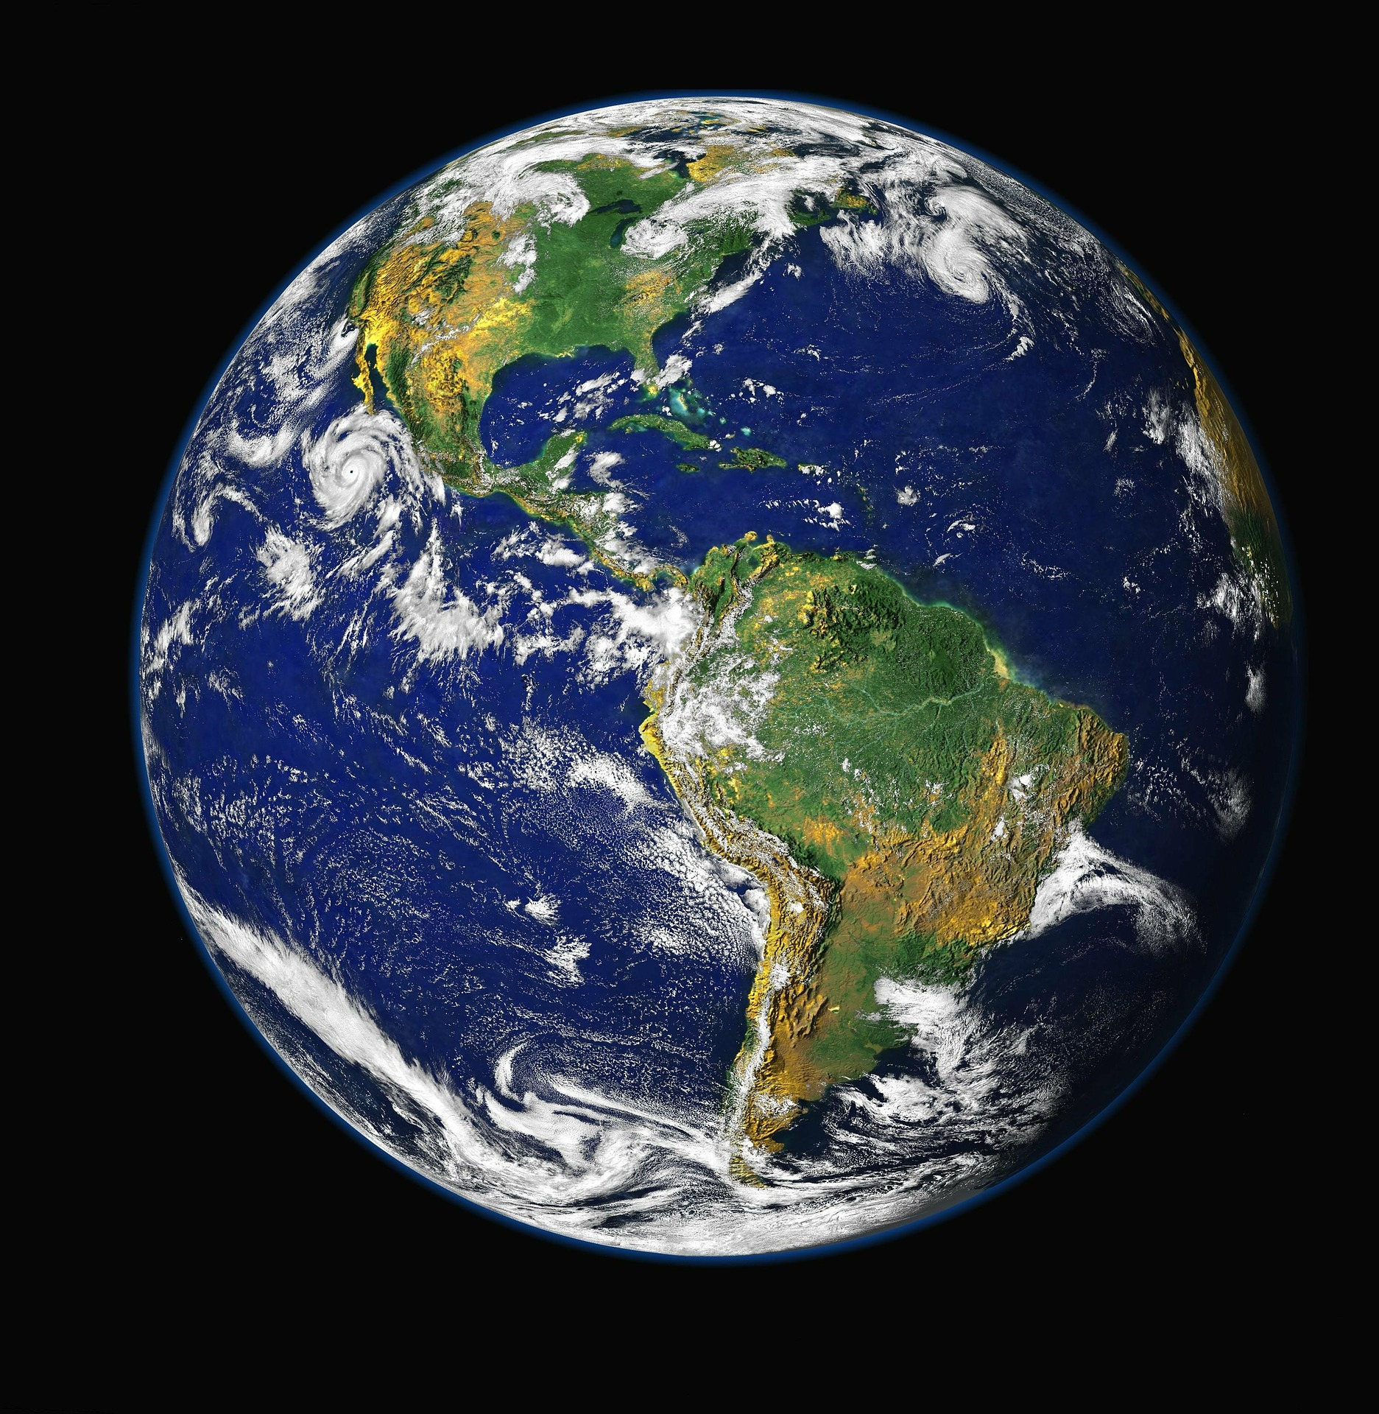

Figure 6.1 - Dark Background Test Image*

Another example is the opposite, a bright a colorful image like the following. This should be the worst at 2D to 3D conversion:



Figure 6.2 - Bright and Colorful Test Image*

Another image that will be used for 2D to 3D conversion testing is a black and white image similar to the following, which is the ideal image for the best 2D to 3D conversion:



Figure 6.3 - Black and White Test Image*

In order to test resizing, dimensions, and resolution of images, these images can be reused and changed to fit the different requirements. In order to fit all the base cases, the images will be made low resolution, medium, and high resolution. Along with those requirements the images will also be made to be small dimensions, medium dimensions, and large dimensions.

Since the 2D to 3D conversion process is not time consuming, more images other than the ones shown can and will be used to completely test out the capabilities of the software’s 2D to 3D conversion.

*\*All images used are free of copyrights under Creative Commons CC0.*

### 6.2.3 RS232 Interface Testing

The RS232 interface is the main external communication point of the laser system being used. Although this interface is old and outdated, it still follows standards of serial communications being used today. Today’s USB serial communications interface can be used to communicate with the RS232 interface. For our project, we are using a USB to RS232 interface adapter that will connect the RS232 interface from the laser to the host computer’s USB.

In order to test the connection between the laser and the computer, a Python script using the PySerial module will be created. This script will contain all settings for the serial communications so that the computer can communicate with the RS232 interface. Settings such as the baud rate will be configured correctly within the script. The script will contain commands such as sending certain information through the serial communications. This information will be based on what the laser manual instructs for each command on the laser. For example, a certain string of characters or bytes will be what controls the laser’s on and off capabilities. Other commands such as energy levels and offset will be tested to ensure that the communications work.

If the laser responds to the information sent using the Python script and through the USB to RS232 interface converter, then the interface can be confirmed to be working properly. Many of the commands and settings for the communications will follow the instruction manual provided by the laser system.

After the interface is confirmed to be working using the standalone Python script, the script’s contents and functionalities will be added to the main software program. In the main software, the laser will be turned on when the etching process is initiated and subsequently turned off when the laser etching process completes. Therefore, in order to test the complete functionality of the RS232 interface communications, several test runs will be carried out with different scenarios. The following are some of the scenarios where the RS232 interface will be tested:

* Laser on, etching process successfully ends, Laser off
* Laser on, etching process abruptly ends, Laser off
* Laser on, etching process times out, Laser off
* Laser on, etching process terminated manually, Laser off

In order for the RS232 interface to be confirmed to be working correctly, it must pass the previous test scenarios.

### 6.2.4 STL to G-Code Conversion

One of the most important processes in the laser engraving system is the conversion of the 3D STL file to G-code. The 3D STL file represents the 3D object that is to be etched into the glass. The G-code is the commands for the motors to move and outline the 3D object that is to be etched. This step is carried out by the slicer, a program that takes the 3D object and slices it into horizontal layers. It then converts those horizontal layers into G-code or commands that will tell the motors how to move to create the shape.

To test the functionality of this G-code conversion, many different types of 3D objects will be passed into the slicer program for the G-code generation. These objects involve 3D STL files that are known to be correctly made and fully functioning 3D STL files for 3D printing and the like. These 3D STL files are guaranteed to not have any abnormalities that could cause problems when converting to G-code. The other set of STL files will be the ones created by the 2-dimensional to 3-dimensional conversion process used in the software. This will confirm that the slicer can take the intended STL files for it to use.

Once the STL files are passed into the slicer, the slicer creates the horizontal layers, and the slicer outputs a G-code file, the G-code file will be manually inspected for any abnormalities. After the manual inspection, the G-code file will be passed into a G-code analyzer that will analyze and reveal any problems with the G-code. If needed, the G-code analyzer is capable of visualizing each layer to try and see if there are any abnormalities in the representation of the 3D object.

The following is a general summary of what is needed to verify that the STL to G-code conversion is working as intended:

* Ensure slicer can correctly slice a 3D STL file
* Ensure that slicer can generate G-code
* Ensure that generated G-code is correct

If the G-code created passes the G-code analyzer, then the last step is to make sure that the G-code is able to be interpreted by the microcontroller’s firmware. That step will be covered in the following section.

### 6.2.5 G-code Streaming and Interpreting

The final part of the verification and prototype testing of the software design is to ensure that the generated G-code is capable of being interpreted and that the G-code streamer is able to send the G-code to the microcontroller. If the microcontroller is not able to receive or interpret the G-code, then the entire design will not work.

The first part of the testing involves the G-code streamer. The firmware to be used on the microcontroller comes with a Python-based script that acts as a G-code streamer. This streamer is a command-line based script as well. The G-code will be streamed to the microcontroller using this script. This script uses Pyserial module to establish the connection between the host computer and the microcontroller. However, in order to ensure that the streamer is working correctly, the firmware’s G-code interpreter must also be working correctly.

The firmware’s interpreter takes in G-code commands and interprets the commands into motor control movements and instructions. The G-code interpreter looks ahead of the current line to help smoothen motor flow and create a smooth etched object. The fundamentals of testing the microcontroller firmware is simple. The G-code streamer will stream G-code into the microcontroller through the USB and the firmware will interpret the G-code into motor movements. To ensure that the interpreter is working correctly, certain G-code will be written that tests each motor in the X, Y, and Z axis. It will also contain instructions on how fast to move the motors and whether or not the motors need to move in a curved motion. If the motors move the platform as intended, then the firmware can be confirmed to be interpreting the G-code correctly.

Along with the sample G-code, the final testing of the interpreter and streamer involves streaming an entire object to the microcontroller. This not only stress tests the design but ensures that the design is capable of running a complete G-code file with instructions for a full 3D object to be etched.

The following is a summary of the testing points that will be covered:

* Streamer successfully streams G-code to microcontroller
* Firmware interpreter successfully reads G-code commands
* Firmware correctly moves motors in response to G-code commands
* Entire objects are able to be streamed, interpreted, and traced out by the motors

## 6.3 Electrical Specific Testing

## 6.3.1 Testing Environment

Testing of the various subsystems of the final project can occur any many of UCF’s engineering and CREOL labs. Specifically, the Optics Senior Design Lab (UCF CREOL - A207) and the ECE Senior Design Lab (UCF Engineering 1 - 456) will be used for hardware testing. Both labs are equipped with DC power supplies, digital multimeters, and oscilloscopes.

Such equipment is important for various reasons. For example, the availability of DC power supplies will allow for testing the LM7805 voltage regulators. The regulators are rated for applied voltages between 7 - 25 volts while maintaining a regulated 5 VDC output. The DC power supply will allow for applying any voltage in that range to check the regulators’ performance. As for oscilloscopes and digital multimeters, this will allow for measuring AC and DC signals, respectively. Although much of the voltages being applied are of digital nature, measuring the amount of noise present may become necessary.

The sections that follow outline the testing procedures of the three categories of electronics previously shown in Figure 4.15. In addition to test procedures, some tests are conducted with their results are provided. The results are used as an example of how parts of the final schematic may operate.

### 6.3.2 Power Distribution Testing

### 6.3.2.1 Final Schematic Components

The main components of the final schematic include the ATmega 328P and an FTDI usb-to-serial converters. Both devices operate at 5 VDC which is outputted by a 5 V standard linear regulator. However, it is imperative that the regulator outputs 5 V consistently as both devices are sensitive to changes in voltage.

Before connecting power to the devices, the following steps should be taken:

1. Connect hen circuit depicted in Figure 6.4.
2. Use an oscilloscope to measure the output at the DC barrel jack and the output of the LM7805 voltage regulator.

Measuring the outputs required from step two ensures that the ATmega 328P and FTDI converter are being supplied the proper DC voltages. The two steps were conducted as a way to understand their functionality of the circuit. A picture of the circuit on a breadboard and its measurement results are as follows.

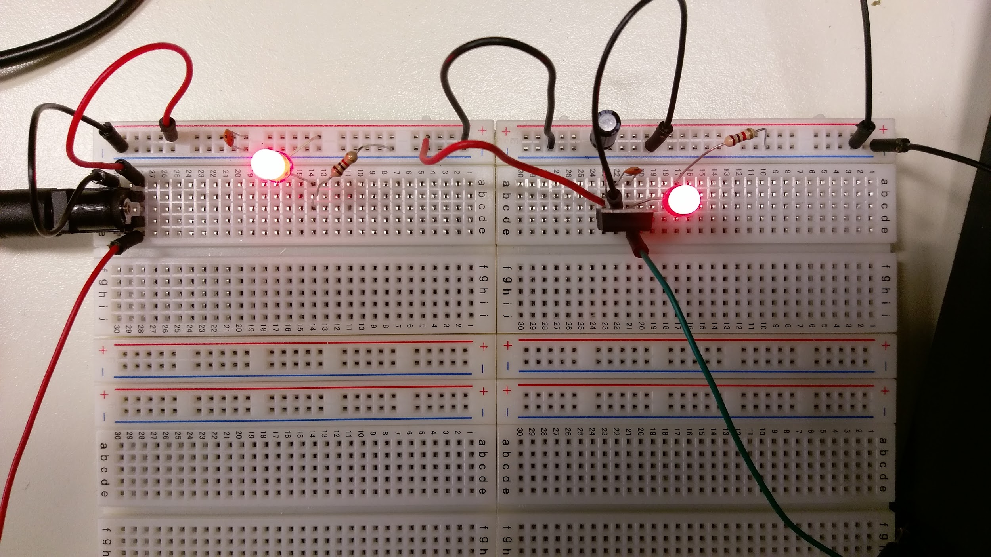

Figure 6.4 - Breadboard Test Setup of Low Voltage Power Schematic; DC Barrel Jack on Left Side with RED wire as 12 VDC; LM7805 Standard Linear Regulator on Right Side.

Figure 6.4 above shows the low voltage power schematic. The red wires depict the 12 VDC coming from the DC barrel jack that interfaces the breadboard and the AC adaptor. The left LED circuit is included as a visual aid to show that power is present at the output of the DC barrel jack. The LED circuit located on the right side shows that power is present at the output of the voltage regulator. The oscilloscope reading shown below provides readings of the voltages existing the barrel jack’s output and the regulator’s output.

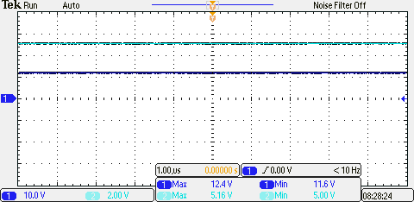

Figure 6.5 - Oscilloscope Output Voltage Readings of the 12 VDC AC adaptor (top blue line) and 5 VDC LM7805 Regulator (bottom blue line)

Figure 6.5 shows that the AC adaptor is properly outputting the 12 VDC needed to manipulation in the low voltage circuit. Although the adaptor’s output fluctuates between 12.4 V (max value) and 11.6 V (min value), it changes slowly enough to resemble a DC voltage regulated at approximately 12 V. The regulator’s output also fluctuates between 5 V (min) and 5.16 V (max). This results confirm that the low voltage power schematic is suited for providing the appropriate power to the ATmega 328P and FTDI converter.

#### 6.3.2.2 Motor Systems and Drivers

It is important to restate that the motors will source their power from the motor drivers. The G201X drivers are rated for +18 to +80 VDC. The steps for connecting power to the G201X drivers are previously given in section 6.3.1. However, before power is applied to the drivers’ terminals, the output of the supply unit must be properly configured.

The DC power supply used for testing the motor systems is a Triple Channel DC Power Supply available in the ECE Senior Design Lab. The steps below outline how to verify the voltage applied to the drivers.

1. Connect the positive probe of a digital multimeter (or oscilloscope) to the positive polarity terminal of the DC supply.
2. Connect the negative probe of a digital multimeter (or oscilloscope) to ground (or negative) terminal of the DC supply.

Following the two steps above provides a reading of the voltage actually being supplied. They should be repeated for all supply voltages for all G201X drivers. Once the supply voltages are verified to be what is needed, they can be applied to the drivers.

#### 6.3.2.3 Laser ICE Unit

Testing for the laser unit may not be necessary. It is designed to connect ONLY to the main external supply. Power supplied from a U.S. standard wall outlet is consistently regulated. Therefore, testing its power output is optional.

### 6.3.3 Communication and Control Testing

After connecting and powering the final schematic given in Figure 4.20, communication between the devices and the user computer can now be tested. Testing can be made between the devices by sending data from the user computer (such as code to be programmed to the microcontroller) and have the ATmega 328P send the data back to the user via serial monitor. The following steps can assist in depicting proper communication between the user computer and the ATmega 328P via the FTDI converter.

1. Open the Arduino IDE software.
2. Create a sketch (or code) that performs the following functions and upload it to the ATmega 328P:
   1. Start Arduino serial monitor
   2. Wait for user input via serial terminal
   3. Read user’s input from serial terminal
   4. Print user’s input back as an output via the serial monitor.

Being able to upload a code to the ATmega 328P and send data via the serial monitor demonstrates that the FTDI converter is working properly. This is critical for streaming G-code to the ATmega 328P during a laser etching process. As the user’s input is outputted back to the serial monitor, this demonstrates that the ATmega 328P can output signals. This is critical considering that the proper PWM signals need to be outputted properly to allow the G201X motor drivers to control motors in the desired 3-D like motion between the laser’s focal point and the etching glass.

### 6.3.4 Motor Driver Control Testing

Testing the motor controls is a matter of being able to output signals via the PWM pins of the ATmega 328P. Each G201X driver requires two PWM pins from the ATmega 328P, providing a step and direction signal. After properly connecting the ATmega 328P PWM pins to each driver and each driver to their respective motors, steps for driver control testing can be taken.

1. Open the Arduino IDE software.
2. Create and upload a code that performs the following procedures
   1. Identify the number of steps per revolution for which each NEMA 23 stepper motor is rated for.
   2. Via the Arduino stepper library, create a stepper motor object (a software depiction used to reference the motor).
   3. Define the desired motor’s speed in RPMs (Revolutions Per Minute)
   4. Command the motor to rotate one revolution in the clockwise direction.
   5. Wait for one second.
   6. Command the motor to rotate one revolution in the counterclockwise direction.

Being able to control each motor by sending signals the G201X drivers demonstrates that all motors can be controlled via the ATmega 328P. Once the G-code is streamed to 3-D motion to be taken, the microcontroller will send the appropriate signals to the three drivers to create the desired 3-D movement of the laser’s focal point relative to the etching glass.

## 6.4 Mechanical Specific Testing

## 6.4.1 Testing Environment

The 3-Dimensional Laser Etching System is heavily based on optics engineering. After the final system is built it will be located in the Nanosecond Spectroscopy Lab (UCF CREOL- 236). Therefore, all testing related to optics and mechanical structure will be located there as well.

### 6.4.2 Safety Shielding Assembly Check Testing

The safety shielding most thoroughly checked. It is important to make sure no stray reflecting laser beam bouncing from mirrors of any optical elements escape the vicinity of the assembly. To make sure our system is secured and meeting the standards ANSI Z 87.1 and ANSI Z 134.1 we will run through these following steps:

1. Assess the opaque cardboard screen we used assemble the surrounding shield
2. Fire the laser to track any beam reflection
3. Adjust optical elements to make sure every angle is respectively in accord

As we proceed with these steps, we will make sure that we’re not misaligning the optical elements in the system guiding the beam to the crystal. The safety check of the system will furthermore evaluate by the University of Central Florida Environmental Health Services to make sure that it is in agreement with the university standards before anyone can use the system. The safety shielding will be an additional safety to the personal protective equipment the operator of the system will wear when using the system.

### 6.4.3 XYZ Platform Weight Testing

Weight testing occurs after the XY platform and Z-axis platform are constructed. Steps to test the weight handling capabilities are as follows:

1. Stationary Weight (up to 20 lb. load)
   1. XY Platform
      1. Mount a 20lb weight onto the XY platform’s adaptor plate.
      2. Observe if there is any change in platform structure (bending or breaking of the platform).
   2. Z-axis Platform
      1. Repeat steps a.i and a.ii for the z-axis platform.

As long as the stationary weight testing is successful and the platforms can withstand a load of 20 lbs., the final structure of the system is stable enough. During the etching process, the actual weight of any etching glass will not exceed 20 lbs. and the laser etching system is able to move the glass’ weight without any issue.

**7.0 Project Management**

7.1 Roles and Responsibilities

Burdley Colas, Optics and Photonics Science and Engineering, serves the role of the primary leader of the group. The primary leader will make sure that the group members are working together productively, meeting due dates for assignments, overseeing the team dynamic, and positive advancements towards the success of the projects. The responsibilities are to determine the status of the selected laser for the system, redesign the optical system for the laser beam, and the safety shielding for the system. The dictated role and responsibilities are critical to the success of the project. The laser system in association of the optical elements must be able to have a nice beam with the correct energy to etch in the transparent crystal cube. The optical system must work collaboratively with the Software, electronics, and mechanical system such that the entire project to work as intended. Furthermore, his responsibilities expand to the order of parts and necessaries for the project. As the Optical Engineer of the group, it is imperative that he communicate clearly the optical knowledge to the rest of the group such that they understand their roles and their responsibilities as well.

Burdley Colas (OPSE)

* Research Prospects
  + Functionality of laser to be used
    - Laser Beam Profile
    - Laser Optical Output Power
    - Laser Pulse Width
  + Safety Materials for Frame
  + Optical Elements for optical system design
* Optical Design
  + Design to be within range for size constraint
  + Telescoping lens system
  + Beam Size and Beam power at etching focal point
  + Safety Frame for project
  + Assisting with XYZ-Motor setup parameters
  + Assisting with software parameters for image resolution and system versatility with respect to the performance of laser.

Other technical responsibilities are divided to other groups members based on their respective disciplines. Phillip Lane and Monushka Sicar, the group’s electrical engineers, are responsible for recognizing how all electrical aspects of the current system will be modernized, while ordering all the parts for the electronics and software. In particular, Phillip will be leading their efforts on researching various options for powering the electronic subsystems and understanding the best options for interfacing the system’s electronics and software. To successfully interface them, he will work closely with Nicolas Ramirez, the group’s computer engineer. Their collaboration will be critical for being able to control the electronics that will ultimately control the motors that assist in the system’s etching process. Without being able to successfully implement etching with the laser, the final product of the system can’t be created. Monushka Sicar is in charge of researching options for implementing 3-D motor movement capabilities. Her research is critical for both hardware and software interfacing, and for being able to meet the constraints of the available power supply. Throughout the schematic design, prototype development, and testing stages, Monushka will serve as the lead as she has prior experience is such activities. Their technical responsibilities are clarified below.

Monushka Sicar (EE)

* Research Aspects
  + Motor Options and Requirements
    - Servo
    - Stepper
  + Motor Driver Options and Requirements
  + Motor Encoder Requirements
    - Specifications
    - Compatibility
  + Power Supply (motors and drivers)
* Design, Test, and Prototyping Aspects
  + Power electronics prototyping and verification of functionality
  + Build Schematic and PCB Design
  + Assist in building mechanical structure XY & Z platforms
  + Test and verify motor and driver capabilities
  + Test and verify power supply compatibility with electronics

Phillip Lane (EE)

* Research Focus Aspects
  + Power Supply Options (all electronics excluding motors and drivers)
  + Methods for obtaining power needs:
    - AC adaptation
    - DC source (batteries)
  + All needs for needed voltage regulation
    - Linear
    - Switching (voltage step down)
  + Microcontroller needs for software and hardware interfacing
    - Flash Memory Capacity
    - Operating electrical characteristics
    - I/O and PWM pins for software and hardware interfacing
    - USB-to-Serial communication
  + Mechanical/Physical structure
    - Weight/Load capacitance for X, Y, and Z axis platforms
* Design, Test, and Prototyping Aspects
  + Test microcontroller communication with user
  + Verify microcontroller communication to motor drivers
  + Verify motor driver control to motors
  + Assist in power electronics prototyping and verification of functionality
  + Assist in Schematic and PCB Design
  + Building Mechanical Structure (X, Y, and Z platforms) for performance verification

As stated before, Nicolas Ramirez is the group’s computer engineer that is responsible for leading the software design of the project. He will take charge of all the research required with regards to software and the main technical design of the software architecture. His responsibilities can be divided into two categories, the front-end user input of the software design and the back-end that communicates directly with the microcontroller and motors. The front-end graphical user interface will all be coded and laid out by Nicolas. He will make sure that the software design meets all the front-end specifications and requirements that the sponsor wanted. For the back-end he will be collaborating with all the others in the group to make sure that the software is integrated into the system.

As the software design relies on all the other aspects of the system, Nicolas will be working closely with the others in the group. He will be working closely with Philip on the areas where the software meets the microcontroller so that the 3-dimensional object is able to be fed into the microcontroller. For the actual motor control and stage control, he will be working with Monushka and Philip. Finally, the entire process of etching will not work unless the laser system is taken into consideration so he will be working with Burdley to make sure that the laser itself can engrave into the glass based. The following is a summary of Nicolas’ responsibilities.

Nicolas Ramirez (CE)

* Research Aspects
  + Graphical User Interface
  + Programming requirements
    - General software architecture
  + 2D to 3D conversion
    - JPG, PNG to STL
  + 3D to G-code conversion
  + Microcontroller G-code interpretation
  + RS-232 Interface laser interaction
    - Laser on/off
* Design, Test, and Prototyping Aspects
  + Graphical User Interface
    - Front-end user interaction
  + 2D to 3D conversion process within software
  + 3D slicing to G-code design and testing
  + G-code streaming to microcontroller
  + G-code interpretation on microcontroller
  + Verification of 3D object etching

## 7.2 Milestones

As Engineers and specifically as humans having a system always help with in project developments, growth, and in many other aspects. In our case, a milestone serves as a potential guide for us to work in the realization of our project which is bounded in the interval of two semesters. Our group will work closely and diligently to meet the set dates on the milestones and achieving the goals which in our case are specifications per time intervals. Although the dates and specifications are recorded, they are also tentative and subject to change with respect of unexpected changes as the group moving forward solving problems and facing in practicality.

|  |  |  |
| --- | --- | --- |
| **Milestone** | **Range** | **Specification** |
| **Create Group** | August 22 – August 27 |  |
| **Project Selection** | August 29 – September 3 | Acquire sponsor and vote on project |
| **Sponsor decision/Decision for Project** | September 3 | Dr. Soileau - 3D etching project |
| **Project Planning** | September 5 – September 23 | Research and meeting with Dr.Soileau (sponsor) |
| **Finalizing Project Blueprint** | September 25 – October 21 | Research and acquiring data sheet for parts |
| **First Draft of Document** | October 24 – November 11 | Research and determining Parts to purchase |
| **Weekly Meeting with**  **Dr. Soileau** | Every Tuesday at 1:30PM | Schedule weekly meetings with Dr. Soileau for updates |
| **Purchasing** | November 1- November 30 | Purchase items for all systems |
| **Testing** | November 10 - November 30 | Test all system parts |
| **Final Draft of Document** | December 6 | Final Documentation Due |
| **Purchase** | December 12 – December 23 | Make Final Purchases |
| **PCB Assembly** | January 9 – January 15 | Assemble PCB design |
| **Optical Assembly** | January 9 – January 15 | Assemble Optical design |
| **Software testing and Electronic testing** | January 15 - January 21 | Test integration between software and electronics |
| **System Assembly** | January 23 – January 31 | Integrate all system |
| **Prototype Assembly** | February 1 – March 10 | Testing system as a whole |
| **Prototype Testing** | March 20 – April 14 | Finalize system |
| **Final Prototype Run** | April 17 – May 2 | DEMO READY! |

## Table 7.1 - Milestone Table

## 7.3 Project Budgeting and Financing

## For our project, budgeting was very essential to our sponsor Dr. Soileau as well as to the team.

|  |  |  |
| --- | --- | --- |
| **Product** | **Quantity Order** | **Final Cost ($)** |
| Nema 23 Stepper Motor | 3 | 85.44 |
| Stepper Driver | 3 | 363.00 |
| Arduino UNO Dev Kit | 1 | 34.95 |
| USB - to - RS232 Convertor | 1 | 9.99 |
| 12 VDC AC Adapter Power Supply | 1 | 5.95 |
| DC Barrel Jack | 1 | 0.95 |
| 5 VDC Linear Regulator | 3 | 2. 85 |
| Atmega 328P | 3 | 12.90 |
| 16 MHz Crystal Oscillator | 3 | 2.85 |
| 200W Switching Power Supply | 1 | 35.02 |
| SMD Green LED (25 count) | 1 | 4.95 |
| SMD Red LED (25 count) | 1 | 2.95 |
| Diode 1N4004G | 10 | 1.63 |
| Mechanical Switch | 10 | 9.03 |
| SMD 10K Resistor | 200 | 5.52 |
| SMD 10uF capacitor (10 count) | 1 | 1.90 |
| SMD 100uF capacitor (10 count) | 1 | 6.50 |
| SMD 22pF (100 count) | 1 | 1.00 |
| SMD 1K Resistor (100 count) | 1 | 2.54 |
| **Product** | **Quantity Order** | **Final Cost ($)** |
| John Guest (PI011222S) Male Connector 3/8" Tube X 1/4" NPTF Gray | 2 | 48.40 |
| John Guest Acetal Copolymer Barbed Tube Fitting, Stem, 1/4" Stem OD x 5/16" Hose ID (Pack of 10) | 2 | 20.26 |
| Colder PLCD22006 Acetal Tube Fitting, Insert, Shutoff, In-Line, 1/4" Insert x 3/8"Barb | 2 | 19.06 |
| Tanz HM-02 Caesar Hardware Miniature Worm Gear Hose Clamp | 2 | 41.72 |
| VRC2 - VIS/IR Detector Card, 400 - 640 nm, 800 - 1700 nm | 1 | 79 |
| RS12 - Ø1" Pillar Post, 1/4"-20 Taps, L = 12", 8-32 Adapter Included | 2 | 109 |
| XE25L48 - 25 mm Construction Rail, L = 48" | 8 | 426.4 |
| SH25LP38 - 1/4"-20 Low-Profile Channel Screws (100 Screws/Box) | 1 | 22.70 |
| RM1S - 1" Construction Cube with Slotted Corners, Three 1/4" (M6) Counterbored Holes | 8 | 152 |
| 25.4mm Dia. x 25.4mm FL, VIS 0° Coated, Plano-Con vex Lens | 1 | 43.00 |
| 25mm Dia. x 50mm FL VIS 0° Coated, UV Plano-Convex Lens | 1 | 114 |
| 12 mm Optics Diameter, Optic Mount | 1 | 39 |
| 25.4mm x 10mm T1 Optic Diameter, Optic Mount | 1 | 42.50 |
| **Grand Total = $ 1,782.61** | | |

# Table 7.2 - Project Budgeting and Finance

# **8.0 Conclusion**

This 3-Dimensional Glass Laser Etching System is an inspiration to modernize its current version owned by the University of Central Florida CREOL department. The current system is extremely outdated and presents many issues that need to be addressed for increased safety, performance, user friendliness, and size.

In the current system, many safety hazards exist that need to be resolved. Critical hazards include, but are not limited to, exposed circuit connections to power supplies near water leakages and wires crossing around the system. The exposed circuitry is a hazard considering that any user could become electrocuted without the proper protection in place. The existence of water leakages in the vicinity of electronics increase chances of electrocution as well. Such an issue is resolved in this senior design project.

In regards to performance, many issues exist here as well. User friendliness and speed performance are not apparent. The current software, known as Ziggy, creates hardship for the user to incorporate and manipulate images to be etched, and it slow in process important data. During etching process, control of the laser itself is not a capability either. In the event any user wants to pause an etching process, the laser will continue to etch and cause undesirable results.

Overall, this senior design project will officially modernize the current laser system. Safety standards are met accordingly, runtimes for product production are improved, and user control and friendliness are emphasized.

# 

# **9.0 References**

[1] Rouse, Margaret. "What Is Burn-in?" WhatIs.com. TechTarget, Oct. 2008. Web. 04 Dec. 2016. <http://whatis.techtarget.com/definition/burn-in>.

[2] "A Beginner's Guide to Switching Regulators." A Beginner's Guide to Switching Regulators. Dimension Engineering LLC., n.d. Web. 04 Dec. 2016. <https://www.dimensionengineering.com/info/switching-regulators>.

[3] Simpson, Chester. "Linear and Switching Voltage Regulator Fundamentals." Linear and Switching Voltage Regulator Fundamental Part 1 SNVA558 (n.d.): n. pag. Texas Instruments, Inc. Web. 04 Dec. 2016.

[4] "A Beginner's Guide to Switching Regulators." A Beginner's Guide to Switching Regulators. Dimension Engineering LLC., n.d. Web. 04 Dec. 2016. <https://www.dimensionengineering.com/info/switching-regulators>.

[5] "A Beginner's Guide to Switching Regulators." A Beginner's Guide to Switching Regulators. Dimension Engineering LLC., n.d. Web. 04 Dec. 2016. <https://www.dimensionengineering.com/info/switching-regulators>.

[6] "Advantages vs Disadvantages in Comparison with Linear Regulator." Tech Web. ROHM Semiconductor Co., Ltd., 12 Nov. 2015. Web. 04 Dec. 2016. <http://micro.rohm.com/en/techweb/knowledge/dcdc/s-dcdc/02-s-dcdc/2642/>.

[7] Lietchi, Chris. "Welcome to PySerial’s Documentation." PySerial 3.0 Documentation. PySerial, 2015. Web. 04 Dec. 2016. <https://pythonhosted.org/pyserial/>

[8] Seliger , Peter. “Potrace,” Peter Selinger: Potrace, Potrace, 2015. Web 04 Dec. 2016 <http://potrace.sourceforge.net/>

[9] LLC, ImageMagick Studio. “Convert, Edit, Or Compose Bitmap Images @ ImageMagick, ImageMagick, 2016. Web. 04 Dec. 2016. <<http://www.imagemagick.org/script/index.php>>

[10] “Welcome to Python.org” Python.org. Python Software Foundation, 2016. Web. 04 Dec. 2016. <<https://www.python.org/doc/essays/blurb/>>

[11] Authors, Multiple. "STL (file Format)." Wikipedia. Wikimedia Foundation, 2016. Web. 04 Dec. 2016. <<https://en.wikipedia.org/wiki/STL_(file_format)>>

[12] Burns, Marshal. "Fabbers.com." The StL Format. Fabbers, 2016. Web. 04 Dec. 2016. <<http://www.fabbers.com/tech/STL_Format>>

[13] Thearn. "Thearn/stl_tools." GitHub. N.p., 19 Feb. 2016. Web. 04 Dec. 2016.< [https://github.com/thearn/stl_tools>](https://github.com/thearn/stl_tools)

[14] Multiple, Authors. "Tkinter." TkInter - Python Wiki. Python, 2014. Web. 04 Dec. 2016. <[https://wiki.python.org/moin/TkInter>](https://wiki.python.org/moin/TkInter)

[15] "WxPython." WxPython. N.p., 2016. Web. 04 Dec. 2016. <<https://wxpython.org/>>

[16] Multiple, Authors. "Page." PyQt - Python Wiki. PyQt, 2016. Web. 04 Dec. 2016. <[https://wiki.python.org/moin/PyQt>](https://wiki.python.org/moin/PyQt)

[17] "PySide." PySide - Qt Wiki. N.p., 2016. Web. 04 Dec. 2016. <<http://wiki.qt.io/PySide>>

[18] "RS-232." Wikipedia. Wikimedia Foundation, 2016. Web. 04 Dec. 2016.< <https://en.wikipedia.org/wiki/RS-232>>

[19] Strangio, Christopher E. "Contact Info | About Us | CableEye | Cable & Harness Testers." CAMI Research. CAMI Research, 2015. Web. 04 Dec. 2016. <<http://www.camiresearch.com/Data_Com_Basics/RS232_standard.html>>

[20] Hodgson, Gary. "Slic3r Manual." Slic3r Manual - Welcome to the Slic3r Manual. Slic3r, 2016. Web. 04 Dec. 2016. <<http://manual.slic3r.org/>>

[21] "G-code." Http://reprap.org/wiki/G-code. RepRap, 2016. Web. 4 Dec. 2016. <<http://reprap.org/wiki/G-code>>

[22] Reed, Frances. "How Do Servo Motors Work." How Servo Motors Work. Jameco Electronics, n.d. Web. 04 Dec. 2016. <http://www.jameco.com/jameco/workshop/howitworks/how-servo-motors-work.html>.

[23]"Stepper Motor Control Block Diagram." Stepper Motor Control Block Diagram. Piclist, n.d. Web. 20 Nov. 2016.

<<http://www.piclist.com/techref/io/stepper/blockdiagram.htm>>

[24] "Stepper Motors." Code Circuits Construction. N.p., n.d. Web. 04 Dec. 2016. <http://www.tigoe.net/pcomp/code/circuits/motors/stepper-motors/>.

[25] G201X / G210X User Manual (2011): n. pag. Gecko Drive Motor Controls, 15 Dec. 2011. Web. 4 Dec. 2016. <http://www.geckodrive.com/gecko/images/cms_files/G201X%20REV-6%20Manual.pdf>.

[26] "Geckodrive." Power Supply Basics - Step Motor Basics - Support | GeckoDrive. Gecko Drive Motor Controls, 2016. Web. 04 Dec. 2016. <<http://www.geckodrive.com/support/step-motor-basics/power-supply-basics.html>>

[27] "Geckodrive." Step Motor Basics - Support | GeckoDrive. Gecko Drive Motor Controls, 2016. Web. 04 Dec. 2016. <<http://www.geckodrive.com/support/step-motor-basics.html>>

[28] "Battery and Energy Technologies." Electric Drives - Control Systems - Description and Applications. Woodbank Communications Ltd., 2005. Web. 04 Dec. 2016. <<http://www.mpoweruk.com/motorcontrols.htm>>

[29] Group, FRABA. "Absolute vs Incremental Rotary Encoders." Posital. FRABA B.V., 2016. Web. 04 Dec. 2016. <<https://www.posital.com/en/products/absolute-encoders/absolute-vs-incremental.php>>

[30] Reed, Frances. "How Do Servo Motors Work." How Servo Motors Work. Jameco, 2016. Web. 04 Dec. 2016. <<http://www.jameco.com/jameco/workshop/howitworks/how-servo-motors-work.html>>

[31] Eglowstein, Howard. "Introduction to Servo Motors." Science Buddies. Science Buddies, 2016. Web. 04 Dec. 2016. <<http://www.sciencebuddies.org/science-fair-projects/project_ideas/Robotics_ServoMotors.shtml>>

[32] Daware, Kiran. "How Does a Servo Motor Work?" Electricaleasy.com. Miscellaneous Machines, 2016. Web. 04 Dec. 2016. <<http://www.electricaleasy.com/2015/01/how-does-servo-motor-work.html>>

[33] "Futaba® Servo Selection Form." Futaba® Servo Selection Form. Futaba, 2016. Web. 04 Dec. 2016. <<http://www.futabarc.com/servos/servo-wizard.php>>

[34] Grbl. "Grbl/grbl." GitHub. Grbl, 26 July 2016. Web. 04 Dec. 2016. <<https://github.com/grbl/grbl>>

[35] Multiple, Authors. "Git." Wikipedia. Wikimedia Foundation, 2016. Web. 04 Dec. 2016. <<https://en.wikipedia.org/wiki/Git>>

[36] "Build Software Better, Together." GitHub. GitHub, 2016. Web. 04 Dec. 2016. <https://github.com/>

[37] MarlinFirmware. "MarlinFirmware/Marlin." GitHub. Marlin, 04 Aug. 2016. Web. 04 Dec. 2016. <https://github.com/MarlinFirmware/Marlin>

[38] Baer, Thomas M., and Mark S. Keirstead. "Patent US4653056 - Nd-YAG Laser." Google Books. Spectra-Physics, Inc., 24 Mar. 1987. Web. 04 Dec. 2016. <https://www.google.com/patents/us4653056>.

[39] "What Is a Motor Driver?" What Is a Motor Driver, Stepper Motor Drivers, Dc, Stepper Motor Drivers - Future Electronics. Future Electronics, n.d. Web. 04 Dec. 2016. <http://www.futureelectronics.com/en/drivers/motor-driver.aspx>.

[40] "Linear Encoder." Wikipedia. Wikimedia Foundation, n.d. Web. 04 Dec. 2016. <<https://en.wikipedia.org/wiki/Linear_encoder>>.

[41] "Power Supplies." Stepper Motor Power Supplies. Stepper Online Motors & Electronics, n.d. Web. 04 Dec. 2016. <http://www.omc-stepperonline.com/power-supplies-c-5.html>.

[42] "IEEE Std 3007.3 Recommended Practice for Electrical Safety in Industrial and Commercial Power Systems." IEEE Xplore. Technical Books Coordinating Committee, 6 Feb. 2012. Web. 4 Dec. 2016.

[43] "Medicare Covered Codes » Standards." Medicare Covered Codes RSS. N.p., n.d. Web. 04 Dec. 2016. <<http://www.medicarecode.net/tag/standards/page/2/>>.

[44] Practice for Occupational and Educational Eye and Face Protection. New York: American National Standards Institute, 1968. Web. <<https://law.resource.org/pub/us/cfr/ibr/002/ansi.z87.1.2003.pdf>>.

[45] Ogawa, Koichi, Junjiro Shintaku, and Tetsuo Yoshimoto. INTERNATIONAL STANDARDIZATION AS A STRATEGIC TOOL (n.d.): n. pag. Web. <<http://www.iec.ch/about/globalreach/academia/pdf/shintaku-3.pdf>>.

[46] Stoev, Nikolay, and Tom Lieb. CDRH/IEC - Who It Applies To? (n.d.): n. pag. Web. <https://www.lia.org/PDF/ILSC/PAS_Course_Notes_Final/Session6_Stoev_Lieb_Final.pdf>.

[46] "Optics Express." OSA | Fabrication and Characterization of Three-dimensional Copper Metallodielectric Photonic Crystals. N.p., n.d. Web. 04 Dec. 2016. <<https://www.osapublishing.org/oe/abstract.cfm?uri=oe-15-26-18283>>.

[47] IDEX Optics and Photonics Marketplace. GAUSSIAN BEAM OPTICS (n.d.): n. pag. Marketplace.idexop.com. Web. <<https://marketplace.idexop.com/store/SupportDocuments/All_About_Gaussian_Beam_OpticsWEB.pdf>>.

[48] Fuchs, Ulrike, Sven Kiontke, and Asphericon. "Beam Expansion- Standard Concepts Re-interpreted, Ulrike Fuchs, Sven Kiontke, Asphericon." (n.d.): n. pag. Web. <<https://www.asphericon.com/wp-content/uploads/asphericon_White-Paper_Beam-Expansion.pdf>>.

[49] Jefferson, Michael C., John A. Hoffnagle, and IBM ALmaden Research Center. "Aspheric Laser Beam Reshaper Applications Guide." (n.d.): n. pag. Web. <<http://assets.newport.com/webDocuments-EN/images/11976.PDF>>.

[50] Universal Laser Systems. "Choosing the Correct Lens." (n.d.): n. pag. Ulsinc.com. Web. <<http://www.engraversnetwork.com/files/Choosing-the-right-Laser-lens-tip-sheet.pdf>>.

[51] Ruslan, Ivanov. "Gaussian Beams." Field Guide to Nonlinear Optics (n.d.): n. pag. Web. <<https://www.kth.se/polopoly_fs/1.569752!/Gaussian%20beams.pdf>>.

[52] Newport. Optics: How to Build a Beam Expander (n.d.): n. pag. Web. <<http://assets.newport.com/webdocuments-en/images/how_to_build_a_beam_expander_5.pdf>>.

[53] "Optics Express." OSA | Elemental Analysis Using Micro Laser-induced Breakdown Spectroscopy (µLIBS) in a Microfluidic Platform. N.p., n.d. Web. 04 Dec. 2016. <<https://www.osapublishing.org/oe/abstract.cfm?uri=oe-16-17-12435>>.

[54] 3-D microstructuring inside photosensitive glass by femtosecond laser excitation, M. Masuda, K. Sugioka, Y. Cheng, N. Aoki, M, Kawachi, M. Shihoyama, K. Toyoda, H. Hellvajian, K. Midorikawa

< <http://link.springer.com/article/10.1007/s00339-002-1937-z> >

[55] Three-Dimensional Micron-Scale Metal Photonic Crystals Via Multiphoton Direct Laser Writing and Electroless Metal Deposition, Amir Ta, Stephen M. Kuebler

< <https://www.osapublishing.org/oe/abstract.cfm?uri=oe-15-26-18283> >

[56] Scanning Galvo Systems, User Guide, THORLABS

<[https://www.thorlabs.com/n ewgrouppage9.cfm?objectgroup_id=3770](https://www.thorlabs.com/newgrouppage9.cfm?objectgroup_id=3770) >

[57] Three Dimensional Laser Microfabrication in Diamond Using a Dual Adaptive Optics System, Richard D. Simmonds, Patrick S. Salter, Alexander Jesacher, Martin J. Booth <<https://www.osapublishing.org/oe/abstract.cfm?uri=oe-19-24-24122> >

# 

# **10.0 Appendix**

## 10.1 Appendix A - Copyright Permissions

#### **ROHM Semiconductor**

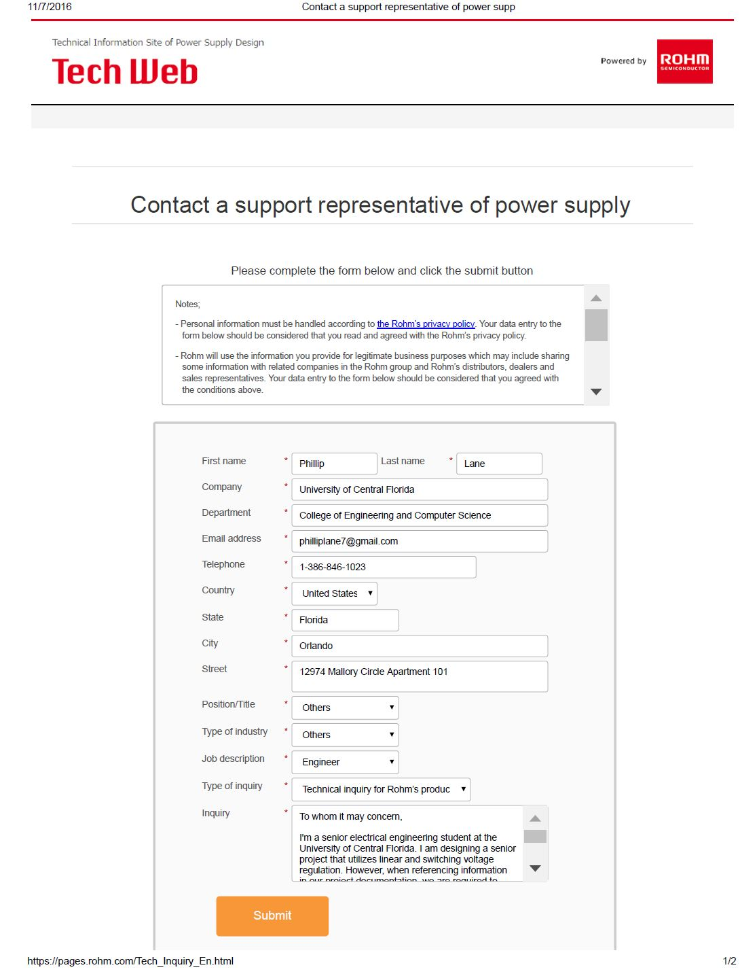

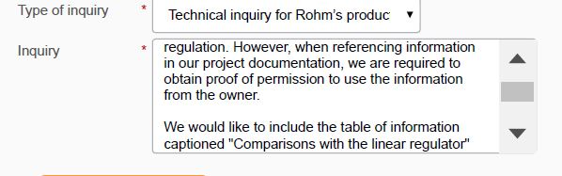

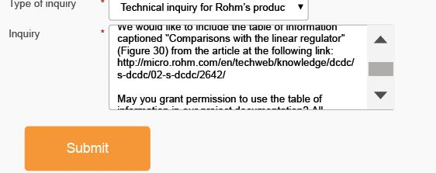

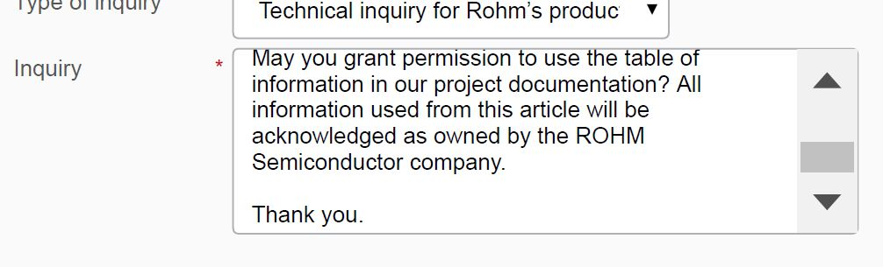

#### **Velmex**



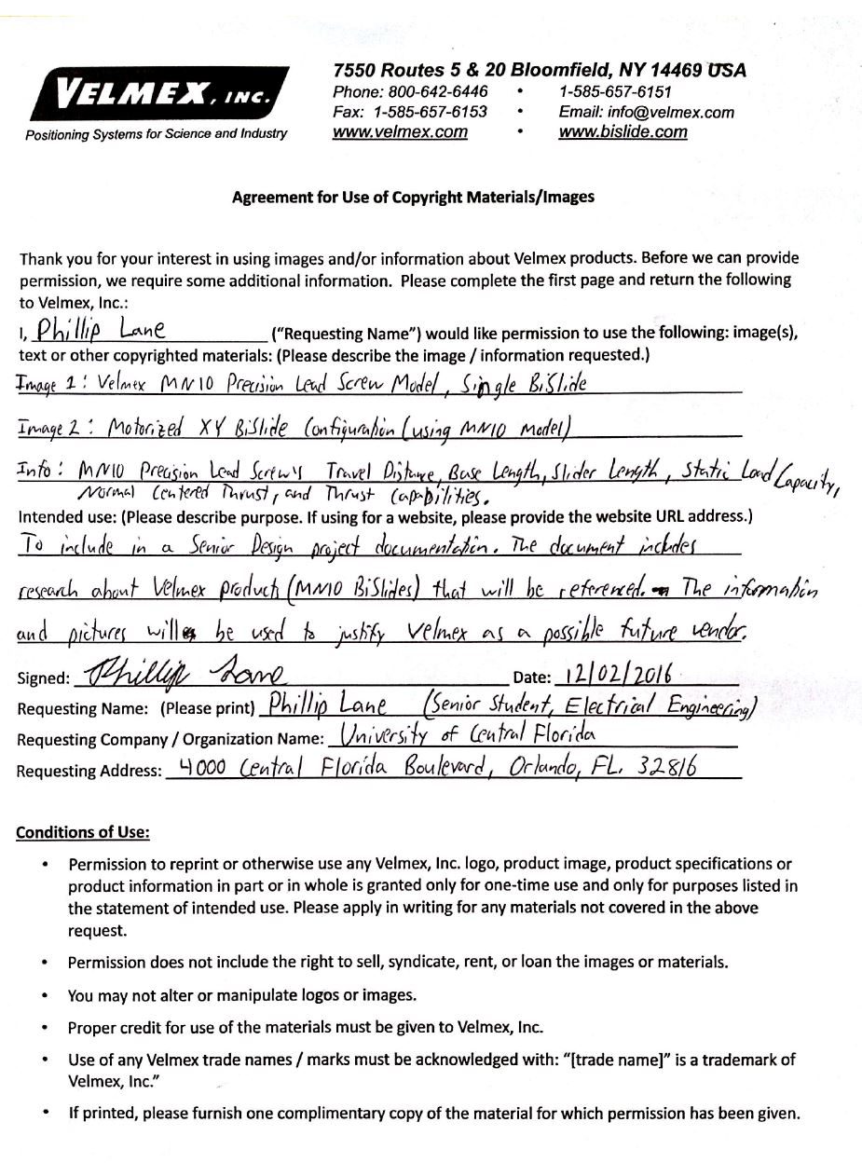

#### **Texas Instruments**

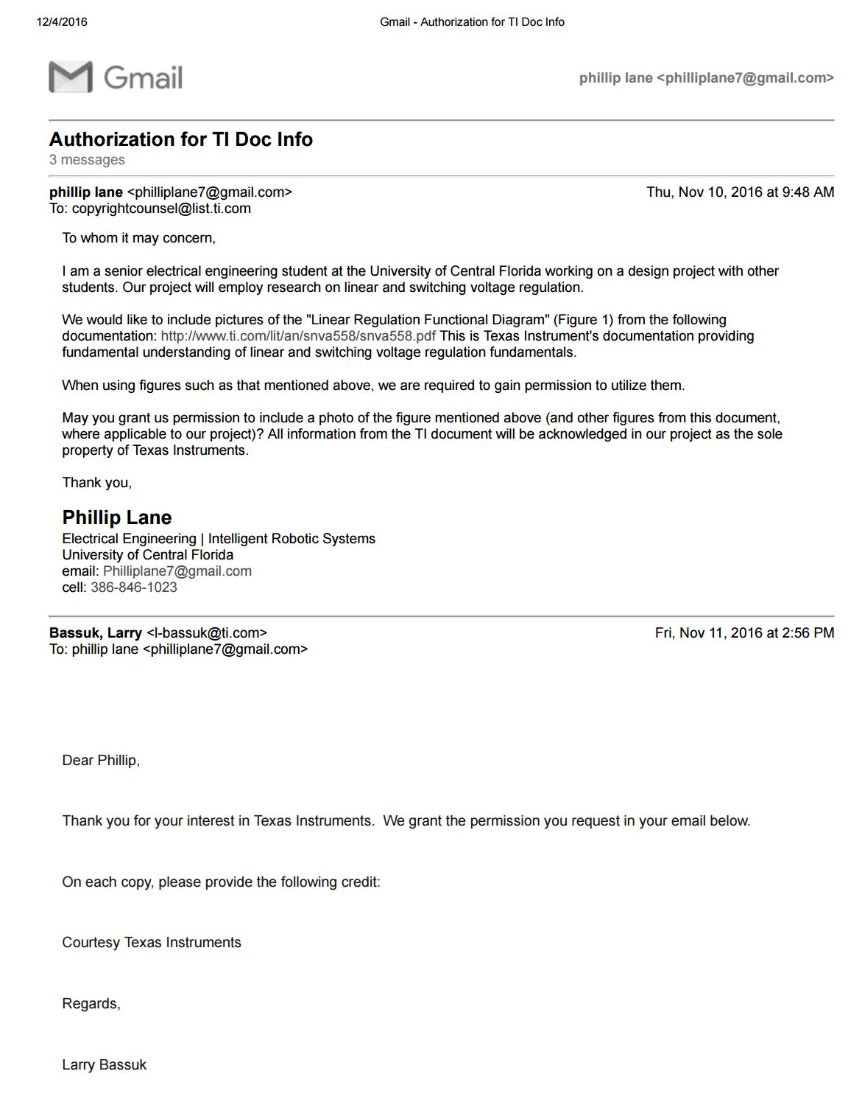

**Science Buddies**

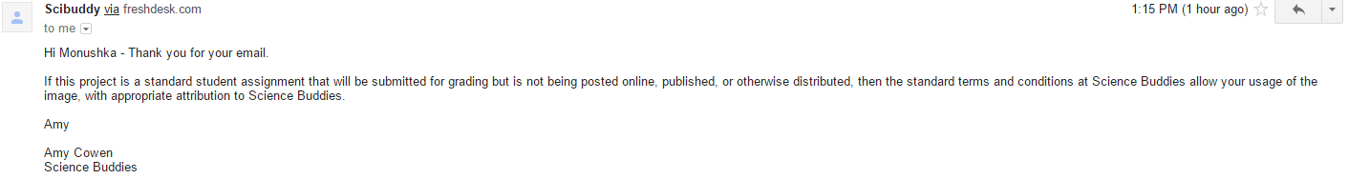

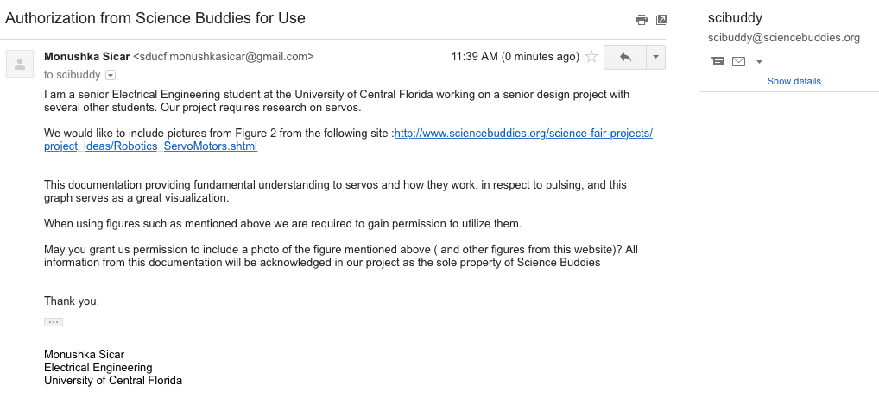

**Gecko Motor Drives**

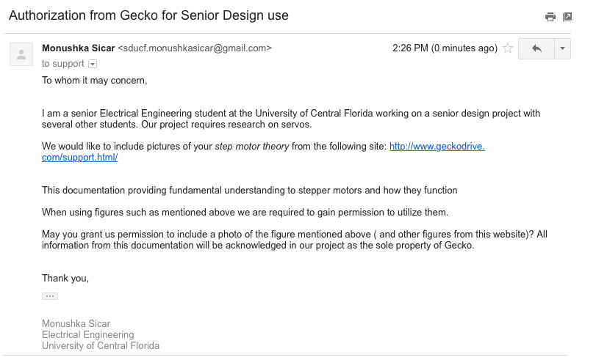

**Jameco Electronics**

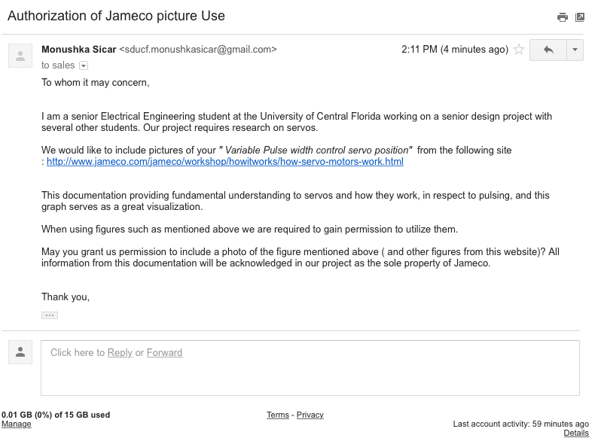

**Thor Labs**





**IntelLiDrives**

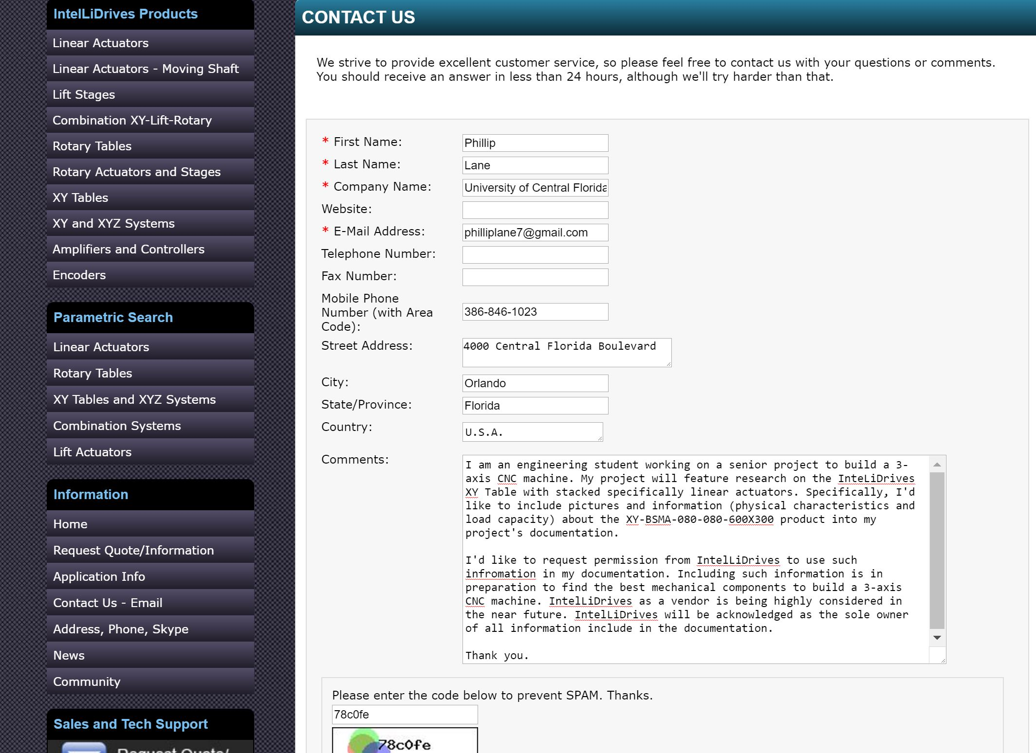

## 10.2 Appendix B - Datasheet Information

**ATmega 328P (Pages 1 and 2)**

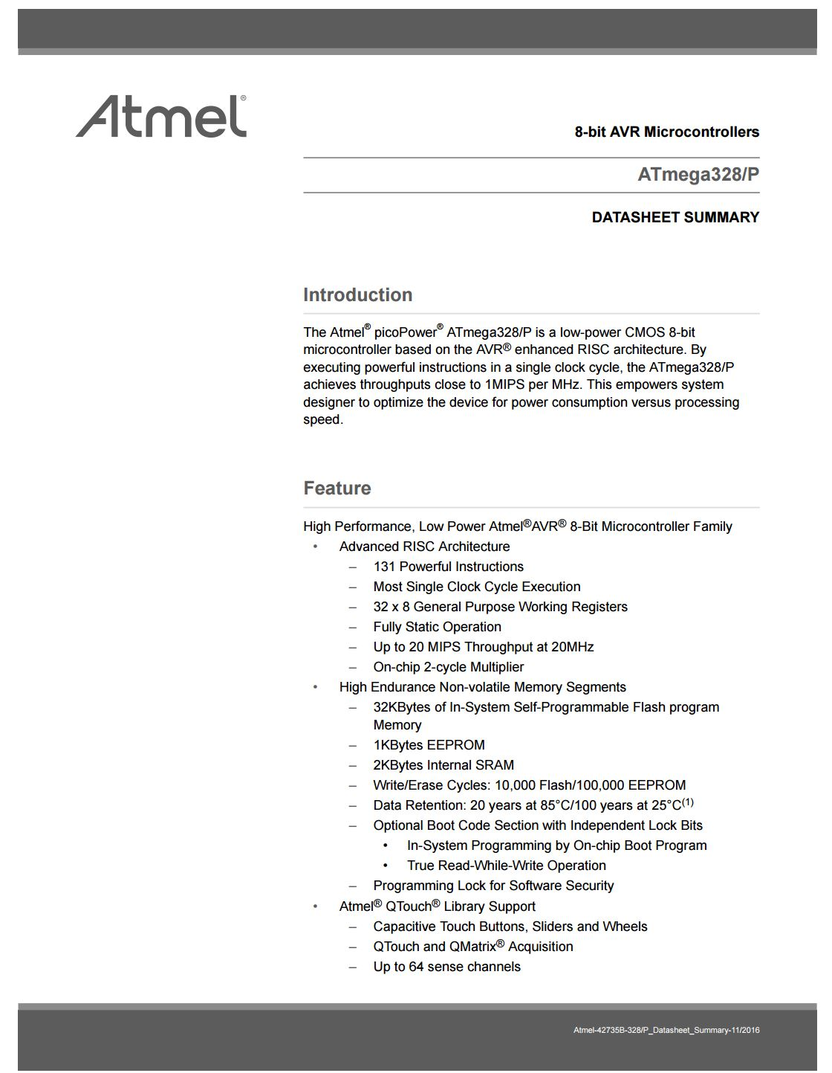

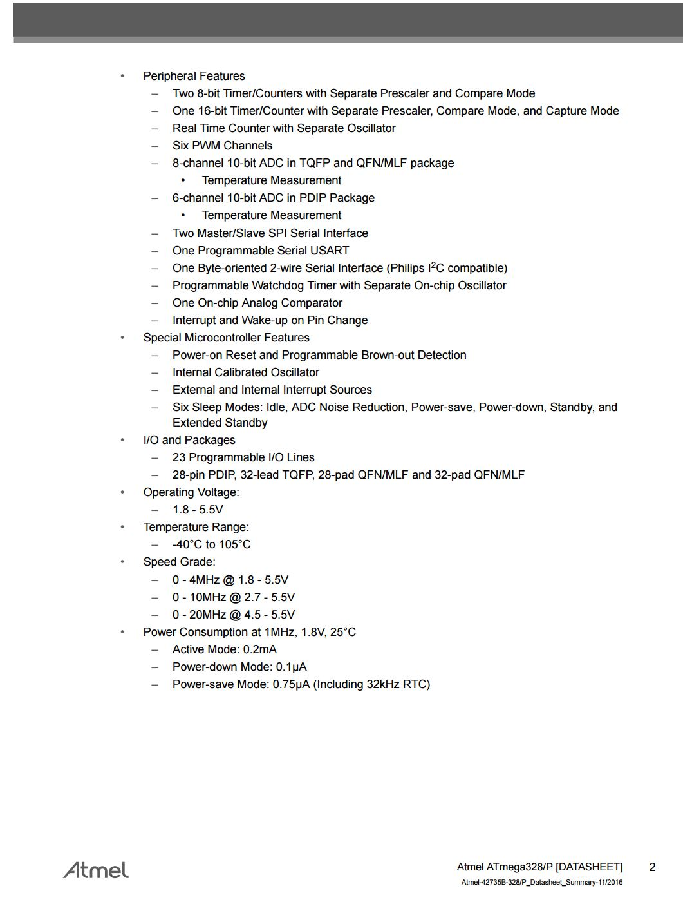

**ATmega 32U4 (Pages 1 and 2)**

